Answer sheet

Identify which layer of the OSI model each component of Tinos driving school’s network corresponds to.

These are the different components of the network and the corresponding layers:
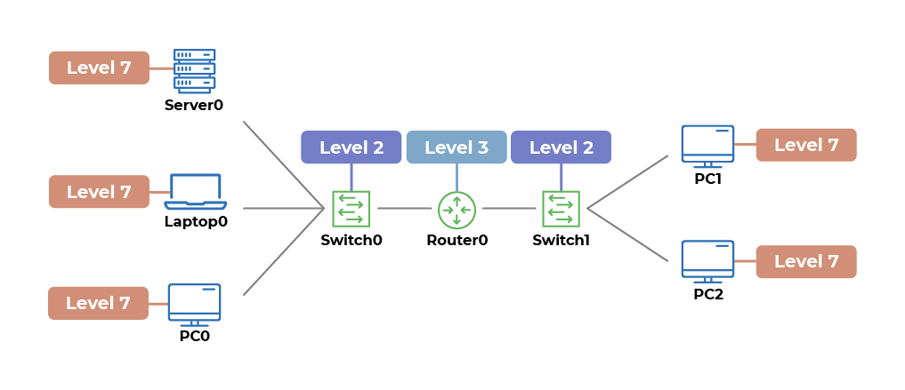
- Switches are level 2 devices which understand MAC addresses.
- Routers are level 3 devices which understand IP addresses.
- All end nodes are level 7 devices, as they host applications which understand level 7 protocols.

