Answer sheet

Task

Add a DHCP server to Cyclade’s architecture with the IP address 192.168.100.250/24.

Add two laptops to the network.

Configure the DHCP server.

Configure the mobile clients.

Check that the two mobile clients have received an IP address.

Once you’ve finished, your architecture should look like this:
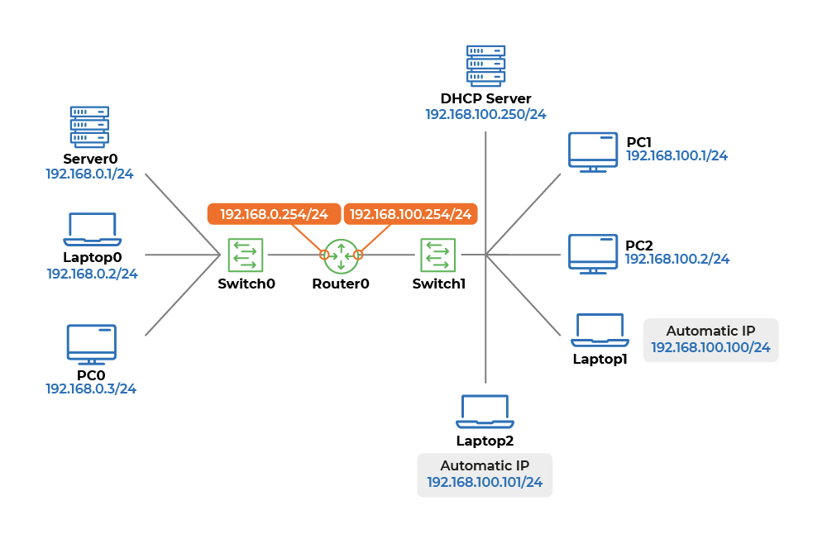

Please note, you may not have exactly the same IP addresses for the two new laptops as the diagram above in your environment. As long as both IP addresses begin with 192.168.100.x then they are configured correctly.

Once DHCP is configured correctly, you no longer need to manually configure IP addresses for new devices in your network. ;)

