**10IOA04 MODBUS RTU Commamd**

**MODBUS command (function code, write 05/06/15/16, read 01/02/03)**

Note :

1 MODBUS command must be HEX

2 Slave ID (device address) must be consistent with the DIP switches (A0-A5)

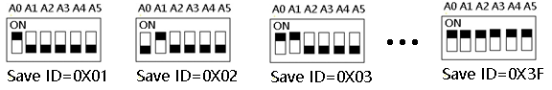

**Supported function codes:**

|  |  |  |  |
| --- | --- | --- | --- |
| Function Code | Modbus  Address (PLC) | Register Address | Describe |
| 01： | 00001 | 0x0000-0x0003  (0-4) | Read DO digital output status (relay) |
| 05： | 00001 | 0x0000-0x0003  (0-4) | Write a single DO digital output (relay) |
| 15： | 00001 | 0x0000-0x0003  (0-4) | Write multiple DO digital output (relay) |
| 02： | 10001 | 0x0000-0x0003  (0-4) | Read DI digital input (optical isolation input) |
| 03 | 40001 |  |  |
| 0x0080-0x00FF  (128-255) | Read special function registers (baud rate 485 address, etc.) |
| 06 | 40001 |  |  |
| 0x0080-0x00FF  (128-255) | Write a single special function register (baud rate 485 address, etc.) |
| 16(0x10) | 40001 |  |  |
| 0x0080-0x00FF  (128-255) | Write multiple special function registers (baud rate 485 address, etc.) |

All states are mapped into 4xxxx range registers. The user can monitor the input and output status of the module by reading or modifying the value of the 4xxxx interval register (03 06 16 function code)

|  |  |  |  |  |
| --- | --- | --- | --- | --- |
| Register address | Register contents | Register value | Remarks | R/W |
|  |  |  |  |  |
| 0x0080  (128) | DO digital output | 0-65536 | Digital output status 0-3 bits | R/W |
| 0x0090  (144) | DI digital input | 0 | Digital input status 0-3 bits | R |
|  |  |  |  |  |
| 0x00F7  (247) | Product ID | 0-65535 | SKU ID  10IOA04 1004 |  |
| 0x00F8  (248) | Automatic reporting of digital input(DI) status | 0-255 | 0: Query function (default) 1-255: Automatically report, the unit is second.  1: Report every 1 second  2: Report every 2 seconds  10: Report every 10 seconds Maximum interval of 255 seconds | R/W |
|  |  |  |
| 0x00FA  (250) | Input and output relationship（DI-DO relationship） | 0X0000-  0X0005 | 0x0000 Unrelated  0x0001 Self-locking (default)  0x0002 Interlocking  0x0003 Momentary  0x0004 Interlocking(2 ch)  0x0005 Output=Input  Other values are the same as 0 | R/W |
| 0x00FB  (251) | Factory Reset | 00 | Factory Reset：  1 Short the RESET jumper for 5 seconds  2 Enter the following command at the current baud rate:  FF 06 00 FB 00 00 ED E5 | R/W |
| 0x00FC  (252) | Command Return Time | 0-25 | Time interval for command return (unit: 40MS) Setting value: 0-25 | R/W |
| 0x00FD  (253) | RS485 address  (Station address) | 1-63 | Products with DIP switches can only read | R |
| 0x00FE  (254) | Baud rate | 0-255 | 0:1200 1:2400 2:4800  3:9600（default）4:19200  5:38400 6:57600  7:115200  Others：Factory reset | R/W |
| 0x00FF  (255) | Parity | 0-2 | 0 None Parity  1 Odd Parity  2 Even Parity | R/W |

9600 Band ,8 Data bits,None Parity,1 Stop Bit。

MODBUS commands you can use "Modbus Poll" input, as shown below

（CRC check generated automatically）

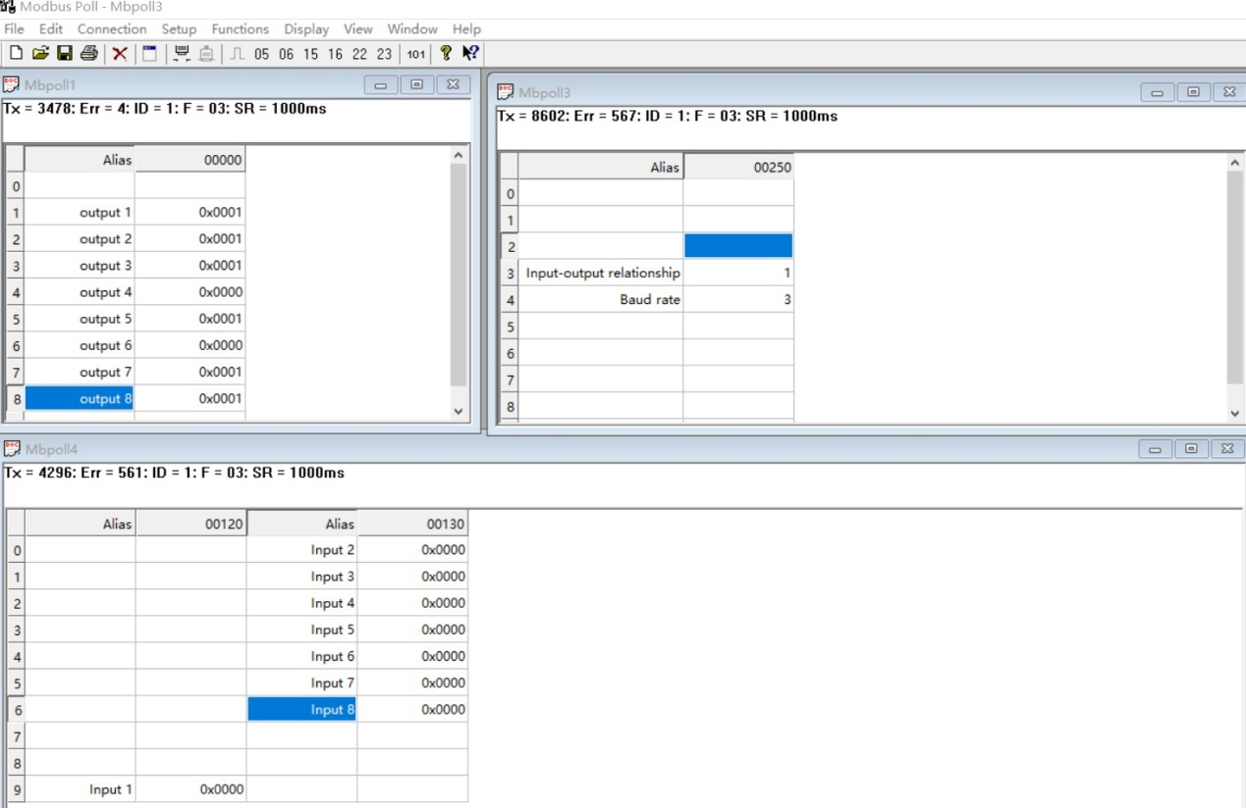

You can also use HyperTerminal serial input, as shown below

（Manually add CRC check）

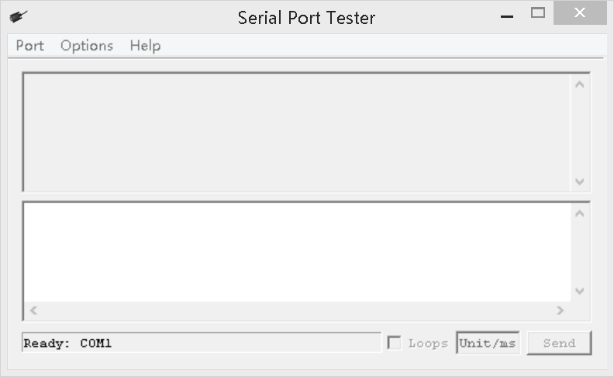

**Example (4-channel 4Di4Do relay):**

**1. Read DI digital input status (NPN photoelectric isolation input):** Send data

|  |  |  |  |  |
| --- | --- | --- | --- | --- |
| RS485 address  (Station address)  (1) | Function (1) | Register address (2) | Read number (2) | CRC16(2) |

Returns data

|  |  |  |  |  |
| --- | --- | --- | --- | --- |
| RS485 address  (Station address)  (1) | Function (1) | Number of bytes (1) | data (n) | CRC16(2) |

Modbus Address(PLC)：10001-10004

RS485 address : 0x01~0x3F

Function code: 0x02

Register address:0x0000-0x0003

Read number :0x0001-0x0004

**For example, read the status of DI digital input of channel 0-3:**

Send data(address 1): 01 02 00 00 00 04 79 C9

Return data : 01 02 01 09 61 8E

01 RS485 address, 02 function code, 01 length, 09 refers to the current DI digital input status, converted to binary 00001001, indicating that 0/3 channels have input, and other channels have no input.

In addition, the DI digital input is also mapped to the 40000 interval register. The user can read the value of the DI digital input through the 03 function code.

Modbus Address(PLC)：40145

RS485 address : 0x01~0x3F

Function code:0x03

Register address:0x0090

Read number: 0x0001

**For example, read the status of DI digital input of channel 0-3:**

Send data(address 1): 01 03 00 90 00 01 84 27

Return data : 01 03 02 00 06 38 46

01 RS485 address, 03 function code, 02 length, 0006 refers to the current DI digital input status, converted to binary 00000110, indicating that 1/2 channels have input, and other channels have no input.

**2.Read DO digital output status (relay output):**

Send data

|  |  |  |  |  |
| --- | --- | --- | --- | --- |
| RS485 address  (Station address)  (1) | Function (1) | Register address (2) | Read number (2) | CRC16(2) |

Returns data

|  |  |  |  |  |
| --- | --- | --- | --- | --- |
| RS485 address  (Station address)  (1) | Function (1) | Number of bytes (1) | data (n) | CRC16(2) |

Modbus Address(PLC)：00001-00004

RS485 address : 0x01~0x3F

Function code: 0x01

Register address:0x0000-0x0003

Read number :0x0001-0x0004

For example, read the status of DO digital output of channel 0-3:

Send data(address 1): 01 01 00 00 00 04 3D C9

Return data : 01 01 01 03 11 89

01 RS485 address, 01 function code, 01 length, 03 refers to the current DO digital output status, converted to binary 00000011, indicating that 0/1 channels have output, and other channels have no output.

In addition, the DO digital output is also mapped to the 40000 interval register. The user can read the value of the DO digital output through the 03 function code.

Modbus Address(PLC)：40129

RS485 address : 0x01~0x3F

Function code:0x03

Register address:0x0080

Read number: 0x0001

For example, read the status of DO digital output of channel 0-3:

Send data(address 1): 01 03 00 80 00 01 85 E2

Return data : 01 03 02 00 0B F9 83

01 RS485 address, 03 function code, 02 length, 0038 refers to the current DO digital output status, converted to binary 00001011, indicating that 0/1/3 channels have output, and other channels no output.

**3.** **Write single DO digital output status (relay output):**

Send data

|  |  |  |  |  |
| --- | --- | --- | --- | --- |
| RS485 address  (Station address)  (1) | Function (1) | Register address (2) | Read number (2) | CRC16(2) |

Returns data

|  |  |  |  |  |
| --- | --- | --- | --- | --- |
| RS485 address  (Station address)  (1) | Function (1) | Number of bytes (1) | data (n) | CRC16(2) |

Modbus Address(PLC)：00001-00004

RS485 address : 0x01~0x3F

Function code:0x05

Register address:0x0000-0x0003

For example 1, Write channel 0 to ON, others OFF:

Send data(address 1):01 05 00 00 FF 00 8C 3A

Return data :01 05 00 00 FF 00 8C 3A

For example 2, Write channel 2 to ON, others OFF:

Send data(address 1):01 05 00 02 FF 00 2D FA

Return data :01 05 00 02 FF 00 2D FA

For example 3, Write channel 3 to ON, others OFF:

Send data(address 1):01 05 00 03 FF 00 7C 3A

Return data :01 05 00 03 FF 00 7C 3A

In addition, the DO digital output is also mapped to the 40000 interval register. The user can write the DO digital output value through the 06/16 function code.

Modbus Address(PLC)：40129

RS485 address :0x01~0x3F

Function code:0x06/0x10

Register address:0x0080

For example, Write channel 0/3 to ON, others OFF:

Send data(address 1):01 06 00 80 00 09 48 24

Return data :01 06 00 80 00 09 48 24

**4.Write multiple DO digital output status (relay output):**

Send data

|  |  |  |  |  |
| --- | --- | --- | --- | --- |
| RS485 address  (Station address)  (1) | Function (1) | Register address (2) | Read number (2) | CRC16(2) |

Returns data

|  |  |  |  |  |
| --- | --- | --- | --- | --- |
| RS485 address  (Station address)  (1) | Function (1) | Number of bytes (1) | data (n) | CRC16(2) |

Modbus Address(PLC)：00001-00004

RS485 address :0x01~0x3F

Function code:0x0F

Register address:0x0000-0x0003

For example 1, Write channel 0-3 to OFF:

Send data(address 1):01 0F 00 00 00 04 01 00 3E 96

Return data :01 0F 00 00 00 04 54 08

For example 1, Write channel 0-3 to ON:

Send data(address 1):01 0F 00 00 00 04 01 FF 7E D6

Return data :01 0F 00 00 00 04 54 08

For example 3, Write channel 0/1/3 to ON, others OFF:

Send data(address 1):01 0F 00 00 00 04 01 0B 7F 51

Return data :01 0F 00 00 00 04 54 08

In addition, the DO digital output is also mapped to the 40000 interval register. The user can write the DO digital output value through the 06/16 function code.

Modbus Address(PLC)：40129

RS485 address :0x01~0x3F

Function code:0x06/0x10

Register address:0x0080

For example, Write channel 0/3 to ON, others OFF:

Send data(address 1):01 06 00 80 00 09 48 24

Return data :01 06 00 80 00 09 48 24

**Special function Register**

**1.Write baud rate**

Send data

|  |  |  |  |  |
| --- | --- | --- | --- | --- |
| RS485 address  (Station address)  (1) | Function (1) | Register address (2) | Read number (2) | CRC16(2) |

Returns data

|  |  |  |  |  |
| --- | --- | --- | --- | --- |
| RS485 address  (Station address)  (1) | Function (1) | Number of bytes (1) | data (n) | CRC16(2) |

Modbus Address(PLC)：40255

RS485 address :0x01~0x3F

Function code:Write 0x06/0x16;Read 0x03

Register address:0x00FE(254)

Value: 2 bytes (values 0-7)

For example 1, Change the baud rate to 4800bps:

Send data(address 1):01 06 00 FE 00 02 69 FB

Return data :01 06 00 FE 00 02 69 FB

Baud rate corresponds to the number: 0:1200 1:2400 2:4800 3:9600 4:19200 6：57600 7： 115200 8: Factory reset

Note: 1 The baud rate will be updated only when the module is powered on again when this command is used!

2 When the number corresponding to the baud rate is 8, the factory settings can be restored

For example:01 06 00 FE 00 08 E9 FC

For example 2 Read the current baud rate:

Send data(address 1):01 03 00 FE 00 01 E5 FA

Return data :01 03 02 00 03 F8 45

01 RS485 address，03 Function,02 length,F8 45 crc16,03 means the current baud rate is 9600bps

Baud rate corresponds to the number: 0:1200 1:2400 2:4800 3:9600 4:19200 6：57600 7： 115200

**2. Set digital input and output relationship (DI-DO relationship):**

Send data

|  |  |  |  |  |
| --- | --- | --- | --- | --- |
| RS485 address  (Station address)  (1) | Function (1) | Register address (2) | Read number (2) | CRC16(2) |

Returns data

|  |  |  |  |  |
| --- | --- | --- | --- | --- |
| RS485 address  (Station address)  (1) | Function (1) | Number of bytes (1) | data (n) | CRC16(2) |

Modbus Address(PLC):40251

RS485 address :0x01~0x3F

Function code:Write 0x06/0x16;Read 0x03

Register address:0x00FA(250)

Value: 2 bytes (values 0-5)

For example, set the input and output to be unrelated, and change the register value to 0X0000:

Send data(address 1):01 06 00 FA 00 00 A9 FB

Return data :01 06 00 FA 00 00 A9 FB

Register value:

0x0000 Unrelated

0x0001 Self-locking relationship (default)

0x0002 Interlocking relationship

0x0003 Momentary relationship

0x0004 Interlocking relationship (2 channels)

0x0005 Output=Input

Other values are the same as 0x0000

For example: read the current input-output relationship

Send data(address 1):01 03 00 FA 00 01 A4 3B

Return data :01 03 02 00 01 79 84

01 RS485 address，03 Function,02 length 0001is Self-locking relationship

,15 FA crc16

**3. Set DI digital input status to automatically report (4 channels are set at the same time):**(Automatic reporting of digital input(DI) status)

Send data

|  |  |  |  |  |
| --- | --- | --- | --- | --- |
| RS485 address  (Station address)  (1) | Function (1) | Register address (2) | Read number (2) | CRC16(2) |

Returns data

|  |  |  |  |  |
| --- | --- | --- | --- | --- |
| RS485 address  (Station address)  (1) | Function (1) | Number of bytes (1) | data (n) | CRC16(2) |

Modbus Address(PLC)：40249

RS485 address :0x01~0x3F

Function code:Write 0x06/0x16;Read 0x03

Register address:0x00F8(248)

Value: 2 bytes (values 0-255)

For example : For example, the current query function should be changed to automatic reporting:

1 second automatic report : 01 06 00 F8 00 01 C9 FB

2 second automatic report : 01 06 00 F8 00 02 89 FA

3 second automatic report : 01 06 00 F8 00 03 48 3A

4 second automatic report : 01 06 00 F8 00 04 09 F8

5 second automatic report : 01 06 00 F8 00 05 C8 38

10 second automatic report : 01 06 00 F8 00 0A 88 3C

Disable reporting function(Query function): 01 06 00 F8 00 00 08 3B

**4.Set Command(Date) Return Time**

Send data

|  |  |  |  |  |
| --- | --- | --- | --- | --- |
| RS485 address  (Station address)  (1) | Function (1) | Register address (2) | Read number (2) | CRC16(2) |

Returns data

|  |  |  |  |  |
| --- | --- | --- | --- | --- |
| RS485 address  (Station address)  (1) | Function (1) | Number of bytes (1) | data (n) | CRC16(2) |

Modbus Address(PLC)：40253

RS485 address :0x01~0x3F

Function code:Write 0x06/0x16;Read 0x03

Register address:0x00FC(252)

Value: 2 bytes (values 0-25)

For example, set the data return delay to 200ms

Send data(address 1):01 06 00 FC 00 05 89 F9

Return data :01 06 00 FC 00 05 89 F9

Return the delay time calculation formula:X = 05 * 40 = 200MS

Note: The maximum can be set to 1000MS. If it exceeds 1000MS, that is, the setting value is greater than 25, and the data return delay will be initialized.

That is: 01 06 00 FC 00 20 48 22 can make the data return delay to restore initialization 0

**5.Set Parity**

Send data

|  |  |  |  |  |
| --- | --- | --- | --- | --- |
| RS485 address  (Station address)  (1) | Function (1) | Register address (2) | Read number (2) | CRC16(2) |

Returns data

|  |  |  |  |  |
| --- | --- | --- | --- | --- |
| RS485 address  (Station address)  (1) | Function (1) | Number of bytes (1) | data (n) | CRC16(2) |

Modbus Address(PLC)：40256

RS485 address :0x01~0x3F

Function code:Write 0x06/0x16;Read 0x03

Register address:0x00FF(255)

Value: 2 bytes (values 0-2)

For example, set the parity to even parity

Send data(address 1):01 06 00 FF 00 01 78 3A

Return data :01 06 00 FF 00 01 78 3A

0 None Parity 1 Odd Parity 2 Even Parity

Note: 1. When using this command, the module is powered on again, and the check digit will be updated!

2. When the setting is greater than 2, the default value will be restored to 0 after powering on again, and there will be no verification.

**6.Factory reset:**

Send data

|  |  |  |  |  |
| --- | --- | --- | --- | --- |
| RS485 address  (Station address)  (1) | Function (1) | Register address (2) | Read number (2) | CRC16(2) |

Returns data

|  |  |  |  |  |
| --- | --- | --- | --- | --- |
| RS485 address  (Station address)  (1) | Function (1) | Number of bytes (1) | data (n) | CRC16(2) |

Modbus Address(PLC)：40252

RS485 address : 0x01~0x3F

Function code:Write 0x06;

Register address:0x00FB(251)

Send data(address 1):FF 06 00 FB 00 00 ED E5

Return data :FF 06 00 FB 00 00 ED E5

Hardware reset: short the RESET jumper of the board for 5 seconds, then power on again.