

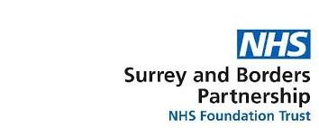

NE Hampshire & Farnham Recovery College and Surrey Recovery College



**Level 1 Award in Awareness of First Aid for Mental Health (4 hour course)**

**Anyone can be affected by a mental health condition either themselves or a family member, friend or colleague.**

This awareness course is suitable for everyone as it provides learners with the knowledge to recognise a suspected mental health condition and the skills to start a conversation and be able to signpost a person towards professional help.

Everyone can benefit from this course and it is a great stepping stone onto Level 2 First Aid for Mental Health.

**Syllabus**

**A range of subjects are covered including:**

* What is First Aid for Mental Health?
* Identifying mental health conditions
* Providing advice and starting a conversation

**Assessment**

The qualification is assessed through a multiple choice question paper

**Certification**

Upon successful completion of the assessment, learners will be awarded the Ofqual regulated Level 1 Award in Awareness of First Aid for Mental Health.

**Numbers**

A maximum of 16 students can be registered on a course.

**Identification**

We will need to see some form of photographic ID (passport, driver’s licence) to confirm identity for each learner so the NUCO awarding body canissue a certificate.

E

E