Meet the Cumbria Rugby Union Development Team

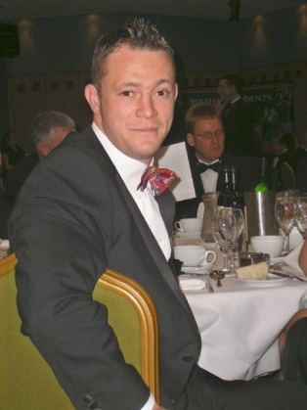  Liam Nicholls  Rugby Development Officer – Cumbria  liamnicholls@rfu.com  07711901374 | Liam has been working in Rugby Development since 2002, and has enjoyed this time immensely working with a vast array of people during this time. Quietly nicknamed ‘Pickles’ he has a BSc (Hons) degree in Sports Studies with Business Management. Currently involved as a player and coach at Egremont RUFC and working with Cumbria U18’s as Head Coach. Hobbies include any fitness particularly cycling and cross fit. His best moment in Rugby was playing International 7’s in Trinidad & Tobago and worst moment was breaking his leg very badly playing for Aspatria in 2003! He says the best part of the job is meeting lots of new, keen and enthusiastic people and the worst part is seeing any club struggling in any area. His dream job is Pilot ‘Red 1’ with the Red Arrows!
Trevor ‘Monty’ Richardson has been working in Rugby Development unofficially since 1985 until the role became official in 2000. He is a Level 2 Coach working across the Allerdale District working with 7 clubs. His hobbies are sport & history and he supports; Wigton RU, Hampshire Cricket & West Bromwich Albion Football. He coaches Allerdale District and works across all schools in the area. Predictably his best moments in Rugby are any wins over Aspatria RU as his local rivals and worst moments are any losses to the aforementioned! His favourite part of the job is working with enthusiastic volunteers and his worst part of the job is unnecessary admin and unsporting supporters! His dream job is a tour guide around Wigton…. Sorry Europe! |  | 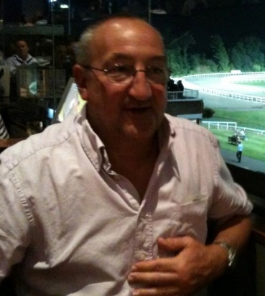  Trevor Richardson  Community Rugby Coach – Allerdale  trevorrichardson@rfu.com  07545921473
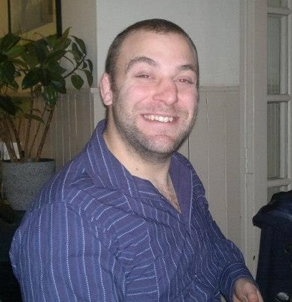  Garry Holmes  Community Rugby Coach – Barrow & South Lakes  garryholmes@rfu.com  07545921474 | Garry Holmes affectionately known as; Garry Yams, Yams or Holmesey has been working in Rugby Development since 2006 in the South Lakes Area taking on Barrow District after the RFU restructure in 2012. He is a Level 2 Coach and RFU Coach Educator and has aspirations to develop further in both aspects. He likes to try different types of fitness and sport and is a follower of big sporting events and is a fan of Ronnie O’Sullivan! He still plays and Coaches at Kendal RU and also works with Cumbria U15/16 & Cumbria Excel Squads AS A Bar Row Mentor. His best moment in rugby is scoring against his brother playing against Fylde and his worst moment is tearing his cartilage just before the start of the season keeping him out for 6 months! His favourite part of the job is coaching and breaking down barriers to participation and his least favourite part is talking to IT as it means he has a problem! His dream ‘job’ is to be a millionaire and do what he likes!
Graham ‘Kiddy’ Kidd started his rugby development career in 2000 on a part time basis and then moved to full time employment in 2004 with Cumbria County Council and latterly the RFU & Cumbria RU. He is a L2 Coach, RFU Coach Educator and Referee. His hobbies are focused around his 2 young boys who keep him busy on a daily basis! He is a fan of Newcastle Falcons and is a member of the Carlisle Club. He coaches Cumbria U15/16, Carlisle 1st XV, Carlisle U8’s and is a Cumbria Excel Squad Coach and Front Row Mentor. His best moment in rugby was representing Cumbria Senior XV and his worst moment was breaking his face and foot in separate incidents! His favourite part of the job is being out and about and meeting new people and his least favourite is being out in the cold Cumbrian Winter when coaching. His dream job is to be an International Beer Connoisseur! |  | 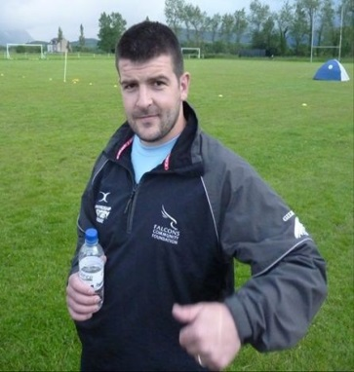  Graham Kidd  Community Rugby Coach – Carlisle & Eden  cumbriacrc@sky.com  07554010560
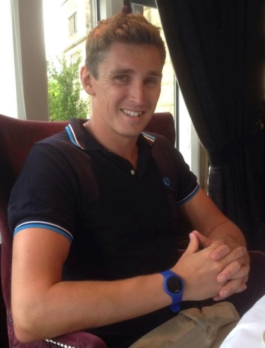  Kieran Marshall  Community Rugby Coach – Copeland  kieranmarshall@rfu.com  07718706568 | Kieran ‘Kiero’ Marshall has been working as the youngest member of the Cumbria Development Team for 6 years now having started in 2008. Originally working in Barrow he moved to his home district of Copeland in 2012. He has a Sports Therapy Degree and is a L2 Coach (Lineout Specialist) and RFU Coach Educator. His hobbies include going to the gym, playing rugby, travelling and socialising which he does very well. He is a member of Egremont RUFC and is the current Cumbria U18 Forwards Coach. His best moment in rugby is captaining his school 1st XV and his worst is constantly being injured. His favourite part of the job is seeing players develop and getting out and about in Cumbria whilst his least favourite part is ADMIN! He was undecided on his dream job so opted for; Pro Golfer for the money and to be good at golf. Pro Surfer to spent all his time at the beach or simply a World Explorer seeing what the globe has to offer!
Andrea ‘Ange’ Fraser has been working as administrative support for Cumbria Rugby Union since 2002 starting the week later than Liam Nicholls in his RDO Position. She holds the following qualifications NVQ 1 & NVQ 2, European Computer Driving Licence in ICT, Child minding, RSA Typing & Minute taking. He hobbies include; shopping, gardening, cross words and hiding the TV remote from her better half. She currently supports all Cumbria Team and is coaching her grandchildren to behave!! Her best moment in rugby is working with a committed Cumbria Development Team and worst moment is Liam forcing her to have her photo taken or to speak in meetings. The best part is apparently all aspects of the job and the worst part is cleaning the office fridge! Her dream job is a double decker bus driver!! |  |  | Andrea Fraser  Cb-yregistrar-cumbria@therfu.com  01946 839316

