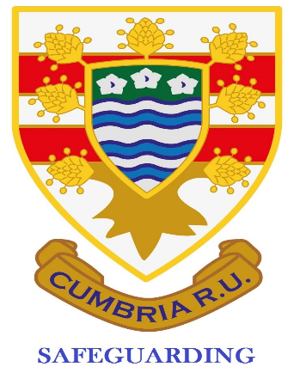
Cumbria Safeguarding Newsletter October 2021
Avril Quinn
cumbriarugbysafeguarding@outlook.com
07879303239

Contents:
- DBS applications – some pointers, why we do and why not?
- In Touch
- Club Approval
- Audits
- Headcase
- Website
- First Aid
- Age Grade organization re changing rooms and showers
Welcome to our second Safeguarding newsletter. I hope you will find some or all of it useful to your role as Club Safeguarding Officer.
I shall be calling in to some clubs to chat informally about all things Safeguarding. When the Safeguarding Audit is live my role requires me to audit several clubs within the county. I will be in touch with you beforehand if you are one of those clubs.
Please make sure your details are correct on GMS. Communication is proving to be very difficult in some cases so please either add me to your email contact list or check your junk box regularly. Thank you.
DBS applications
- We can continue to complete the DBS applications via Facetime of Messenger etc. The applicant must send you a copy of their documents so you can see them (delete when DBS awarded) and that the applicant shows you the original ones at the next convenient time. This facility may not last forever.
- When you have applied for the DBS you must then keep an eye on its status through the DBS site and then the DBS Applications tab. You can track the progress very easily.
- I mentioned last time about completing the whole DBS and not referring it to the applicant to do their bit. In the last 2 months 18 applications have been cancelled by the Disclosure Department as the applicant has failed to complete their bit; what a waste of time for all concerned!
- The county website has a form that you can use to complete the DBS – it just helps with accuracy when completing online details. One digit wrong and the application fails.
- Why we DBS
- I know you will be aware of the recent well publicised court case against a Governor, Referee and ex teacher. This is why we complete DBS checks! You have to be sure that your personnel that are involved with Age Grade players and with any adults deemed to be at risk as mentioned in Reg 21.5.
- Why not?
- We are trying to promote good practice within our county, for all players be they Age Grade, male or female or adult. To ensure you are doing your bit, you must ensure that your coaches have a current DBS and have completed the appropriate courses for coaching, Play it Safe and Headcase. Why not DBS check these personnel is the question you have to ask yourself?
In Touch
If any SO/Deputy SO needs to complete the In Touch course please email me as I now book the online courses for you through an access I have. There is a booklet to read before the course date but I can send that out.
Club Approval
We have now received Club Approval applications for only 2 clubs so far in Cumbria. Before this is approved, checks are made to see that your club is compliant, a brief meeting is held by the Compliance team and then the decision to approve or decline until further conditions are met, is made. The checks include Discipline, DBS, Coaching.
Audits
I’m sorry but as this is being written the following audits;
- Safeguarding and
- RugbySafe – you have a bit to do here
are still not on GMS. Can you please keep an eye on your GMS so these can be completed in a timely fashion as they are a useful tool to ensure you are rugby ready and compliant. I’d like to think that next year they will be out much earlier.
Headcase
The Headcase module on the RFU website has been updated and the advice from RFU is that all First Aiders, coaches and any other personnel from within the club are advised to complete and supply you their certificate to show that this has been completed. It might be useful if you keep a log of who has valid Headcase certificates so you can ensure people are up to date.
Website
Please use the Cumbria website for any guidance you may need. The Safeguarding tab has been populated now and does get updated (thank you Garry Holmes) and if we can improve this or make it easier to use, please get in touch. This needs to be your go-to if you are unsure about anything.
First Aid
Just to be aware that a L3 First Aid at Work course is acceptable to the RFU as a rugby first aid qualification. I shall be running one at Aspatria RUFC in the new year for a £50 fee to include all refreshments and lunch. It will be on a Saturday.
Age Grade changing and shower facilities
At Aspatria I’m lucky enough to be able to section off a changing room, toilets and showers for our U18 personnel on a regular match day; players, ball boys, linesman, scoreboard lads. They have all had a letter explaining why this has to happen and why they must follow the guidelines I have laid down. This has been done with the full support of the General Committee and Coaching staff. What arrangements do you have for your U18 on an adult match day? Can you give some thought as to how you manage your young people at this time of the week to ensure they are safe? U18 players have to have the option to shower and change away from the adult players; we have chosen to make this mandatory because of our other young people involved every match day.
Remember that if you need support there are people available:
Avril Quinn - Cumbria SM and Aspatria SO – details at the top of the newsletter
Garry Holmes – Kendal RUFC
Stu McNee – Egremont RUFC

