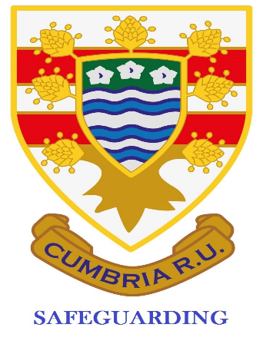
Cumbria Safeguarding Newsletter November 2021
Avril Quinn
cumbriarugbysafeguarding@outlook.com
07879303239

Contents:
- Age Grade competitions
- Accidents and injury on the pitch
- DBS applications – important!
- In Touch training
- Club Approval
- Audits
- Headcase
- Website

Welcome to our latest Safeguarding newsletter; November 2021.
Age Grade games and competitions
It’s great to see that plans are in place for the Age Grade competitions and finals dates have been confirmed; 2 at St Benedicts and 2 at Wigton. I will be there on both dates and I will be sending out check sheets for completion before the match so all is in place re DBS, Safeguarding in the changing rooms and First Aid x 2 is in place.
Liam Nicholls is running a session on Age Grade if you are unsure on playing up/down. Please get in touch with him if you need clarification/joining instructions.
Accidents and injury on the pitch
Do you, or does someone in your club, keep a record of injuries that happen during a game?
Most of these will not actually be Reportable Injuries but will help your club to pinpoint areas that might need attention.

REPORTABLE INJURY EVENTS
These are defined as:
- An injury which results in the player being admitted to a hospital (this does not include those that attend an Accident or Emergency Department and are allowed home from there)
- Deaths which occur during or within 6 hours of a game finishing.
https://keepyourbootson.co.uk/wp-content/uploads/2019/05/Incident-Injury-Report-Form-Template.pdf
I think its useful to keep head injury data up to date so you/coaches can monitor progress. I include this from the RFU;

‘The RFU’s advice:
The general rule that the RFU is advising everyone in rugby to follow is the Recognise-Remove-Recover and Return principle:
- The welfare of the player both short and long term must always come first
- Concussion is a functional disturbance of the brain
- All health care professionals involved in rugby must be able to recognise concussion
- Players with suspected concussion must be removed from play
- The treatment for concussion is physical and cognitive rest
- All players must be allowed to recover before returning to play. Complications can occur if a player is returned to play before complete recovery
- All players with diagnosed or suspected concussion must undergo a graduated return to play
A player who has suffered from a concussive injury must not be allowed to return to play before having a medical clearance. In accordance with current consensus guidelines, there is no mandatory period of time that a player must be withheld from play following a concussion.’
During some training pre season ((Webinar on Immediate Care Provision is still available on RFU website), it is now required that you have 2 named First Aid personnel on duty for all senior home matches, 1 per team. It is the home team’s responsibility to provide this or check it is in place. We always initial who those people are on our Home Game checksheet.
DBS applications
- Can I plead with you to do the whole DBS application while you have the applicant present. It doesn’t take much more time and saves the application being cancelled. 28 have been cancelled recently as the applicants have not responded in time. What a waste of your time!
- You need them to bring:
- Current passport
- Current photo driving licence
- Birth certificate
- Details of different addresses in last 5 years]
- Details of any different names they have used and the dates
- I have sent reminders to people from the Disclosure system but they have not responded.
- The photo IDs must be current. The driving licence cannot be on paper!
- Chat to them informally before you do them to see if there is any reason the application will fail and they do!
- If you need me to come and do an few at a time just ask! I’m here to help.
In Touch
In Touch training is being done online until December. Every Wednesday 7 – 9.30. Once it is back in person it’s a 6 hour course and you will have to travel. Please take advantage of this if you need updated (it lasts 3 years). Send me your details and I book you onto the system. Nearer the time I will email you the accompanying booklet that does not need printed. As an SO you are required to have a current In Touch qualification and completed within 6 months of taking up the post. I’m going to do mine early to save my time later.
Club Approval
What a pain in the neck this is proving to be! Your coaches need to have current DBS checks and you need to have a current DBS and the In Touch qualification. Approval is not automatic. If and when you get approval you then need to apply for Individual Approval per player. The forms are all on the Cumbria RFU website under Safeguarding.

Audits
I’m sorry but the Safeguarding Audit is still not live. When it is, I will be coming to some clubs to complete it with them. This is not meant to be onerous but it is there to safeguard both you, club personnel and the young people/adults that need it. It is mandatory!
Headcase
The Headcase module on the RFU website has been updated and the advice from RFU is that all First Aiders, coaches and any other personnel from within the club are advised to complete and supply you their certificate to show that this has been completed. It might be useful if you keep a log of who has valid Headcase certificates so you can ensure people are up to date.
Website
Please use the Cumbria website for any guidance you may need. Its not there to look pretty to be a useful tool for you.
Remember that if you need support there are people available:
Avril Quinn - Cumbria SM and Aspatria SO – details at the top of the newsletter
Garry Holmes – Kendal RUFC
Stu McNee – Egremont RUFC

