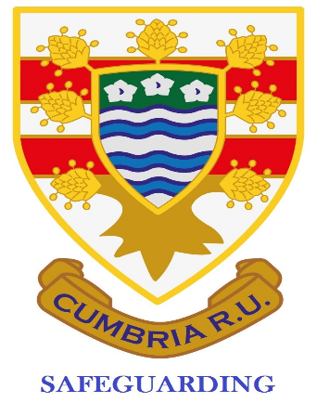
Cumbria Safeguarding Newsletter January 2022
Avril Quinn
cumbriarugbysafeguarding@outlook.com
07879303239

Contents:
- WhatsApp groups
- Club and Player Approval
- DBS Applications
- Website

And just like that its January 2022! I hope you have all managed to enjoy some time off/with families/out!
Short Newsletter this month. Can you please share these with your General/Management Committee and Coaches. Some of this is vital for them to know; its not solely your responsibility. Share the information so that you can be supported. Some clubs think because you have the job title all is well, but they need the information.
WhatsApp groups
Can I remind you that you CANNOT have anyone in a WhatsApp group that is U18 (5-17) without their parents also being in the group. This can be very problematic for some people but unfortunately that’s the RFU ruling. Please make sure your coaches know this so you are not put in an awkward situation.
Club and Player Approval
Please remember that if you want players who are 17 to play adult rugby you have to complete the Club Approval form, submit that and have it approved. Can you please ensure it is completed fully. There are a few clubs who have had them returned for further details and so are not approved yet!
Once this has been approved you can apply for individual player (who have been assessed) approval. Until all this is in place you cannot field a 17 year old even if he is a registered player.
DBS Applications
Please ensure that you see evidence of the applicant completing the online e-safeguarding course before you apply for their DBS. The DBS will not be approved until this is complete.
Website
Please use the Cumbria website for any guidance you may need. Its not there to look pretty but to be a useful tool for you.
Remember that if you need support there are people available:
Avril Quinn - Cumbria SM and Aspatria SO – details at the top of the newsletter
Garry Holmes – Kendal RUFC
Stu McNee – Egremont RUFC

