Name and full postal address of your Bank or Building Society

To: The Manager Bank/Building Society
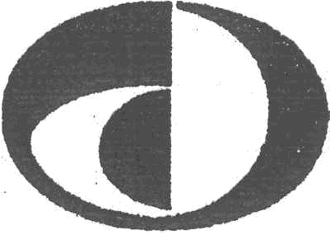
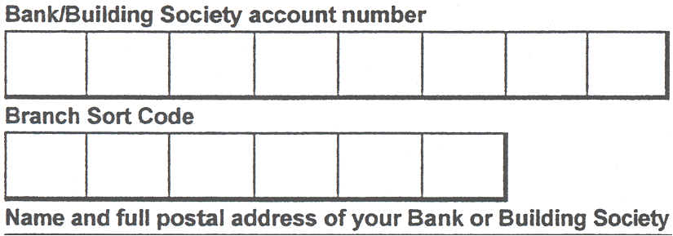
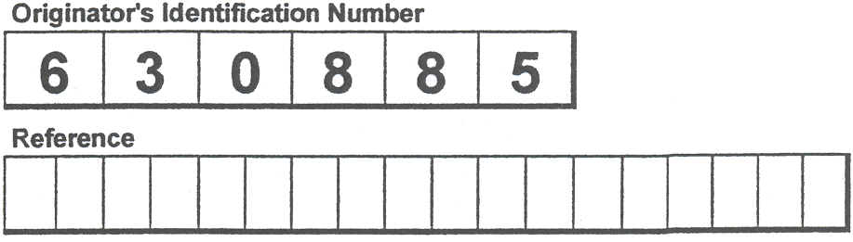
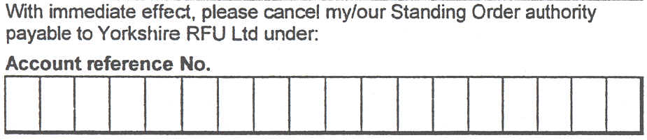
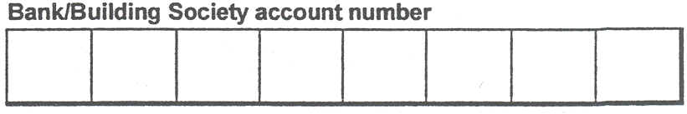
Yorkshire Rugby Football Union Ltd
Please fill in the whole form including official use box using a ball point pen and send it to:
Yorkshire Rugby Football Union Ltd
Griffin House
24 Station Road
Morley
Leeds
LS27 BJW
Name(s) of Account Holder(s)

To: The Manager Bank/Building Society
Direct
Debit
Instruction to your Bank or Building Society to pay by Direct Debit
FOR YORKSHIRE RFU LTD OFFICIAL USE ONLY
This is not part of the instruction to your Bank or Building Society.

Instruction to your Bank or Building Society
Please pay Yorkshire RFU Ltd Direct Debits from the account detailed in
this Instruction subject to the safeguards assured by the Direct Debit Guarantee. I understand that this Instruction may remain with Yorkshire RFU Ltd and if so, details will be passed electronically to my Bank/Building Society.

Signatures

Date
Address
Postcode
Banks and Building Societies may not accept Direct Debit Instructions for some types of account
DDI3
-----------------------------------------------------------------------------------------------------------------
Address

Postcode

Name(s) of Account Holder(s)
Standing Order Cancellation
Signatures
Date
This guarantee should be detached and retained by the Payer.
The Direct Debit Guarantee
---------------------------------------------------------------------------------------------------------------
~ DIRECT
~ Debit
- This Guarantee is offered by all Banks and Building Societies that accept instructions to pay Direct Debits.
- If there are any changes to the amount, date or frequency of your Direct Debit Yorkshire RFU Ltd will notify you 14 working days in advance of your
account being debited or as otherwise agreed. If you request Yorkshire RFU Ltd to collect a payment, confirmation of the amount and date will be given to you at the time of the request.
- If an error is made in the payment of your Direct Debit by Yorkshire RFU Ltd or your Bank or Building Society. you are entitled to a full and immediate refund of the amount paid from your Bank or Building Society.
- If you receive a refund you are not entitled to, you must pay it back when Yorkshire RFU Ltd asks you to.
- You can cancel a Direct Debit at any time by simply contacting your Bank or Building Society. Written confirmation may be required. Please also notify us.

