Bristol & District Rugby Football Combination History
Introduction
The Bristol & District Rugby Football Combination was formed in 1901 and for the last 110 plus years has been the focal point for local rugby in the City. Its “mission statement”, (written well before such became part of management speak) of ”A non-profit organisation, founded in 1901, for the promotion of rugby football and the mutual well being of clubs” has stood it in good stead and allowed it to adapt to the hugely changing circumstances in the game over the last century.
Initially the organisation was set up to run Leagues and this lasted till just after the First World War. In the 1920’s, and 1930’s the Combination was involved in many activities, playing Representative matches, organising a Seven-a-side Tournament, a relay race, printing a Handbook, organising meetings giving advice to new Clubs, granting loans etc. A fixture against Bristol ‘A’ was always a feature of the season and games against member clubs to celebrate various milestones, were held most years. The Filton Ground, given for use by the Combination took a deal of management and welcoming new clubs and advising those who were struggling took much of the Committee’s time.
After the Second World War, the Combination was instrumental in ensuring a swift and smooth restart to activities which had been suspended for most of the war period. In addition the Combination purchased the Lockleaze Ground and with a considerable amount of effort made the ground the home for a number of member clubs.
During the latter quarter of the twentieth century, the Combination organised its very successful Cup Competition and oversaw the move from a set up where fixtures were purely “friendly” to one with a formalised league structure.
The relationship with the Bristol Club has always been a key part of Combination’s role. Whilst, on many occasions this has been very good, on others the relationship has become strained and required diplomacy to put it back on track.
The Combination Officers and Committee seem to be of particularly hardy stock, with many serving for many, many years, Charlie Humby was Hon Secretary and President for 50 years, Barry Jones, Chairman for 30 years, Cyril Parsons served for 40 years in various roles plus many more who have served the Combination for a huge part of their lives.
Current problems include the very significant reduction in the number of adult sides playing on a Saturday afternoon, late cancellations and the rise of “professionalism” even at lower levels. The Combination provides an extremely useful talking shop for these issues as well as its more traditional roles of organising Cups, Representative Sides etc.
History 1901 - 2001
The Early Years
Rugby started in the Bristol Area in the 1870’s, the County Union’s of Gloucestershire and Somerset being formed in 1878 & 1875 respectively. These followed similar boundaries to that established by cricket i.e. in Bristol north of the River Avon was in Gloucestershire and south of the river in Somerset. Clifton RFC was formed in 1872 and the Bristol Club formed in 1888 by the merger of two local clubs, Carlton & Redland. An organising body, the Bristol & District Rugby Football Union was formed in 1890 with a remit to administer the game, look after discipline, sort out arguments and to organise two leagues. This situation continued during the 1890/1900’s when some of the current Bristol Clubs were formed i.e. Avonmouth, Bishopston, Bristol Saracens, Dings Crusaders and St Mary’s O B’s. All of the other sides, e.g. Brighton School House, Clift House Rangers, Dings (different from Dings Crusaders) Gaunt House, Raglan, St Agnes Stapleton Road, St Vincents etc. have ceased to exist.
By 1901, the Union seemed to have faded into the background and those involved in administering the game decided to form a new body the Bristol & District Rugby Football Combination to run leagues and to stop poaching. However the Combination was not recognised by either the English Rugby Union or the Gloucestershire or Somerset RFU’s. Walter Pearce, a power in the Bristol Club, and a future president of the GRFU (1911 – 1913) and the Rugby Football Union in the early 1930’s, was elected as the first Chairman of the Combination. In 1904 he resigned as secretary of the Bristol Club to devote all his energies to winning official recognition for the Combination. Five years after its inception the Combination were elected as members of the Rugby Union.
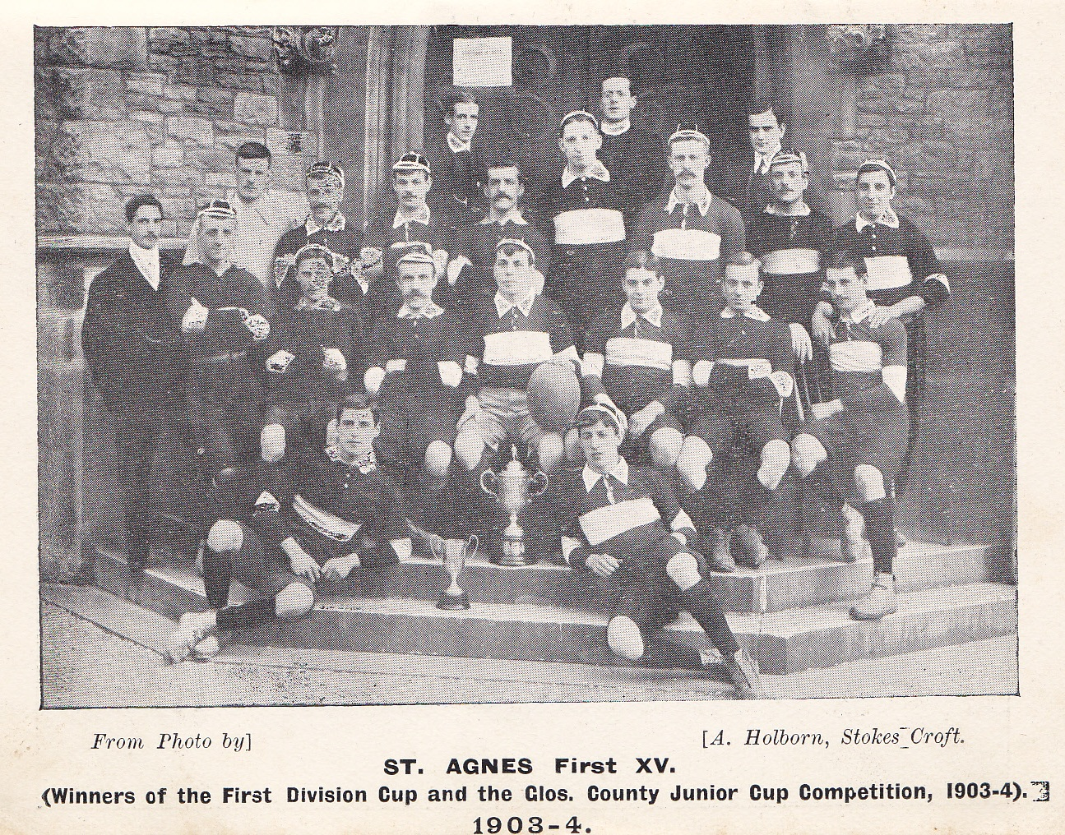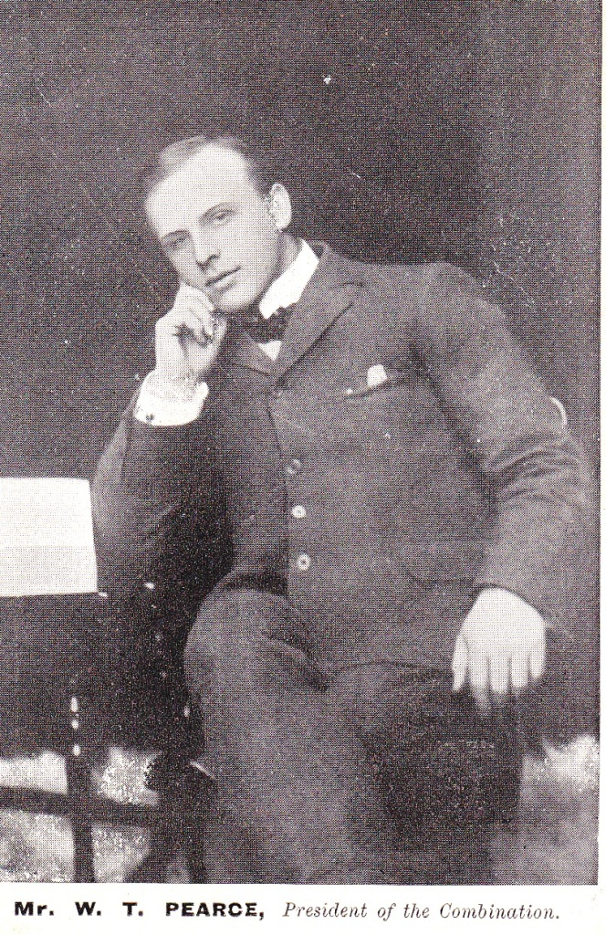

The earliest Combination Handbook (1901/1902) shows a thriving league set up with seven clubs in Division 1 and two further Divisions with the rest and some second XV’s. Not all local clubs played in the Combination Leagues or were members. Fixture list for some of the member clubs show fixtures with Keynsham, Merchant Venturers Training College, Stokes Croft Athletic, YMCA and Redland. Bristol was also not a member but several clubs played the Bristol Club’s second XV. There is a mystery as to where were Avonmouth, St Mary’s and Bishopston, all formed well before 1901, however they do appear in later early Handbooks. The last pre-war handbook (known to the author) was for the 1905/06 Season, and since the Rules of the Combination were printed in a 1913/14 GRFU Handbook it would appear that the Combination decided to join in with the GRFU to produce a single Handbook. At that time three Divisions (Leagues) were operating with the winners of each being awarded a cup. The current Combination Cup was presented by the Bristol Club to the Bristol & District Rugby Football Union in 1891, for the winners of the Division 1 Cup and was first awarded to the Oakfield Club at the end of the 1891/92 season.
Between the Wars
Clubs began to play again in the 1919/20 season and the Cup was revived as knock-out competition not as a series of leagues. In that season, in one semi-final Saracens beat Bishopston and in the other, after a replay Dings beat St Mary’s. In the final with no score at full time, extra – time was played and Dings got the winning try. Cup rugby was deemed to be too hard and the competition was discontinued. It was another 50 years before the Combination Cup was resurrected.
For the 1923 24 season the Combination decided to resuscitate the Handbook and these have been produced continuously (apart for the Second World War interlude) until 2011/12. As well as full fixture lists for member clubs, names and addresses of club officials and referees, the first edition contains not only the rules of the games but useful advice on playing the game from Walter Pearce and R C W Pickles of Bristol F C and an English International. The Chairman of the Combination, Jesse Milburn’s Footballer’s Alphabet, printed below contains the essence of the game and is as relevant today as it was in 1923. It should be recalled that there was virtually no coaches and other than watching top games and newspaper reports, there was no way for a new player could get know how the game was played at the higher levels.
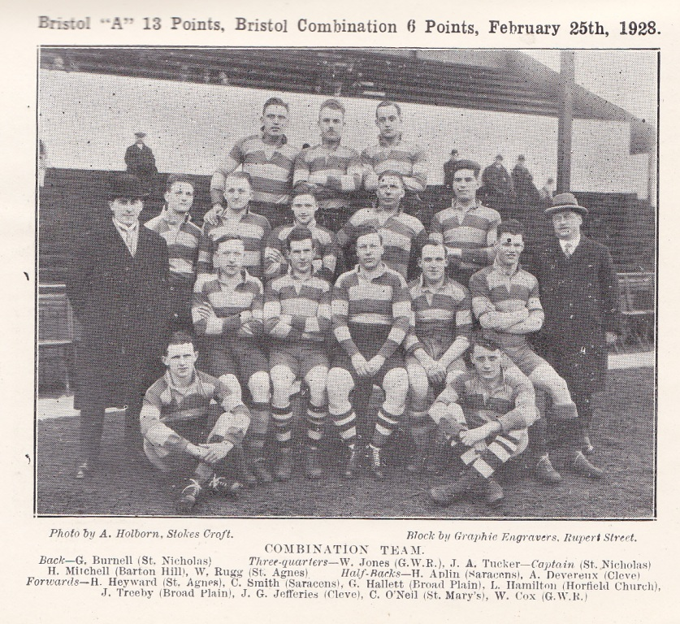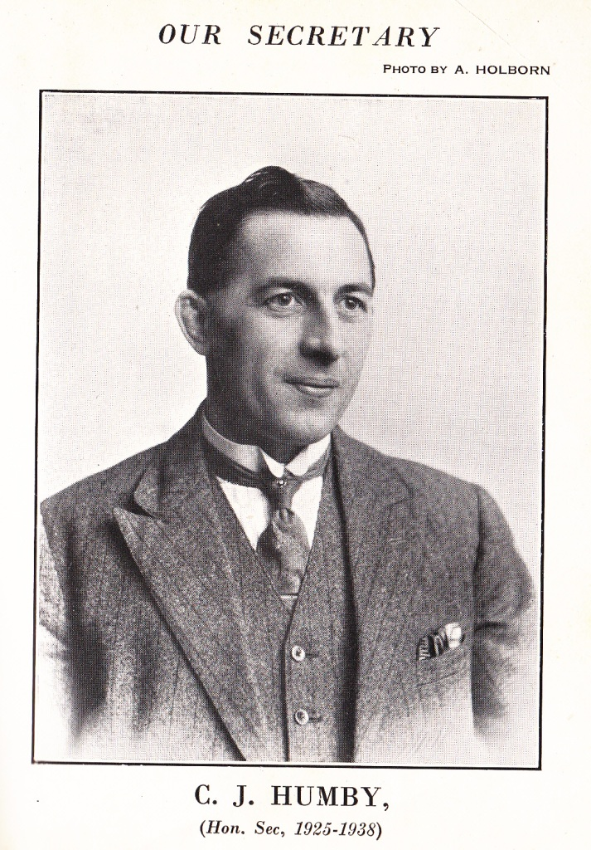
The 1920’s and 1930’s saw the birth of many new clubs and the demise of some long standing ones. Some were Old Boys Clubs, notably Old Bristolians, Old Elizabethans, Old Redcliffians, St Brendan’s OB’s, Old Cathadrelians and Old Cothamians, the latter two disbanded in the 1980’s. Others like Bristol Aeroplane Company, Bristol Harlequins, North Bristol, Whitehall etc. are firmly established and thriving. During the 1930’s the game continued to grow with many clubs being formed only to disappear in quite a short space of time. In addition many clubs, who had previously played near the city centre e.g. on the Downs now moved out to the suburbs.
The generosity of Francis Cowlin and his family helped this exodus. Having given land to the Bristol Club for the Memorial Ground, in memory of the fallen of the Great War and Eastfield Road for Clifton RFC, he gave the Filton “Polo” Ground at the end of the runway for the use of Combination Clubs. A pavilion was built and opened on 7th October 1933, there were 16 new changing rooms, two shower rooms, a tea room etc. - such opulence was almost unheard of amongst member clubs.
A handbook was produced for the 1939 40 Season and this contains the Hon Secretary’s (Charles Humby) report for the 1938 39 Season. “A very active and successful one with membership (including Bristol and Clifton) remaining at 50”. However once hostilities commenced, an emergency committee arranged a few fixture during the first two years of the war but after 1941 rugby was to all extents suspended for the rest of the war.
The 1940’s, 1950’s and 1960’s
Rugby started up again in the 1945 46 Season with some 21 clubs operating with the major problems being getting grounds fit again and obtaining clothing coupons to purchase kit. The Combination Seven-a-side Tournament, started before the war, was held at the Memorial Ground at the close of the 1946 season with BAC winning the trophy. This Tournament was the only Competition organised by the Combination until the Cup was restarted in 1970.

Jubilee Match 21st October 1950 Eastfield Road
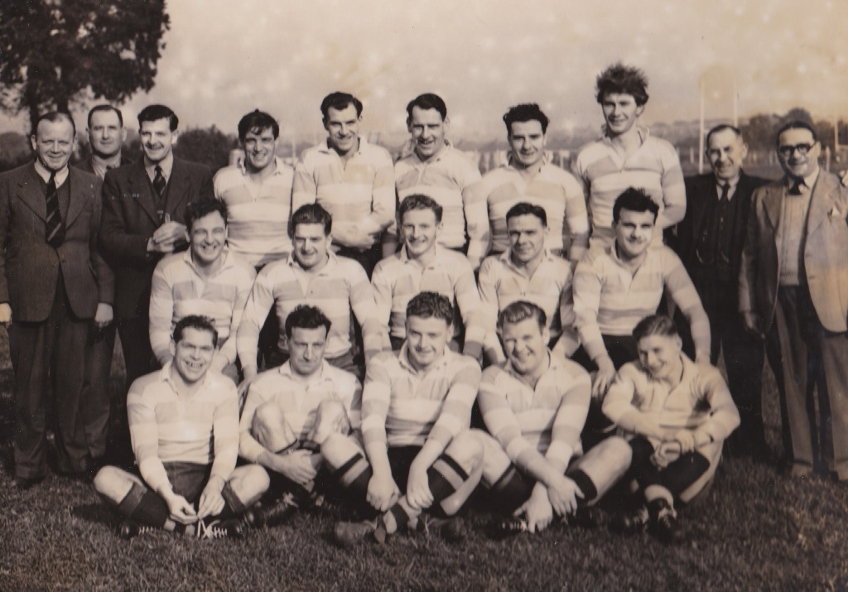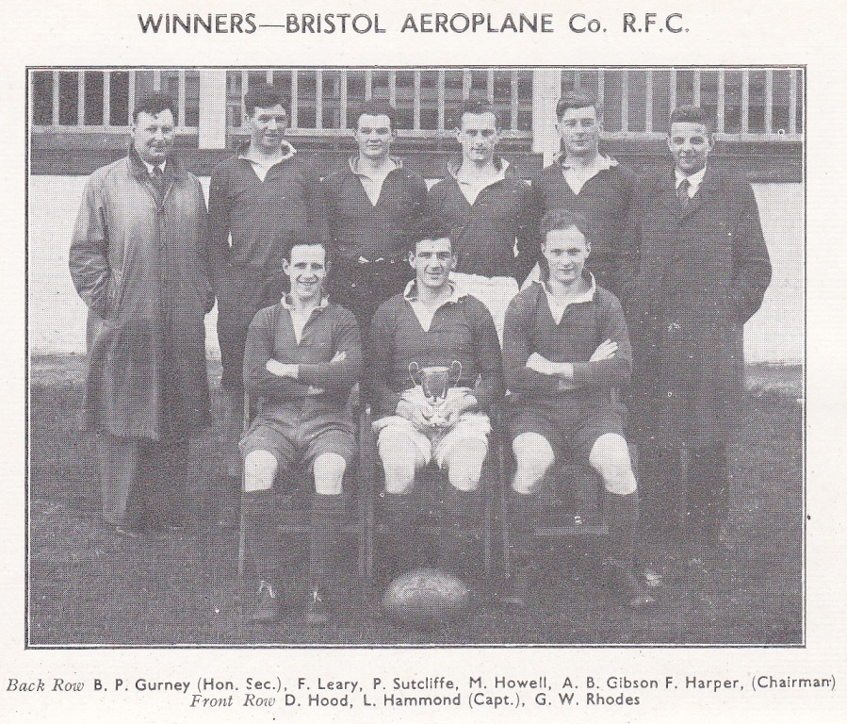
Clifton RFC 6 Combination 8 Seven-a-side Tournament 1946
With the pitches at Lockleaze being over-subscribed the Combination Hon Secretary, Charlie Humby took the extraordinary step in 1948 of putting down a deposit, without consultation of the Committee, for the purchase of land Lockleaze. Some years later with loans from the RFU, a grant from Ministry of Education, and huge support from the Bristol FC, the GRFU and individuals the ground became usable by Broad Plain, Old Cathedralians and later Ashley Down OB’s, as well as a number of other clubs. By 1960 5 pitches were available. In the 1950’s All Star games were played at the Memorial Ground with the profits going to pay off the loans. Players like Jeff Butterfield, J V Smith, Bert MacDonald, Tony O’Reilly all played and contributed to paying off the Combination’s debts.
The Jubilee Season of 1950/51 was most successful with matches against Clifton and Bristol University the former won 8 – 6 and the latter 6 – 3. A Dinner at the Grand Hotel on 4th November 1950 with the President of the RFU, Sir Wavell Wakefield and 180 club representatives in attendance. In February 1951 a Jubilee Dance was held at The Victoria Rooms.
For the 50 years following the First World War the game in England and hence Bristol, was full of competitive rugby but, other than the Seven-a-side Tournament, lacked any formal competitions. Fixtures were regular “friendlies” against well known opposition, played on the same Saturdays year on year. Games were all of a pretty similar level and none of the Clubs, other than Bristol & to some extent Clifton dominated. The way the good player progressed was to be invited to play for Bristol United (Second XV), a huge honour for both the player and the club and the Bristol First XV was full of players who came from local clubs. There were a few issues, notably late call-ups on a Friday of fringe United players, particularly when the Counties were playing, which unsettled local team selection. By and large Bristol was the pinnacle of most local players ambitions and most, when no longer needed by Bristol returned to be better players for their Combination sides. Club loyalty was paramount, clubs being largely “tribal” with sons following fathers, generation after generation.
Competitions return
In the early 1970’s things began to change, initially in a quite small way but, which over the next 30 years altered the whole complexion of the game in the City. At about the same time local Cup Competitions were introduced both at County and Combination level. In addition the local Evening Paper published a Merit Table based upon the results of games between local clubs. There was no formal structure and the Combination Committee frowned on this but the printing of the Tables was a source of great interest to players and most in the Clubs. The award of the Green ‘Un Merit Table Pennant was the highlight of the season and these can still be seen in local clubhouses today.
A Dinner was held in 1976 to celebrate the 75th Anniversary and the photo below shows the five Honorary Secretaries who served from 1925 to 2001.
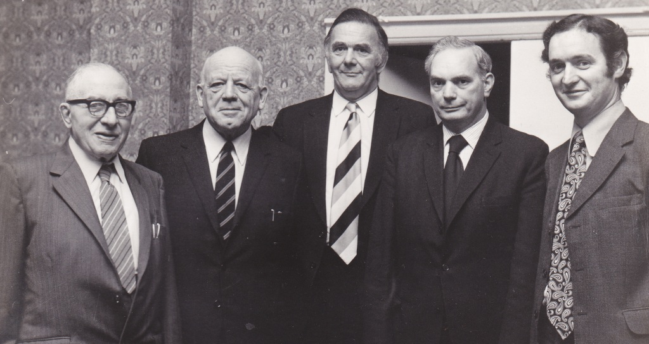
Charlie Humby 1923 1949; Sid Grant 1949 – 1960; Cyril Gardner 1960 – 1965; Cyril Parsons 1965 – 1974; Sandy Mitchell 1974 - 2001
The Combination Cup soon became a hugely important Competition of great interest to local clubs and the Finals, held at the Memorial Ground were always hard fought and showed the strength of local rugby. During the 1980’s, 1990,s and up to the start of Leagues, the Combination Cup along with the Evening Post Merit Tables were the way that the rugby public measured the standard of Clubs. In the 31 seasons, up to the Jubilee, two Clubs, Avonmouth and Dings Crusaders held the trophy 5 times a piece but dominating, having run out winners on nine occasions were St Mary’s OB’s.
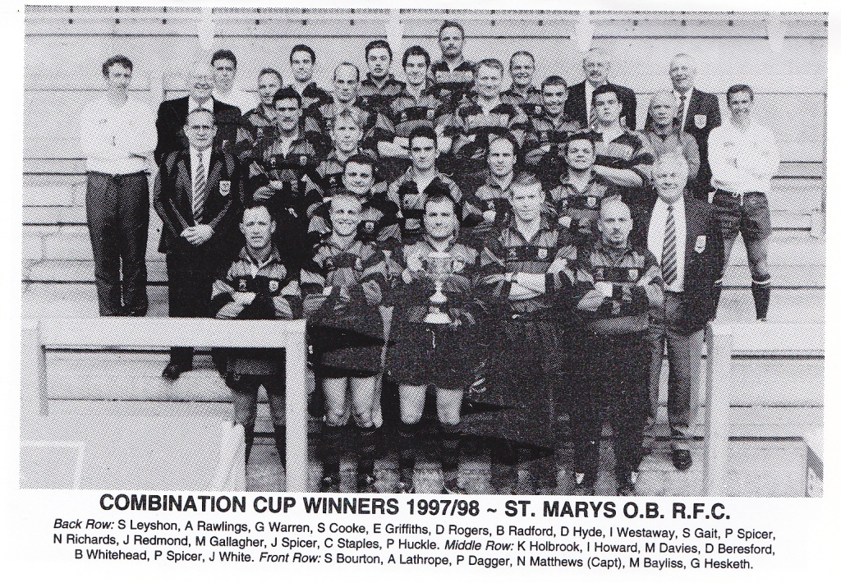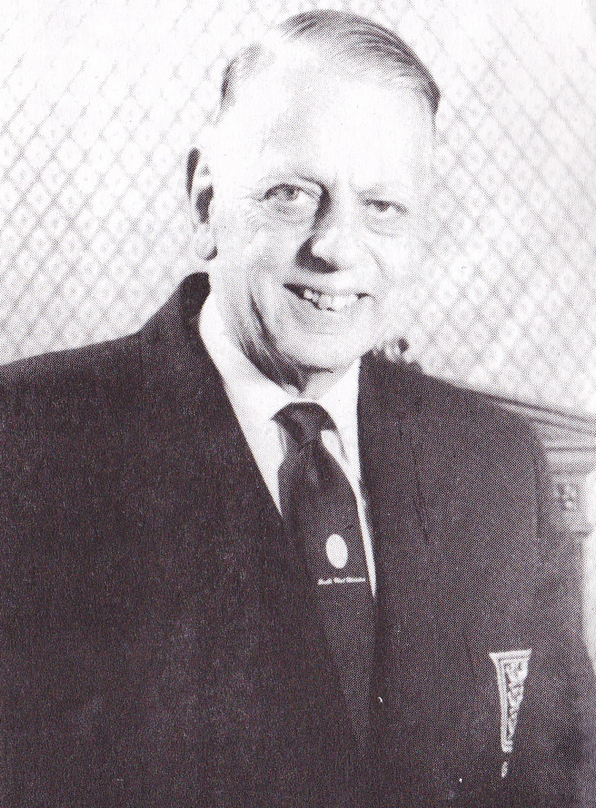
Barry Jones Chairman 1961 - 1991
As professionalism came into the picture, Bristol F C, as the “beneficial” owner of the Combination Ground at Filton exercised their rights, the Trustees were deemed to be surplus to requirements and the land became one of the Club’s assets. When the club went into receivership the land was sold to pay off its debts. This was a particularly difficult time for the Combination, as the ground had been the home to many Combination Clubs for more than 60 years.
The increased competition, the rise of coaching, and Mini & Youth Rugby moving largely from Schools to Clubs also had an effect on the game but it was not till the introduction of Leagues and professionalism in the mid 1990’s that the things began to alter significantly. Initially, the Combination sought to have a league structure based on its member clubs but the Constituent Bodies of Gloucestershire and Somerset would have none of it and the structure at the lower levels was entirely CB based, with the loss of many traditional fixtures. Once the Leagues had settled down, a number of things happened, traditional fixtures were lost, club loyalty declined, the ambitious player moving clubs to gain a better standard of rugby and lower sides became less important as Clubs put all their efforts into maintaining and improving League position. Some clubs were clearly doing more than just recompensing players for legitimate travel expenses and this led to tensions over player movement and poaching. The Combination set up Merit Tables to address the issues with Second, Third & Fourth XV’x and this worked reasonably well for a number of years. However, the 1982/83 Handbook shows 28 member clubs running 4 or more sides and by the Jubilee Season of 2000/01 this number had dropped to 10. By the 2012/13 season this had dropped to 4.
The Second Century
In the first decade of this century, many of the issues raised above have continued to effect clubs, not only in Bristol but across the country. The Combination is dedicated to its role of supporting its member clubs in whatever way possible, by organising events, giving advice etc as it has done over the past 100 years. The Combination Cup has been split into levels of Main, Vase and Bowl, thus giving all Clubs an opportunity to contest on a level playing field and the Finals are still one of the highlights of the local rugby year.
N A (Sandy) Mitchell February 2014
Hon. Sec 1974 – 2001 Chairman 2001 – 2011 Vice- Chairman 2011 –

Sources:
Combination Handbooks: 1901/02, 1902/03, 1903/04, 1904/05, 1905/06 & 1906/07.
GRFU Handbook 1913/14
Combination Handbooks: 1923/24 – 1939/40 & 1946/47 – 2011/12
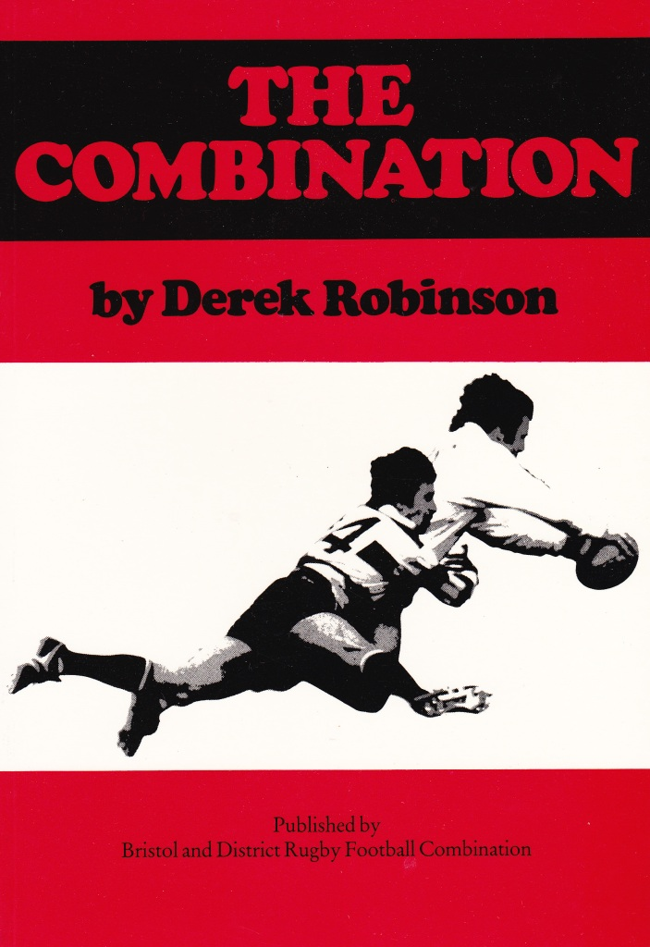
The source for much of the information comes from Derek Robinson’s excellent book “The Combination” published in 1986.
Copies are available from
Sandy Mitchell 0117 962 4149 Price £3 including P & P
Handbooks are available to borrow.
The Footballer’s Alphabet Jesse Milburn Chairman 1923
Always work for your club it is working for you.
Better still try for it – it’s worth it.
Count all your Club mates personal friends – avoid cliques.
Don’t squeal because you are dropped – train harder to regain your place again.
Every member should strive for the club spirit.
Forget selfishness and your play becomes a pleasure to others and your self.
Go down to the ball with your eyes open.
High tackling is a bad failing – give it a miss.
It is very bad form to tackle a man after he has parted with the ball.
Jaw does not win matches – it makes feelings run high.
Knowing the rules should help you.
Learn the rules thoroughly – a little knowledge is a dangerous thing.
Mind your boots are well studded – they keep you from slipping and help you to dodge.
Never “buy” the dummy – it’s not so easily “sold” again.
Offside player can intercept a pass from an opponent.
Play the whistle it pays.
Quick following up hampers your opponent – try it.
Referees who have not made a mistake are not yet born.
Smoking affects the wind unless dropped three days prior to a match and three days after.
The spirit of the game is its unwritten rules.
U only have one football life – make the most of it.
Various players have little idiosyncrasies.
What is yours?
X XX! Wait til the season is over.
Your motto should be “clean sport”.
Zeal for your club means easier work for your officials.

