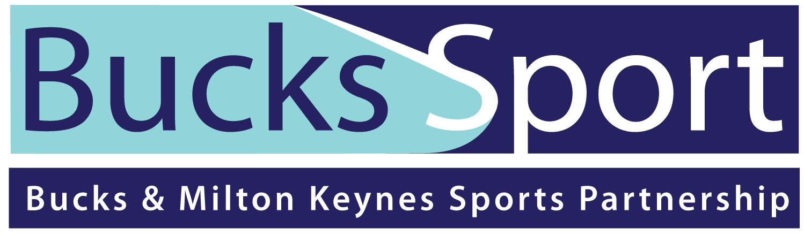



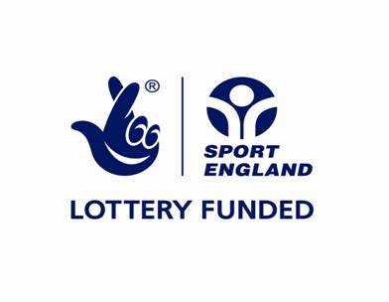

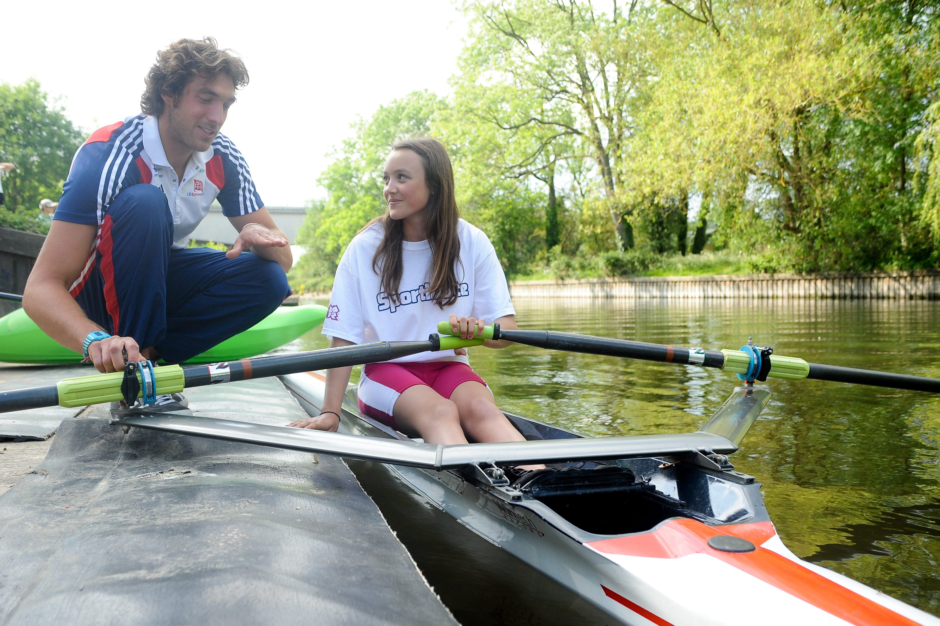

SPORTIVATE YEAR 4

GUIDANCE NOTES

What is Sportivate?

Sportivate is a nationwide campaign that captures the excitement of the London 2012 Games, providing opportunities for teenagers and young adults (aged 11-25) to receive 6 to 8 weeks of coaching in a sport of their choice and guiding them into regular participation within their community.

Sportivate launched in June 2011 as a four-year programme aimed at 14-25 year-olds but, due to its success, additional funding of £10m per year has been invested allowing the programme to run until March 2017.
From September 2013, Sportivate extended its age group so that 11-13 year-olds can also take part.

Sportivate is delivered against a simple national framework but with local flexibility to produce the following outcomes:

- providing a supply of sporting activities that will match as well as generate demand;
- getting more 11-25 year olds regularly participating in sports activities in the community by responding to their needs and working with a range of providers to develop a menu of activities;
- focusing on high quality sports providers all operating within robust Safeguarding Standards;
- creating more opportunities for the growth and deployment of coaches and volunteers;
- increasing take up in leisure centres and other facility stock; and
- generating close links with clubs to drive more participants to take part and volunteer in National Governing Body (NGB) community sports clubs.

Aims

Within Buck & Milton Keynes our mission is to use the Sportivate campaign to ensure that more young people and young adults have the opportunity to find a sports activity that is attractive, affordable and accessible to them, with the ultimate aim of supporting them into life-long participation.

Bucks Sport has a target of retaining 3,645, 11 – 25 year olds in 6-8 weeks of activity over 4 years. To help us achieve this, we have been awarded nearly £400,000 of Lottery Funding over 4 years.

Target Group

Sportivate targets 11-25 year olds who may not seek out sporting opportunities themselves and would not prioritise doing sport in their own time or those who are doing sport for a very limited amount of time. These participants might be described as the 'semi-sporty'.

Focus Target groups

For year 4 delivery we would like to see projects with an emphasis on the following groups;

- 19- 25
- Females
- NEETS (not in education, employment, or training)
- Disabled people

Applicant Eligibility

To apply to the Bucks Sport Sportivate programme, deliverers must be aware of the following and be able to justify that these points have been met. Bucks Sport will assess whether deliverers have met these points through the submitted Sportivate Plan and through follow-up questions where necessary or where the submitted plan is unclear.

- Funding should not be used to replace statutory funding.
- We cannot fund projects intended primarily for private gain.
- The organisation to receive the funding needs to have a bank or building society account that requires two authorised signatories – as payments will be made by BACS.
- Organisations must be in a position to complete safe recruitment practice and if providing activity for under 18s or vulnerable adults, have a current Child Protection Policy.
- Organisations must be equitable and have an Equal Opportunities Policy or Equity Statement.
- Organisations must have Public Liability Insurance cover suitable for the activity they are running.
Sportivate deliverers must be advised that Sport England have the final approval on funding and projects to be delivered as they are the licensed National Lottery funding distributor. No secondary distribution of lottery funding is allowed.

Application Process

Open application

- Applications should be put forward by a lead organisation, but are encouraged to work in conjunction with at least one other partner to evidence need and demand. This strengthens the application demonstrating robust partnership working. For example this could be a National Governing Body linking with a Leisure provider, a Sports club linking with a local HE/FE institute, or a Local Authority linking with a Youth Organisations and local sports club.
Critical Dates

Applications Open | 22nd October 2013
Application Closing Date | 10th December 2013
Initial assessment and feedback | 11th December- 17th December 2012
Bucks Sport Sportivate Panel | 17th December 2013
Feedback and Decision from Panel | w/c13th January 2014
Submission of plan to Sport England | 5th February 2014
Sport England Approval | 3rd – 7th March 2014
Year 4 Q1 delivery starts | 1st April 2014
Year 4 Q2 delivery starts | 1st July 2014
Year 4 Q3 delivery starts | 1st October 2014
Year 4 Q4 delivery starts | 1st January 2015

Key Criteria – What should your application look like?

- Projects must be pre-fixed with the word Sportivate in the title e.g. Sportivate AVDC Basketball. This will help to build the brand of Sportivate and link the participants to the mass participation legacy programme and London 2012, and should be used in all promotion.

- Sessions must be aimed at young people aged 11-25 years.

- Sessions must be aimed at 'semi-sporty' young people who are currently not doing too much sport in their own time.

- There must be an identified need for the project using Whole Sport plans, market segmentation and local knowledge from the deliverer. Applicants must demonstrate demand for the activity or how they will generate demand and recruit participants to ensure the project is a success.

- 6-8 weeks of coaching must be delivered (at least one hour and no more than two of coaching to be delivered).

- The project can run a maximum of two additional sessions on top of the Sportivate block. Within the project period (maximum 10 weeks) you must decide at what point you start to count the official Sportivate course (which would be 6, 7 or 8 weeks) and thus counting participants against the retain target.

For example,
- A 6 week Sportivate block with 2 weeks of taster sessions before (total 8 weeks)
- A 7 week block with 2 exit route integration sessions at the end (total 9 weeks)
- An 8 week block, with 1 taster session followed by the 8 week block with a 10th session being a fun competition/tournament format

Once the official Sportivate course starts, participants must meet the current retain criteria i.e. they can only miss one session.

- The sessions must be weekly as Sportivate will aim to create behavioural change in the participants. Bucks Sport can take the decision to be flexible on this approach on limited occasions where it is needed and justified (e.g. an outdoor pursuit’s project using 4 x 2 hour sessions, or a disability project running fortnightly) but the most suitable approach to create behavioural change should be used.

- Activities must be new, or an extension of current provision to new participants. An extending project must offer additionally in at least one of a combination of the following areas; a new group of people; a new time; or a new format.

- Participants must be new to the activity (e.g. not existing club members) and commit to attending all of the ‘Sportivate’ sessions in a 6-8 week block. These activities could be delivered to new members separately (e.g. Return to Sport, fun sessions etc) or you may wish to invite potential new members to join in existing activities for a 6-8 week trial.

- Participants will only be counted as ‘retained’ if they complete 5 of 6, 6 of 7, or 7 of 8 sessions. Try and sell the sessions as a course, rather than a just turn up when you can option so participants commit to the 6+ weeks of the project.

- Sessions will have a sense of structure and be participant led in that they will be affordable, accessible, appropriate and attractive.

- The person leading the sessions can be either a coach or leader, depending on the content of the sessions and the participants. e.g. For basketball sessions aimed at 14-16 year olds, you may want a Level 2 qualified coach to provide quality coaching. For futsal sessions aimed at anyone you may just have a leader to meet and greet participants and allow them to just play. Please make sure the level of leader is reflected in coaching costs.

- Delivery may take place at anytime of the day, except if the activity is based at a school. This activity must take place outside of school curricular hours and must not be part of a curriculum/academic course. Activity at Colleges and Universities can occur during lunch hours as long as open to all, or delivered by community provider (please see below points).

- Where Sportivate projects are ONLY targeted at students and/or staff within an educational institution, the project must be delivered by a community provider and a community exit route must be supplied. It is ineligible for the institution to run the sessions themselves; another community provider must be brought in.

- Schools, colleges and HEIs can deliver Sportivate projects that are run within their own facilities if these projects are open to the wider community and not just its own students and/or staff. In this instance colleges and HEIs can be considered as a community provider, but projects would need to be based on community demand. The deliverer of the sessions must be community focused.

- There must be a confirmed exit route for the project that has the capacity to take on increased number of participants. This should either be continuation of sustainable session on a regular basis, a club or alternative sports provision.

- Clear details should be provided on where and how participants will be sustained in the Sportivate funded sport (or another relevant sport/opportunity). The exit route and owner of the exit route should be named. This should be an actual person that is responsible for supporting the participants into regular participation. You may have more than one (it could be coach, SportMakers or chair of club, etc.).

- Providers may use an event, competition or personal challenge for participants (either as part of each session or as a final week culmination of the sessions).

- Projects should demonstrate value for money (cost per retained head) and applicants should bear in mind eligible costs (see page 9).

- Activities should create opportunities for the growth and deployment of coaches and volunteers. Use of the Bucks Sport Coaching Bursary and SportMakers programme should be considered, and if to be used stated in the application. For example, are you going to apply to the bursary to have a coach ready to deliver, or will you use the bursary to support the sustainability of the exit route. Do you need SportMakers to help the project – someone to support the deliver with promotion, inputting data, etc?

Eligible project costs – What can you apply for?

Eligible | Ineligible
- Staffing / coaching costs to deliver projects. Exceptionally high staffing costs may affect sustainability of the project. We encourage coaching costs to be no more than £30ph for a level 2 coach/instructor.  - Volunteers expenses to help run projects  - Resources and materials – items to be used in projects  - Hire of facilities used to deliver projects  - Transport – to get participants and staff/coaches to projects  - Marketing / Publicity – posters, websites etc.  - Training / Coach Education Courses – needed to run and/or sustain the project. Please apply to the coaching bursary for funding towards coaching qualification courses. (See page.10 for more info)  - Equipment – equipment may be purchased to support direct Sportivate delivery. Your equipment costs must not be more that 20% of your total project costs, unless you can balance a higher percentage with in-kind or cash income specifically towards equipment.  - Exceptionally – caretakers / CRB checks.  - Extra sessions (to increase the project up to a maximum 2 additional weeks), these may be taster sessions at the beginning of the course or perhaps competition/ graduation session at the end (running additional to the 6, 7 or 8 week Sportivate block)  - Incentives – e.g. towards discounted membership to support exit route, goodies for ‘retained’ participants  - Additional funding to help support the sustainable exit route | - Overheads (storage of equipment, insurance etc)  - Contingency costs – replacing damaged equipment  - Purchase of vehicles (they can be leased/hired)  - Buildings & Refurbishments – capital building works, bike sheds, pavilions  - Items with poor value for money  - Items for projects that take place outside of Bucks  - Retrospective Activities – no funding can go to a project that has already started or equipment that has already been purchased  - Projects that have no clear community / sustainable exit route  - Projects that are insufficiently targeted  - Projects for gifted and talented participants  - Activities for people who are not aged 14-25.

Participant Cost - We would also encourage projects to set a participant cost, even if minimal – say £1 per session or £10 for the block (which could be for 6-10 weeks), to bring value to the project, support sustainability and ensure participants are already ‘buying’ in to the sessions and when paid sessions start there isn’t such as financial jump.

Cost per head. We understand realistically this will vary from sport to sport and target audience, i.e. a Sailing project or disability project will be higher equipment costs. However we would like to see cost per head around the £30ph mark.

Delivery information

You must provide the name and qualification level of the coach/instructor who will be delivering the project within the SLA. Without these details (along with the project delivery details) your funding request will not be released. If they consent to providing their contact details, Bucks Sport can then keep them up to date with any coach development opportunities available to them, as well as ensure your coaches are being supported appropriately through our Coach Bucks programmes.

Recruitment of coach/instructor

- Please make sure you have identified a coach/instructor to deliver the project on application or if not you can evidence how you are going to recruit. Please see below.

- Coach Bucks can assist in the recruitment of coaches/instructors to deliver Sportivate projects.

- If your named coach/instructor pulls out at the last minute, we can produce an urgent request to coaches, to hopefully avoid having to cancel the project.

Bursary scheme

- Coach Bucks is able to provide funding support for coaches through the Bucks Sport Bursary Scheme. The bursary provides financial support to qualifying coaches at Level 1 or level 2, instructors or a required qualification needed to coach/facilitate the Sportivate sport/activity (the latter two qualifications are specifically for delivers of Sportivate only). Funding may be for up-skilling an individual to deliver the project or perhaps as an incentive for a volunteer to support the project and have a course funded.

CPD programme

- Coach Bucks is able to provide access to, and coordinate a programme of continuous professional development (CPD) opportunities. These will include coach education workshops and access to informal learning opportunities and communities.

Coach Management Support

- Coach Bucks is able to provide support for people who manage coaches, both in a professional and voluntary capacity through the delivery of a ‘Supporting Coaches Effectively’ workshop. Please contact Bucks Sport for more details.

Promoting your project

Along with this essential requirement, all projects should comply with the following in terms of promotion;

- Sportivate must be in the title

- Use of the Lottery funded logo (as can be found on our website) on promotional material and webpage if relevant

- Use of the Bucks Sport logo (as can be found on our website) on promotional material and webpage if relevant

To aid promotion we have created the following resources which you can use, and can be found on our website

- Poster template

Incentive Prize Draw

Each quarter 3 names will be randomly drawn from a list of engaged participants. Once confirmed by the deliverer that they were a retained participant, we will communicate with the deliverer to select an appropriate voucher in line with the exit route for that project as stated on the application form. Therefore the voucher may be used towards a club joining fee, membership at the venue/facility or to cover a weekly participant charge.

There will be 3 monetary vouchers of: £30, £40 and £50.

Reporting – Monitoring and Evaluation

Delivery partners will be required to collect and report simple Key Performance Indicator data relating to participation and throughput during the 6-8 week block.

Sportivate will focus on a number of key performance indicators (KPIs) for 2011-15 (the 4 financial years of delivery for the programme).

The following 4 KPIs will be used to measure progress:

- KPI Participants – The number of participants registering and taking part in at least one session of the 6-8 week coaching sessions of sports activity (participants engaged).

- KPI Throughput – Attendance: the cumulative total number of participants taking part at the series of weekly coaching sessions.

- KPI Retain – The number of participants who attend 5 of 6, 6 of 7 or 7 of 8 weekly coaching sessions (participants retained).

- KPI Sustain – The number of participants who indicated that after taking part in Sportivate weekly coaching sessions they continued to participate regularly in activity (in their own time) for at least the next 3 months in either: a) informal settings (such as casual or pay and- play opportunities) or b) via more formal opportunities such as becoming members of facilities/clubs/leagues (participants sustained).

An online portal will be used for the collection of Sportivate KPIs. Deliverers will be required to collect the following information and input it on to the online portal:

- Sportivate project name
- Dates of sessions
- Participant data from the Sportivate registration forms
- Attendance record for all of the sessions and participants

We will also ask deliverers for a case study/success story at the end of the project, to use for publicity purposes, and to promote the Sportivate programme in Bucks.
Funding Release
The funding will only be released after submission of KPI data. Submission of KPI data by the stated deadline in the project Service Level Agreement is mandatory for the release of the funding.
If a project achieves less than 80% of its agreed retain target, funding will be released on a cost per retained head basis, as stated in the SLA.

Delivery Partners who achieve their target or exceed their target will receive a bonus plus additional amount if the portal is completed by the deadline date. This is at the discretion of Bucks Sport.

Project Checklist – Make sure you are on track!

When completing your application, please ensure you use the guidance notes on tab 1 of the project application form, all the information in this guidance and this checklist.

Criteria | Tick
Is your organisation eligible to apply for Sportivate funding? (See page 4)

Have you read the Key Criteria to ensure your project meets the Sportivate requirements? (See page 7-8)

Is your project in Bucks/ MK?

Is your project focusing on young people aged between 11-25 years?

Is your project targeting the ‘semi sporty’ types and have you identified this?

Have you demonstrated a demand or a need for the activity and the age group targeted? You need to detail this on your project application in the ‘Evidence of Demand / Need Description’ section.

Is your project a new activity or extending provision? In the ‘Weekly Coaching Sessions Description’ make sure you detail how your project is new, or attracting a new group of participants to current provision.

Have you identified a coach/instructor that is of the minimum standard to carry out the stated activity?

Have you given as much detail as possible in the ‘Weekly Coaching Sessions Description’ detailing where the sessions are taking place, when (month at least), what/structure, etc.?

Does the project contribute to the retain KPI (participants attending 5 of 6, 6 of 7 or 7 of 8 weekly sessions). Is the retain figure you have detailed in your project spreadsheet realistic and achievable?

Does the project offer value for money in terms of the number of young people you will be retaining versus the funding requested? Is the project linking with other funding sources? Has the project got partnership funding?

Have you ensured all your costs are eligible?

Is the activity sustainable / does it provide exit routes that are likely to sustain regular participation? Have you detailed and named a specific exit route and person to manage this?

Does the project link with any other programmes or initiatives that are being run in the area? Does it fit with your Whole Sport Plans?

Does your organisation or named deliverer have the necessary Safeguarding, Equity and Insurance requirements in place?

Have you read the Guidance Notes of the project application sheet (tab 1) to ensure you have completed your project application form correctly?

