Case Study: Crossbank Methodist Cricket Club: New Changing Room Facility

Crossbank Methodist Cricket Club wanted funding to fit-out a new clubhouse that would replace the old clubhouse that is was over 30 years old and required extensive modification and refurbishment to bring our facilities into the 21st Century and meet the demand for current usage

Why was it needed?
The current state of the old clubhouse was a significant factor in holding back the development of the club. The club had exhausted all their current funds on getting to the current stage where they had made the new clubhouse water tight, with the shell and roof completed (see below). The clubhouse needed to be properly insulated and become more eco efficient so that the club and other groups could use its facilities all year round and not just during the summer.

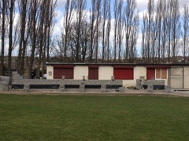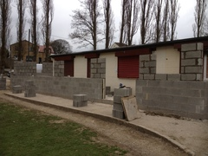

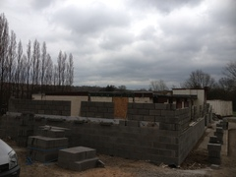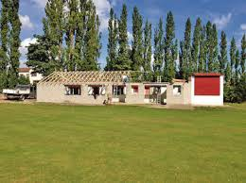

What difference would it make?
The club intended to have an U9 and U13 team through their work with local Schools with the long term aim of having a full Junior section from U9 through to U17’s. As well as this they aimed to form a 3rd XI in order to offer opportunities for further competitive development for their youth teams. Finally they aimed to increase the involvement of girls, both playing and supporting by the development of a women’s team.
.

How did they make it happen?
After attending a club workshop organised by the Yorkshire Cricket Board of which Funding 4 sport delivered a presentation on funding for cricket clubs, the club contacted Funding 4 Sport to write a Sport England’s Inspired Facilities for the above work.

Funding 4 Sport wrote the club an application to Inspired Facilities on a ‘No Win, No Fee’ basis, and was successful in getting the club £50k of funding they required complete their build.

After receiving this funding Club Secretary, Clive Barrett from the club said; “We are delighted to get this funding and thank Funding 4 Sport for writing our application to enable us to complete the work on our clubhouse. Like many sports clubs, the volunteers connected to the club are very busy people through their work and other commitments, but Funding 4 Sport project managed the bid really well, providing templates for us to complete and ensuring we supplied the correct evidence within the timescales required.”

To view stages of the development from start to finish please see the slide show of photos below.

