 Essex Senior Football League

Certificate of Match Postponement

Please forward completed form to Lee Dorling, 39 Milwards, Harlow, Essex, CM19 4SG

It is the duty of the HOME club to have informed the Match Officials, their opponents, the Referees’ Appointments Secretary and the Results Service (07939850627) of the postponement without delay.

Match
vs.
Match date Competition:

Name of appointed Match Referee:

Reason for the postponement and rule covering circumstances: |  |  | Identify areas of the field which are unplayable (where applicable):
 |  |  | 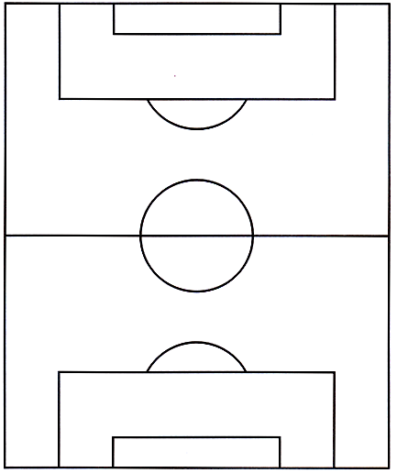
Name of inspecting Referee (where applicable) |  |  | Signature
Date |  |  | Time
Name of Home Club Official |  |  | Signature
Date |  |  | Time

