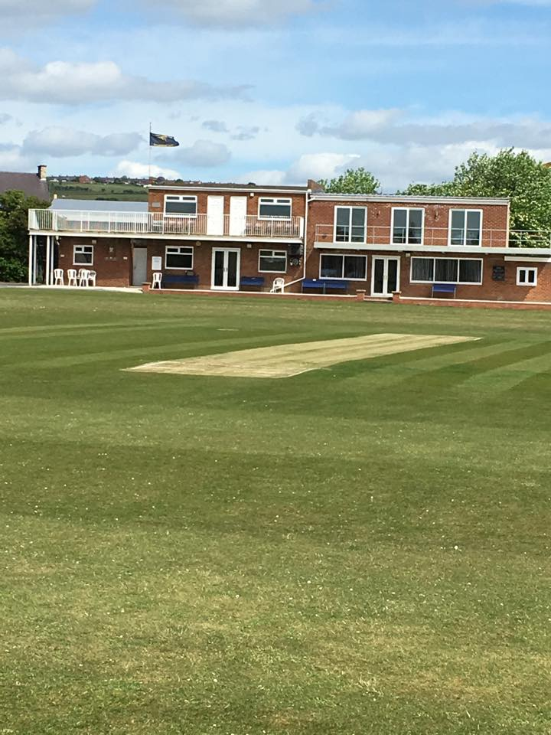

CROOK TOWN CRICKET CLUB – COVID-19 RISK ASSESSMENT

Risk Assessment Template
As a facility provider, you should complete your own COVID-19 Risk Assessment and publish this to your users.

If you are not the facility provider, then you should consider which sections will apply to your clubs individual situation upon returning to play and complete a risk assessment based on your activity, including (but not limited to) people management and communication, hygiene and first aid. You may still wish to record that you have assessed facility risks through enquiries made with your facility provider.

We have provided an example risk assessment below, which is for illustrative purposes only, and includes some examples of things to consider. Consider how this will apply to each aspect of your operation and identify the controls you require to meet Government guidance regarding health, social distancing and hygiene etc. Remember that you must review your other Health and Safety, and Safeguarding, risk assessments for other hazards such as fire, first aid etc.

What are the hazards? |  | Transmission of COVID-19
Who might be harmed? |  | Facility users, staff, volunteers, visitors and the wider community
No | Controls required |  | Action Taken by the Club
People Management and Communication
 | Self-screening of individuals before they arrive at the venue to ensure individuals displaying COVID-19 symptoms or those who should be shielding do not travel or attend. |  | Note and guidance given to each individual player and official giving instruction of not to attend if the have Covid-19 symptoms or have been advised be the Government or Medical Professional to shield.  Email and text message sent to all members highlighting this information.
 | An assessment of user numbers, space capacities, venue circulation and layout planning to maintain social distancing. |  | All players on site will adhere to social distancing measures. Dressing Rooms will be closed with players to prepare for the fixture in their vehicle or on changing area which will be located outside. One dressing room will be open for the sole purpose of preparing to bat.  Bar and lounge will be open to the public with chairs and tables 2m+ apart with a maximum of 4 individuals per table with a maximum of 2 bubbles mixing per tables as detailed in UK government Guidelines
 | A plan for where parents and players will sit whilst watching cricket activities. |  | Setting set out within the club with separate players/spectator areas. All seating set out to ensure Social distancing.
 | Signage and communication so that all participants and visitors are aware of the control measures in place and how to act appropriately to minimise the risk of transmission of COVID-19. |  | Signage attached at entrance to the ground covering control measures in place. Copies also to be given to away team captain and officials when they arrive at the ground.  This document also attached to the entrance of the ground and given to the away to captain.
 | Staff and volunteer training to support the implementation of the plan, with suitable training records. |  | Once training is completed all Staff and volunteers are required to sign this off in the Health and Safety folder to prove they understand all controls implemented.
Buildings
 | Assess ventilation in your building (natural and mechanical) and take appropriate measures to maximise ventilation and minimise risk of transmission. |  | The only building in use is the Clubhouse. This is covered by the Clubhouse Covid-19 Risk Assessment and Government issued Covid-19 Safety Certificate.  (Action Needed)  Ventilation varies across the building.  Where possible within the bar lounge the doors and windows will remain open to ensure maximum ventilation within this area. Capacity of this space to reduce to 20 to ensure social distancing is maintained as per UK government guidelines.  Due the Main Hall having no windows the extractor fans will be served prior to this space opening once signed off as operational the space will have a reduced capacity of 32 to ensure Social distancing is maintained. Where possible doors will be propped open to ensure further ventilation where possible.  When the building is fully operational a way way system will be in place and service to the bar and kitchen will remain outdoors.  Hand Sanitizer will be located at the entrance and throughout the building.
 | Assess the maximum occupancy of your rooms at 2m social distancing (or 1m with risk mitigation where 2m is not possible) and establish a suitable circulation system/one-way system. Use signage and floor markings to communicate this. |  | As mentioned above the capacity of both spaces to ensure 2m social distancing will be 32 for the Main Hall and 20 for the Bar Lounge.  One way system will be in place when the building opens.  Hand Sanitizer will be located at the entrance and throughout the building.
 | Assess the arrangement of seating areas to maintain social distancing and minimise the risk of transmission. |  | Seating to be set at a minimum 2m per table to ensure Social distancing in maintained. Hazard tape will be in place to display where tables must be situated and a maximum of 4 individuals per table in the Lounge and 6 in the Main Hall. Signage will also be displayed advising social distancing and outlining maximum occupancy per table.  Hand Sanitizer will be located at the entrance and throughout the building.
 | Consider your wet weather plans and describe what actions you will take to maintain social distancing in wet weather. |  | In the case of Wet Weather both teams will share the Main Hall to ensure Social distancing is Maintained. Spectators to use the Bar Lounge with a capacity of 20.
Social and Hospitality Areas
 | Plan to solicit and maintain records of your member attendance, customers and visitors - to be maintained for 21 days and then destroyed. |  | All individuals who visit the club are required to fill in the attendance log and document their name and contact number.  Visiting Captain is asked to complete this for the away team.
 | Identification of suitable areas for outdoor service that don’t overlap with cricket activity. |  | Players area be located on the far side of the clubhouse to ensure this does not overlap with bar service.  Bar service will take place outdoors only with one way queuing system to be displayed to ensure 2m social distancing.
 | Steps taken to minimise time and the number of people at the bar. |  | Bar service will take place outdoors only with one way queuing system to be displayed to ensure 2m social distancing.  All individuals are asked to follow this system and move on once serviced. The system is clearing marked with 2m intervals to ensure social distancing. Bar staff are to monitor the queue to ensure all guidelines are being followed.
 | Steps taken to minimise contact points at payment or around the hospitality space. |  | Bar service will take place outdoors only with one way queuing system to be displayed to ensure 2m social distancing. Contactless payment available and screens in place to ensure safety for staff and patrons.
 | Suitable PPE provision and training for staff and volunteers. |  | All staff are to be taken through the updated processes and procedures ensuring the safety for themselves and the patrons.  Once training is completed all Staff and volunteers are required to sign this off in the Health and Safety folder to prove they understand all controls implemented.
 | Strategy for the safe serving, clearing and cleaning of glassware and tableware. |  | All staff to be trained in safe service.  Screens in place and PPE provided when clearing tables and cleaning glassware.  Hand Sanitizer available for all staff to use as required .
 | Deep cleaning strategy to minimise COVID-19 transmission risk |  | Deep cleaning to take place weekly following opening of the club with this being documented.
 | Daily cleaning strategy to minimise COVID-19 transmission risk. |  | Daily cleaning to take place in all contact areas and toilets to minimize the chance of COVID transmission.
 | High-frequency touchpoint cleaning strategy to minimise COVID-19 transmission risk and how you will keep records. |  | Touch Point cleaning to take place every 2 hours across the full site with written record kept.
Hygiene and Cleaning
 | Materials, PPE and training that you have provided to your staff for effective cleaning. |  | Screens placed within service areas, Masks, Gloves, Visors and Hand Sanitizer have all be provided.
 | Provision of hand washing facilities with warm water, soap, disposable towels and bin. |  | Male and Female Toilets to be available with hand washing facilities with warm water, soap, disposable towels and bin.
 | Provision of suitable hand sanitiser in locations around the facility to maintain frequent hand sanitisation. |  | Hand Sanitizing Stations to be located at all entry and across the building, this will be checked every 2 hours when touch point cleaning is taking place. These will also be clearly marked with signage.
 | Provision of suitable wipes and hand sanitiser on the field for hygiene breaks. |  | Wipes have been purchased and these will placed for easy access.
 | What are the hazards? | Other venue hazards to be considered after temporary closure such as Legionnaire’s Disease, fire, electrical safety etc.
 | Who might be harmed? | Facility users, staff, volunteers and visitors
 | Controls required |  | Action Taken by the Club
Preparing Your Buildings
 | Consider the risk of Legionnaire’s disease and carry out necessary work to make your water supply safe for users. Refer to the specific guidance in the document above. |  | All water tap outlets are to be flushed before opening following lockdown
 | Check that routine maintenance has not been missed and certification is up to date (e.g. Gas safety, Electrical Safety and Portable Appliance Testing, Fire Safety, Lifts and Heating – Ventilation and Air Conditioning). |  | All routine maintenance certification checked for compliance
 | Check that your ground is ready and safe to play. Look at what work is required and how this can be done safely at a social distance. |  | Ground and playing areas have been maintained during lockdown and is safe and satisfactory
 | What are the hazards? | Vital first aid equipment is not available when needed. First aiders do not have adequate PPE to carry out first aid when required.
 | Who might be harmed? | First aiders, facility users, staff, volunteers and visitors
 | Controls required |  | Action Taken by the Club
First Aid
 | Check that your first aid kits are stocked and accessible during all activity. |  | First Aid boxed stocked and placed behind the bar.
 | What steps have you taken to improve your first aiders’ understanding of first aid provision under COVID-19? |  | All First Aiders have been given updated guidance from https://www.gov.uk/government/publications/novel-coronavirus-2019-ncov-interim-guidance-for-first-responders/interim-guidance-for-first-responders-and-others-in-close-contact-with-symptomatic-people-with-potential-2019-ncov
 | If you have an AED then check that it is in working order, service is up to date and that it is available during all activity. |  | N/A
 | What are the hazards? | Pitches or outfield are unsafe to play on
 | Who might be harmed? | Players, officials, ground staff
 | Controls required |  | Action Taken by the Club
Preparing your Grounds
 | Safety checks on machinery, sightscreens and covers. |  | Undertaken by Groundstaff in working order
 | Check and repair of any damage to pitches and outfields. |  | Undertaken by Groundstaff and satisfactory.
 | Surfaces checked and watering regime adjusted based on lack of rainfall. |  | Undertaken by Groundstaff all in order
 | What are the hazards? | Use this space to identify hazards at your venue
 | Who might be harmed? | Use this space to identify who might be harmed
 | Controls required |  | Action Taken by the Club
 | Protecting the ball and keeping it COVID-19 safe. |  | Players and officials to be briefed that sweat and saliva must not be used on the ball.
 | Protecting the ball and keeping it COVID-19 safe. |  | Ball cleaned at regular intervals (every 6 overs)
 | Protecting the Umpires from COVID-19. |  | Social distancing to be maintained between umpires and players. No clothing to be given to the umpires during the course of the game.
 | Protecting the Players from COVID-19. |  | Players to sanitise their hands at regular intervals (every 6 overs)

 | What are the hazards? | Use this space to identify hazards at your venue
 | Who might be harmed? | Use this space to identify who might be harmed
 | Controls required |  | Action Taken by the Club
 | Providing meals / teas for all Players and Officials. |  | Meals / teas will not be provided by the Club. Each Player and Official will provide their own food and drink to be consumed. All Players and Officials must enure social distancing is maintained during this period.
 | Providing drinks during game. |  | No drinks will be provided by the club. Players and Officials are to provide their own drinks to be consumed. All Players and Officials must enure social distancing is maintained during this period.

 | What are the hazards? | Use this space to identify hazards at your venue
 | Who might be harmed? | Use this space to identify who might be harmed
 | Controls required |  | Action Taken by the Club
 | Use of the Scorebox if only the Home and Away Team Scorers are scoring. |  | Scorers will operate from the balcony of the clubhouse on 2 socially distant tables. Home scorer will operate electronic scoreboard console from this position.

