COVID-19 Risk Assessment for Felling Cricket Club.

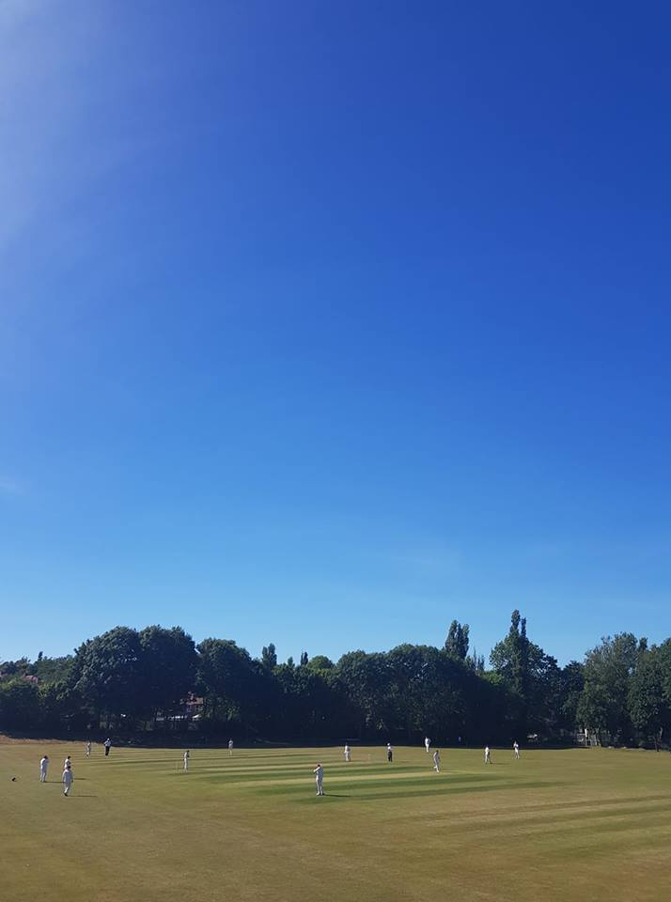

What are the hazards? |  | Transmission of COVID-19
Who might be harmed? |  | Facility users, staff, volunteers, visitors and the wider community
No | Controls required |  | Action Taken by the Club
People Management and Communication
 | Self-screening of individuals before they arrive at the venue to ensure individuals displaying COVID-19 symptoms or those who should be shielding do not travel or attend. |  | Guidance given to each individual player and official giving instruction of not to attend if they have Covid-19 symptoms or have been advised be the Government or Medical Professional to shield.
 | An assessment of user numbers, space capacities, venue circulation and layout planning to maintain social distancing. |  | The club gaining permission on appeal from Gateshead Councils trading standards and licensing to re-open Clubhouse limited to a maximum of 50 people as per our bar risk assessment. Layout amended to comply with 1m+ guidelines.  Both changing rooms allocated to the visting club to conform with 2m guidelines. Home club will be housed in the back room in the clubhouse (tea room) .
 | A plan for where parents and players will sit whilst watching cricket activities. |  | Batting side not to congregate around changing rooms and are asked to sit on the wall which encircles the boundary line.  For junior games clubs will be allotated an area of the bankside away from the clubhouse.
 | Signage and communication so that all participants and visitors are aware of the control measures in place and how to act appropriately to minimise the risk of transmission of COVID-19. |  | Signage attached at entrance to the ground and also clubhouse covering control measures in place. Copies emailed to visiting clubs prior to the game and also handed to visiting captain on arrival.  All clubs asked to provide a track and trace form before they arrive listing contact details of their entire party.
 | Staff and volunteer training to support the implementation of the plan, with suitable training records. |  | Sign off sheets in place for individuals to complete once training is completed.
Buildings
 | Assess ventilation in your building (natural and mechanical) and take appropriate measures to maximise ventilation and minimise risk of transmission. |  | The clubhouse is covered in the bar risk assessment.  Any rooms used by the players will have all doors pinned open to reduce points of contact and maximise ventilation.  All windows open where possible.
 | Assess the maximum occupancy of your rooms at 2m social distancing (or 1m with risk mitigation where 2m is not possible) and establish a suitable circulation system/one-way system. Use signage and floor markings to communicate this. |  | This is covered by the bar Covid-19 Risk Assessment. Both dressings split between visiting side to allow for a 6 / 5 split which conforms with 2m social distancing guidelines.  Back room in clubhouse closed off to everybody other than the home team which again allows us to conform to the 2m social distancing rules.
 | Assess the arrangement of seating areas to maintain social distancing and minimise the risk of transmission. |  | This is covered by the bar Covid-19 Risk Assessment . Capacity greatly reduced, clubhouse open to FCC and visiting club members only. Tables and chairs spaced out to conform to 1m+ guidelines.
 | Consider your wet weather plans and describe what actions you will take to maintain social distancing in wet weather. |  | Individuals may return to their vehicles if rain occurs. Given the additional space in the allocated changing rooms players who don’t have a vehicle may remain in there changing room or may sit in the club bar providing it is not at capacity. Umpires to be alloated space in the bar or alternatively the scoreboard
Social and Hospitality Areas
 | Plan to solicit and maintain records of your member attendance, customers and visitors - to be maintained for 21 days and then destroyed. |  | This is covered by the bars Covid-19 Risk Assessment. Visiting clubs asked to submit a list of their entire party prior to arrival. Only visitors listed on their form will be granted permission to enter the clubhouse.
 | Identification of suitable areas for outdoor service that don’t overlap with cricket activity. |  | Patrons of the bar have been allocated the seated area directly outside the clubhouse. The banksides and outfield remain out of bounds for everyone not participating in the game.
 | Steps taken to minimise time and the number of people at the bar. |  | This is covered by the bar Covid-19 Risk Assessment. No queuing at the bar at any time , capacity greatly reduced to facilitate this.
 | Steps taken to minimise contact points at payment or around the hospitality space. |  | This is covered by the bar Covid-19 Risk Assessment – patrons asked to pay by contactless payment and reduce visits to the bar by drinking in rounds and electing one member of their group to act as a ‘bar runner’ who approaches the bar.
 | Suitable PPE provision and training for staff and volunteers. |  | This is covered by the bar Covid-19 Risk Assessment
 | Strategy for the safe serving, clearing and cleaning of glassware and tableware. |  | This is covered by the bar Covid-19 Risk Assessment  Desposable plastic glasses used during busier periods to minimize cleaning of glassware. Tables and chairs sanitized regularly .
 | Deep cleaning strategy to minimise COVID-19 transmission risk |  | This is covered by the bar Covid-19 Risk Assessment.  Bar closed for a minimum of 72 hours during the week . Full deep clean to take place after the bar has been closed each day.
 | Daily cleaning strategy to minimise COVID-19 transmission risk. |  | This is covered by the bar Covid-19 Risk Assessment  Tables / Chairs / Points of contact and Toilet facilities regularly sanitised throughout the day.
 | High-frequency touchpoint cleaning strategy to minimise COVID-19 transmission risk and how you will keep records. |  | This is covered by the bar Covid-19 Risk Assessment
Hygiene and Cleaning
 | Materials, PPE and training that you have provided to your staff for effective cleaning. |  | This is covered by the bar Covid-19 Risk Assessment
 | Provision of hand washing facilities with warm water, soap, disposable towels and bin. |  | This is covered by the bar Covid-19 Risk Assessment.  All players asked to bring their own hand sanitizer and towel for washing of hands. The club can provide sanitizer for anyone who needs it.
 | Provision of suitable hand sanitiser in locations around the facility to maintain frequent hand sanitisation. |  | Hand Sanitiser available within our facility located on entrance to the bar and at all toilet and changing facilities
 | Provision of suitable wipes and hand sanitiser on the field for hygiene breaks. |  | Hand Sanitiser to be placed on the boundary for use as described below for fielders and umpires.
 | What are the hazards? | Other venue hazards to be considered after temporary closure such as Legionnaire’s Disease, fire, electrical safety etc.
 | Who might be harmed? | Facility users, staff, volunteers and visitors
 | Controls required |  | Action Taken by the Club
Preparing Your Buildings
 | Consider the risk of Legionnaire’s disease and carry out necessary work to make your water supply safe for users. Refer to the specific guidance in the document above. |  | Not Applicable
 | Check that routine maintenance has not been missed and certification is up to date (e.g. Gas safety, Electrical Safety and Portable Appliance Testing, Fire Safety, Lifts and Heating – Ventilation and Air Conditioning). |  | All records have been checked and are up to date.
 | Check that your ground is ready and safe to play. Look at what work is required and how this can be done safely at a social distance. |  | Ground has been maintained throughout the lockdown period is will be ready and safe when we are allowed to play.
 | What are the hazards? | Vital first aid equipment is not available when needed. First aiders do not have adequate PPE to carry out first aid when required.
 | Who might be harmed? | First aiders, facility users, staff, volunteers and visitors
 | Controls required |  | Action Taken by the Club
First Aid
 | Check that your first aid kits are stocked and accessible during all activity. |  | First Aid Kit is available and stocked. First aid box located behind the bar, in the kitchen and in the home dressing room.
 | What steps have you taken to improve your first aiders’ understanding of first aid provision under COVID-19? |  | First Aiders briefed on their roles and how to be COVID-19 safe.
 | If you have an AED then check that it is in working order, service is up to date and that it is available during all activity. |  | Not Applicable.
 | What are the hazards? | Pitches or outfield are unsafe to play on
 | Who might be harmed? | Players, officials, ground staff
 | Controls required |  | Action Taken by the Club
Preparing your Grounds
 | Safety checks on machinery, sightscreens and covers. |  | All machinery, sightscreens and covers have been checked by the Groundsman.
 | Check and repair of any damage to pitches and outfields. |  | All repairs have been checked by the Groundsman.
 | Surfaces checked and watering regime adjusted based on lack of rainfall. |  | Watering regime is in place. Club have purchased a new sprinkler system which operates with a moisture sensor
 | What are the hazards? | Ensuring the Players and Officials are COVID-19 Safe on the field.
 | Who might be harmed? | Fielders & Umpires.
 | Controls required |  | Action Taken by the Club
 | Protecting the ball and keeping it COVID-19 safe. |  | Players and officials to be briefed that saliva must not be used on the ball.
 | Protecting the ball and keeping it COVID-19 safe. |  | Small bottles of Sanitiser to be kept on the boundary and the ball is sprayed at the end of each over.
 | Protecting the Umpires from COVID-19. |  | Umpires to sanitise their hands at the end of each over.
 | Protecting the Umpires from COVID-19. |  | Social distancing to be maintained between umpires and players. No clothing to be given to the umpires during the course of the game.
 | Protecting the Players from COVID-19. |  | Players to sanitise their hands every 6 overs

 | What are the hazards? | Provisions during break time
 | Who might be harmed? | Players and Officials
 | Controls required |  | Action Taken by the Club
 | Providing meals / teas for all Players and Officials. |  | Meals / teas will not be provided by the Club. Each Player and Official will provide their own food and drink to be consumed. All Players and Officials must enure social distancing is maintained during this period.
 | Providing drinks during game. |  | No drinks will be provided by the club. Players and Officials are to provide their own drinks to be consumed. All Players and Officials must enure social distancing is maintained during this period.

 | What are the hazards? | Protecting Home and Away Team Scorers during game.
 | Who might be harmed? | Home and Away Team Scorers
 | Controls required |  | Action Taken by the Club
 | Use of the Scorebox if only the Home Team Scorer is scoring. |  | The scorebox will be used for scoring the game.
 | Use of the Scorebox if only the Home and Away Team Scorers are scoring. |  | The scorebox has been fitted out with a Perspex screen separating the two scorers. The window is not glazed to allow ventilation. Each scorer has their own desk and only the home team scorer should use the console.

