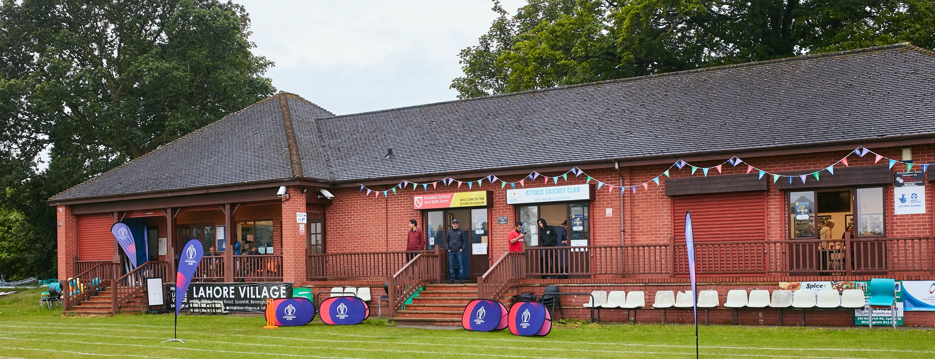

RISK ASSESSMENT TEMPLATE FOR CLUBS PREPARING TO OPEN THEIR CLUBHOUSE

Risk Assessment Template
As a facility provider, you should complete your own COVID-19 Risk Assessment and publish this to your users.

If you are not the facility provider, then you should consider which sections will apply to your clubs individual situation upon returning to play and complete a risk assessment based on your activity, including (but not limited to) people management and communication, hygiene and first aid. You may still wish to record that you have assessed facility risks through enquiries made with your facility provider.

We have provided an example risk assessment below, which is for illustrative purposes only, and includes some examples of things to consider. Consider how this will apply to each aspect of your operation and identify the controls you require to meet Government guidance regarding health, social distancing and hygiene etc. Remember that you must review your other Health and Safety, and Safeguarding, risk assessments for other hazards such as fire, first aid etc.
PHILADELPHIA CC

What are the hazards? |  | Transmission of COVID-19
Who might be harmed? |  | Facility users, staff, volunteers, visitors and the wider community
No | Controls required |  | Action Taken by the Club
People Management and Communication
 | Self-screening of individuals before they arrive at the venue to ensure individuals displaying COVID-19 symptoms or those who should be shielding do not travel or attend. |  | Guidance given to all players and club officials instructing them not to attend the ground if they have symptoms of Covid-19 or have been advised by the Government or Medical Professional to shield. Message displayed on club website with links to government information on symptoms and self-isolation.
 | An assessment of user numbers, space capacities, venue circulation and layout planning to maintain social distancing. |  | All people attending to adhere to social distancing. Dressing rooms open for toilet facilities only and limited to two people at a time. Function room/team closed to players and officials.
 | A plan for where parents and players will sit whilst watching cricket activities. |  | Seating for players and parents set out to ensure social distancing. This must not be altered. Benches spread out around the ground to avoid large groups congregating together.
 | Signage and communication so that all participants and visitors are aware of the control measures in place and how to act appropriately to minimise the risk of transmission of COVID-19. |  | Signage attached at entrance to the ground covering control measures in place. Message also displayed on club website advising of measures in place at the ground.
 | Staff and volunteer training to support the implementation of the plan, with suitable training records. |  | Sign off sheets in place for individuals to complete once training is completed.
Buildings
 | Assess ventilation in your building (natural and mechanical) and take appropriate measures to maximise ventilation and minimise risk of transmission. |  | Only the bar is in use. Double patio doors remain open and windows open as much as possible to allow ventilation.
 | Assess the maximum occupancy of your rooms at 2m social distancing (or 1m with risk mitigation where 2m is not possible) and establish a suitable circulation system/one-way system. Use signage and floor markings to communicate this. |  | Signage displayed on the bar instructing people not to gather there. Bar stools removed to discourage groups from congregating around the bar area. Bar toilets restricted to one person at a time. People encouraged to sit outside. Council check undertaken and measures approved.
 | Assess the arrangement of seating areas to maintain social distancing and minimise the risk of transmission. |  | Outside seating encouraged. Benches spread around the ground to discourage large groups congregating together.
 | Consider your wet weather plans and describe what actions you will take to maintain social distancing in wet weather. |  | Individuals to return to their vehicles if rain occurs.
Social and Hospitality Areas
 | Plan to solicit and maintain records of your member attendance, customers and visitors - to be maintained for 21 days and then destroyed. |  | Council check undertaken and measures approved.
 | Identification of suitable areas for outdoor service that don’t overlap with cricket activity. |  | N/A
 | Steps taken to minimise time and the number of people at the bar. |  | Signage displayed on the bar instructing people not to gather there. Bar stools removed to discourage groups from congregating around the bar area. Contactless payment encouraged.
 | Steps taken to minimise contact points at payment or around the hospitality space. |  | Signage displayed on the bar instructing people not to gather there. Bar stools removed to discourage groups from congregating around the bar area. Contactless payment encouraged.
 | Suitable PPE provision and training for staff and volunteers. |  | Council check undertaken and measures approved.
 | Strategy for the safe serving, clearing and cleaning of glassware and tableware. |  | Council check undertaken and measures approved.
 | Deep cleaning strategy to minimise COVID-19 transmission risk |  | Council check undertaken and measures approved.
 | Daily cleaning strategy to minimise COVID-19 transmission risk. |  | Council check undertaken and measures approved.
 | High-frequency touchpoint cleaning strategy to minimise COVID-19 transmission risk and how you will keep records. |  | Council check undertaken and measures approved.
Hygiene and Cleaning
 | Materials, PPE and training that you have provided to your staff for effective cleaning. |  | Council check undertaken and measures approved.
 | Provision of hand washing facilities with warm water, soap, disposable towels and bin. |  | Council check undertaken and measures approved.
 | Provision of suitable hand sanitiser in locations around the facility to maintain frequent hand sanitisation. |  | Hand sanitiser available at the entrance to the facility with signage encourage its use. Players and club officials encouraged to bring their own hand sanitiser.
 | Provision of suitable wipes and hand sanitiser on the field for hygiene breaks. |  | Players encouraged to bring their own hand sanitiser for use during hygiene breaks. Hand sanitiser to be placed behind the stumps for use by fielders and umpires.
 | What are the hazards? | Other venue hazards to be considered after temporary closure such as Legionnaire’s Disease, fire, electrical safety etc.
 | Who might be harmed? | Facility users, staff, volunteers and visitors
 | Controls required |  | Action Taken by the Club
Preparing Your Buildings
 | Consider the risk of Legionnaire’s disease and carry out necessary work to make your water supply safe for users. Refer to the specific guidance in the document above. |  | N/A
 | Check that routine maintenance has not been missed and certification is up to date (e.g. Gas safety, Electrical Safety and Portable Appliance Testing, Fire Safety, Lifts and Heating – Ventilation and Air Conditioning). |  | All records have been checked and are up to date.
 | Check that your ground is ready and safe to play. Look at what work is required and how this can be done safely at a social distance. |  | Ground has been maintained throughout the lockdown period is will be ready and safe when play commences.
 | What are the hazards? | Vital first aid equipment is not available when needed. First aiders do not have adequate PPE to carry out first aid when required.
 | Who might be harmed? | First aiders, facility users, staff, volunteers and visitors
 | Controls required |  | Action Taken by the Club
First Aid
 | Check that your first aid kits are stocked and accessible during all activity. |  | First Aid Kit is available and stocked.
 | What steps have you taken to improve your first aiders’ understanding of first aid provision under COVID-19? |  | First Aiders briefed on their roles and how to be COVID-19 safe.
 | If you have an AED then check that it is in working order, service is up to date and that it is available during all activity. |  | N/A
 | What are the hazards? | Pitches or outfield are unsafe to play on
 | Who might be harmed? | Players, officials, ground staff
 | Controls required |  | Action Taken by the Club
Preparing your Grounds
 | Safety checks on machinery, sightscreens and covers. |  | All machinery, sightscreens and covers have been checked by the Groundsman.
 | Check and repair of any damage to pitches and outfields. |  | All repairs have been checked by the Groundsman.
 | Surfaces checked and watering regime adjusted based on lack of rainfall. |  | Watering regime is in place.
 | What are the hazards? | Use this space to identify hazards at your venue
 | Who might be harmed? | Use this space to identify who might be harmed
 | Controls required |  | Action Taken by the Club
 | Protecting the ball and keeping it COVID-19 safe. |  | Players and officials to be briefed that saliva must not be used on the ball.
 | Protecting the ball and keeping it COVID-19 safe. |  | Bottles of sanitiser to be kept behind the stumps and anti-bacterial wipes and/or spray provided to clean the ball during hygiene breaks.
 | Protecting the Umpires from COVID-19. |  | Social distancing to be maintained between umpires and players. No clothing to be given to the umpires during the game.
 | Protecting the Players from COVID-19. |  | Players to sanitise their hands before and after each innings. Hand santisier available behind the stumps for each hygiene break.

 | What are the hazards? | Use this space to identify hazards at your venue
 | Who might be harmed? | Use this space to identify who might be harmed
 | Controls required |  | Action Taken by the Club
 | Providing meals / teas for all Players and Officials. |  | Meals / teas will not be provided by the Club. Each Player and Official will provide their own food and drink to be consumed. All Players and Officials must ensure social distancing is maintained during this period.
 | Providing drinks during game. |  | No drinks will be provided by the club. Players and Officials are to provide their own drinks to be consumed. All Players and Officials must ensure social distancing is maintained during this period.

 | What are the hazards? | Use this space to identify hazards at your venue
 | Who might be harmed? | Use this space to identify who might be harmed
 | Controls required |  | Action Taken by the Club
 | Use of the scorebox. |  | The scorebox will not be used. Scorers to sit outside with social distancing. Score box can be operated remotely. If required, scorers could be positioned inside the function room (which will be closed to others) as this would allow social distancing. Doors and windows to be open to maintain ventilation.

