**COVID-19 Risk Assessment for Sacriston Colliery Cricket Club.**



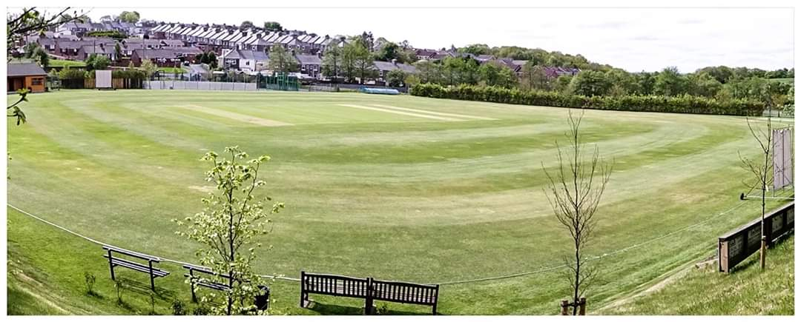

|  |  |  |  |
| --- | --- | --- | --- |
| What are the hazards? | | Transmission of COVID-19 | |
| Who might be harmed? | | Facility users, staff, volunteers, visitors and the wider community | |
| No | Controls required | | Action Taken by the Club |
| **People Management and Communication** | | | |
|  | Self-screening of individuals before they arrive at the venue to ensure individuals displaying COVID-19 symptoms or those who should be shielding do not travel or attend. | | Guidance given to players, officials, parents and spectators not to attend if they are displaying symptoms of Covid-19 or are shielding. Advice given on website, twitter, email and facebook pages. |
|  | An assessment of user numbers, space capacities, venue circulation and layout planning to maintain social distancing. | | All people attending to adhere to social distancing. Dressing rooms for use by individual players only to fit attire for batting or wicket keeping.  Visitors requested to circulate in an anti-clockwise direction. |
|  | A plan for where parents and players will sit whilst watching cricket activities. | | Players and officials area expanded to incorporate socially-distanced seating. Seating not to be altered. Other seating around the perimeter of the ground moved to comply with social distancing. |
|  | Signage and communication so that all participants and visitors are aware of the control measures in place and how to act appropriately to minimise the risk of transmission of COVID-19. | | Signage attached at entrance to the ground covering control measures in place. Copies also to be emailed to away team contact and officials ahead of arrival at the ground. |
|  | Staff and volunteer training to support the implementation of the plan, with suitable training records. | | Sign off sheets in place for individuals to complete once training is completed. |
|  | | | |
| Buildings | | | |
|  | Assess ventilation in your building (natural and mechanical) and take appropriate measures to maximise ventilation and minimise risk of transmission. | | The Clubhouse is covered by the Clubhouse Covid-19 Risk Assessment and Government issued Covid-19 Safety Certificate. Only club members can enter the Clubhouse (subject to maximum occupancy levels being maintained) and they must be signed-in as part of the test, track and trace requirements.  In respect of the pavilion, access will be provided for use of changing area for players to fit batting and wicket-keeping protective attire only. Access will be on a one-out-one-in basis. Toilet facilities for players and officials only will also be provided on a one-out-one-in basis |
|  | Assess the maximum occupancy of your rooms at 2m social distancing (or 1m with risk mitigation where 2m is not possible) and establish a suitable circulation system/one-way system. Use signage and floor markings to communicate this. | | Clubhouse is covered by the Clubhouse Covid-19 Risk Assessment and Government issued Covid-19 Safety Certificate.  The changing facility (for the application of protective attire and use of toilets only) has capacity for 8 people in each changing room BUT only **one** person will be permitted in each room at a time. |
|  | Assess the arrangement of seating areas to maintain social distancing and minimise the risk of transmission. | | Clubhouse is covered by the Clubhouse Covid-19 Risk Assessment and Government issued Covid-19 Safety Certificate.  Seating in front of pavilion is set out to maintain 2m social-distancing. Sigange is in place to remind players and officials not to move seating |
|  | Consider your wet weather plans and describe what actions you will take to maintain social distancing in wet weather. | | Home scorer to remain in scorebox. Away scorer to remain in gazebo.  Players to return to cars with exception of umpires and captains who can remain in open-air covered section of pavilion so as to assist with making decisions regarding restarts. |
|  | | | |
| **Social and Hospitality Areas** | | | |
|  | Plan to solicit and maintain records of your member attendance, customers and visitors - to be maintained for 21 days and then destroyed. | | This is covered by the Clubhouse Covid-19 Risk Assessment and Government issued Covid-19 Safety Certificate. |
|  | Identification of suitable areas for outdoor service that don’t overlap with cricket activity. | | Patio area to the rear of the club will be used for outdoor service, subject to being able to maintain social distancing. |
|  | Steps taken to minimise time and the number of people at the bar. | | This is covered by the Clubhouse Covid-19 Risk Assessment and Government issued Covid-19 Safety Certificate. Queueing system in place with 2m distancing. |
|  | Steps taken to minimise contact points at payment or around the hospitality space. | | This is covered by the Clubhouse Covid-19 Risk Assessment and Government issued Covid-19 Safety Certificate. Perspex screens have been installed and card reader available. |
|  | Suitable PPE provision and training for staff and volunteers. | | This is covered by the Clubhouse Covid-19 Risk Assessment and Government issued Covid-19 Safety Certificate. Perspex screens installed. Masks and gloves available for staff and volunteers. |
|  | Strategy for the safe serving, clearing and cleaning of glassware and tableware. | | This is covered by the Clubhouse Covid-19 Risk Assessment and Government issued Covid-19 Safety Certificate. Disposabe plastic to be used instead of glassware. |
|  | Deep cleaning strategy to minimise COVID-19 transmission risk | | This is covered by the Clubhouse Covid-19 Risk Assessment and Government issued Covid-19 Safety Certificate. |
|  | Daily cleaning strategy to minimise COVID-19 transmission risk. | | This is covered by the Clubhouse Covid-19 Risk Assessment and Government issued Covid-19 Safety Certificate. |
|  | High-frequency touchpoint cleaning strategy to minimise COVID-19 transmission risk and how you will keep records. | | This is covered by the Clubhouse Covid-19 Risk Assessment and Government issued Covid-19 Safety Certificate. |
|  | | | |
| **Hygiene and Cleaning** | | | |
|  | Materials, PPE and training that you have provided to your staff for effective cleaning. | | This is covered by the Clubhouse Covid-19 Risk Assessment and Government issued Covid-19 Safety Certificate. |
|  | Provision of hand washing facilities with warm water, soap, disposable towels and bin. | | This is covered by the Clubhouse Covid-19 Risk Assessment and Government issued Covid-19 Safety Certificate. |
|  | Provision of suitable hand sanitiser in locations around the facility to maintain frequent hand sanitisation. | | Hand Sanitiser available at various locations around the ground, within the players and officials areas and within clubhouse. |
|  | Provision of suitable wipes and hand sanitiser on the field for hygiene breaks. | | Players and officials requested to provide own hand sanitizer for personal use. Additional hand sanitiser and wipes to be placed behind the stumps for use during hygiene breaks. |
|  | | | |
|  | What are the hazards? | Other venue hazards to be considered after temporary closure such as Legionnaire’s Disease, fire, electrical safety etc. | |
|  | Who might be harmed? | Facility users, staff, volunteers and visitors | |
|  | Controls required | | Action Taken by the Club |
| **Preparing Your Buildings** | | | |
|  | Consider the risk of Legionnaire’s disease and carry out necessary work to make your water supply safe for users. Refer to the specific guidance in the document above. | | Not Applicable as showers not in use |
|  | Check that routine maintenance has not been missed and certification is up to date (e.g. Gas safety, Electrical Safety and Portable Appliance Testing, Fire Safety, Lifts and Heating – Ventilation and Air Conditioning). | | All records have been checked and are up to date. |
|  | Check that your ground is ready and safe to play. Look at what work is required and how this can be done safely at a social distance. | | Ground has been maintained throughout the lockdown period.  A check of outfield identified some holes that have subsequently been filled. |
|  | | | |
|  | What are the hazards? | Vital first aid equipment is not available when needed. First aiders do not have adequate PPE to carry out first aid when required. | |
|  | Who might be harmed? | First aiders, facility users, staff, volunteers and visitors | |
|  | Controls required | | Action Taken by the Club |
| **First Aid** | | | |
|  | Check that your first aid kits are stocked and accessible during all activity. | | First Aid Kit is available and stocked. |
|  | What steps have you taken to improve your first aiders’ understanding of first aid provision under COVID-19? | | First Aiders briefed on their roles and how to be COVID-19 safe. |
|  | If you have an AED then check that it is in working order, service is up to date and that it is available during all activity. | | Not Applicable. |
|  | | | |
|  | What are the hazards? | Pitches or outfield are unsafe to play on | |
|  | Who might be harmed? | Players, officials, ground staff | |
|  | Controls required | | Action Taken by the Club |
| **Preparing your Grounds** | | | |
|  | Safety checks on machinery, sightscreens and covers. | | All machinery, sightscreens and covers have been checked by the Groundsman. |
|  | Check and repair of any damage to pitches and outfields. | | All repairs have been checked by the Groundsman. |
|  | Surfaces checked and watering regime adjusted based on lack of rainfall. | | Watering regime is in place. |
|  | | | |
|  | What are the hazards? | Ensuring the Players and Officials are COVID-19 Safe on the field. | |
|  | Who might be harmed? | Fielders & Umpires. | |
|  | Controls required | | Action Taken by the Club |
|  | Protecting the ball and keeping it COVID-19 safe. | | Players and officials to be briefed that saliva and sweat must not be used on the ball. Anti-bacterial wipes to be stored behind stumps to allow for cleaning of ball every 6 overs or 20 minutes. |
|  | Protecting the Umpires from COVID-19. | | Umpires to sanitise their hands during hygiene breaks. Gloves and masks available for umpires should they wish to use.  Social distancing to be maintained between umpires and players. No clothing to be given to umpires during the game.  Radios to be cleaned with antibacterial wipe prior to use.  Umpires are to avoid contact with ball wherever possible, ball to be rolled to base of stumps at the fall of a wicket or hygiene break.  Umpires are only people permitted to re-apply stumps and bails.  Stumps will be in-situ and wiped ahead of game starting. |
|  | Protecting the Players from COVID-19. | | Players to sanitise their hands every 6 overs, 20 minutes or at the fall of a wicket.  Players to pass ball back to bowler using fewest number of touches (ideally wicket-keeper back to bowler)  Players advised to maintain social distancing at all times including during hygiene breaks and when celebrating a wicket. |
|  | Protecting the Scorers from Covid-19 | | Home scorer to be based in scorebox so as to be able to operate electronic scoreboard console. Console to be cleaned with anti-bacterial wipe before and after use. Scorebox window and door to remain open to aid ventilation.  Away scorer to be based in covered gazebo outside of scorebox window to facilitate communication between scorers.  Both scorebox and gazebo will be within a clearly marked “players and officials only” area. |

|  |  |  |  |
| --- | --- | --- | --- |
|  | What are the hazards? | Provisions during break time | |
|  | Who might be harmed? | Players and Officials | |
|  | Controls required | | Action Taken by the Club |
|  | Providing meals / teas for all Players and Officials. | | Meals / teas will not be provided by the Club. Each Player and Official will provide their own food and drink to be consumed. All Players and Officials must enure social distancing is maintained during this period. |
|  | Providing drinks during game. | | No drinks will be provided by the club. Players and Officials are to provide their own drinks to be consumed. All Players and Officials must ensure social distancing is maintained during this period. |