COVID-19 Risk Assessment for Tynemouth Cricket Club.

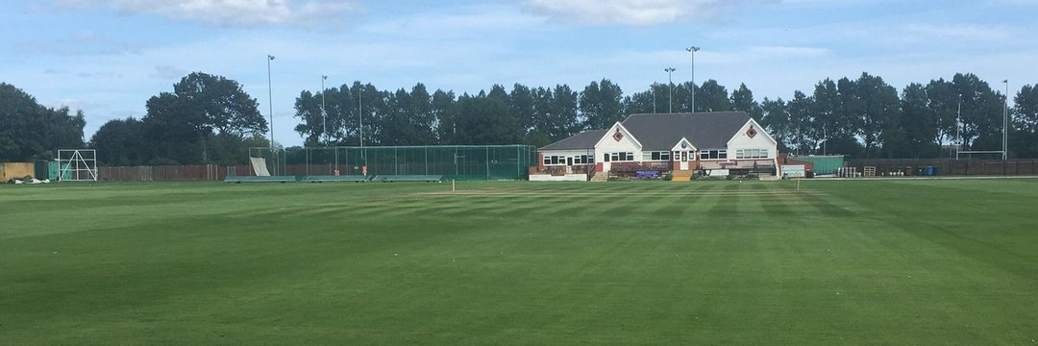

What are the hazards? |  | Transmission of COVID-19
Who might be harmed? |  | Facility users, staff, volunteers, visitors and the wider community
No | Controls required |  | Action Taken by the Club
People Management and Communication
 | Self-screening of individuals before they arrive at the venue to ensure individuals displaying COVID-19 symptoms or those who should be shielding do not travel or attend. |  | Note and guidance given to each individual player and official giving instruction of not to attend if the have Covid-19 symptoms or have been advised be the Government or Medical Professional to shield.
 | An assessment of user numbers, space capacities, venue circulation and layout planning to maintain social distancing. |  | All people attending to adhere to social distancing. Dressing rooms for use by individual players only to fit attire for batting or wicket keeping. Marquee available with social distancing measures in place for extra changing/privacy.
 | A plan for where parents and players will sit whilst watching cricket activities. |  | Seating for players and parents set out to ensure social distancing. Clear markings on field set out highlighting where people are allowed to sit at a safe distance away from other “bubbles”. This must not be altered.
 | Signage and communication so that all participants and visitors are aware of the control measures in place and how to act appropriately to minimise the risk of transmission of COVID-19. |  | Signage attached at all entrance/exit points at pavilion covering control measures in place. Before the toss has taken place the Club’s Covid-19 Match Manager will introduce himself / herself to the umpires and captains  and will explain any procedures that will apply before, during and after  the match.
 | Staff and volunteer training to support the implementation of the plan, with suitable training records. |  | All officials of the club and voluneteers have been brieifed as to control measures in place and records kept of those briefings.
Buildings
 | Assess ventilation in your building (natural and mechanical) and take appropriate measures to maximise ventilation and minimise risk of transmission. |  | When the clubhsouse is in usebothe the entrance and exite doors to the main part of the pavilion (exc changing rooms) will be open to increase ventilation. There are 6 windows at the front of the main room which will alos be kept open.
 | Assess the maximum occupancy of your rooms at 2m social distancing (or 1m with risk mitigation where 2m is not possible) and establish a suitable circulation system/one-way system. Use signage and floor markings to communicate this. |  | There is clear signage directing pople to the one-way system in place. Clear signage, measures and supervison to ensure 2m social distancing is in place.
 | Assess the arrangement of seating areas to maintain social distancing and minimise the risk of transmission. |  | A clearly marked seating area has been identified with supervison provided to ensure social distancing measures.
 | Consider your wet weather plans and describe what actions you will take to maintain social distancing in wet weather. |  | There are marquees available that has clear social distancing measures in place that can provide some cover for rain. Walls of the marquee are vacant to prodivde the necessary ventilation to ensire safety. See above designated seating area in pavilion for a small number of speactators, max occupancy clearly marked and will be supervised. Individuals may also return to their vehicles.
Social and Hospitality Areas
 | Plan to solicit and maintain records of your member attendance, customers and visitors - to be maintained for 21 days and then destroyed. |  | A sign in book is visible upon entering the pavilion. Satff have been briefed to ensure all members and vistors sign that book and provide contact details.
 | Identification of suitable areas for outdoor service that don’t overlap with cricket activity. |  | Clear white markings have been painted onto the field away from the cricket area that provide sfae areas for outsoddr service. There is also a decking area that has clear signage and SD measures in place.
 | Steps taken to minimise time and the number of people at the bar. |  | A clearly marked one way system has been implemented, floor markings are avuialble to direct customers on where to wait safely until it is their turn to approach the bar.
 | Steps taken to minimise contact points at payment or around the hospitality space. |  | One contact point is vailable for payment and there is clear signage that contactless payments are preffered.
 | Suitable PPE provision and training for staff and volunteers. |  | Masks have been provided for staff.
 | Strategy for the safe serving, clearing and cleaning of glassware and tableware. |  | Bar staff have been briefed regarding changes and how they must act.  Wherever possible only one person will serve at any one time. Also only one person will collect and clean glasses and clean tables.
 | Deep cleaning strategy to minimise COVID-19 transmission risk |  | A full deep clean was done before reopening
 | Daily cleaning strategy to minimise COVID-19 transmission risk. |  | All table tops , bar tops, door handles, tills are sanitised before use.
 | High-frequency touchpoint cleaning strategy to minimise COVID-19 transmission risk and how you will keep records. |  | Regular cleaning is done by staff and recorded by them
Hygiene and Cleaning
 | Materials, PPE and training that you have provided to your staff for effective cleaning. |  | Suitable cleaning products have been provided and will be used regularly
 | Provision of hand washing facilities with warm water, soap, disposable towels and bin. |  | Hand washing is possible behind the bar and in several other rooms including kitchen and toilets.
 | Provision of suitable hand sanitiser in locations around the facility to maintain frequent hand sanitisation. |  | Hand Sanitiser available within our facility.
 | Provision of suitable wipes and hand sanitiser on the field for hygiene breaks. |  | Hand Sanitiser to be placed behind the stumps for use as described below for fielders and umpires.
 | What are the hazards? | Other venue hazards to be considered after temporary closure such as Legionnaire’s Disease, fire, electrical safety etc.
 | Who might be harmed? | Facility users, staff, volunteers and visitors
 | Controls required |  | Action Taken by the Club
Preparing Your Buildings
 | Consider the risk of Legionnaire’s disease and carry out necessary work to make your water supply safe for users. Refer to the specific guidance in the document above. |  | Not Applicable
 | Check that routine maintenance has not been missed and certification is up to date (e.g. Gas safety, Electrical Safety and Portable Appliance Testing, Fire Safety, Lifts and Heating – Ventilation and Air Conditioning). |  | All records have been checked and are up to date.
 | Check that your ground is ready and safe to play. Look at what work is required and how this can be done safely at a social distance. |  | Ground has been maintained throughout the lockdown period is will be ready and safe when we are allowed to play.
 | What are the hazards? | Vital first aid equipment is not available when needed. First aiders do not have adequate PPE to carry out first aid when required.
 | Who might be harmed? | First aiders, facility users, staff, volunteers and visitors
 | Controls required |  | Action Taken by the Club
First Aid
 | Check that your first aid kits are stocked and accessible during all activity. |  | First Aid Kit is available and stocked.
 | What steps have you taken to improve your first aiders’ understanding of first aid provision under COVID-19? |  | First Aiders briefed on their roles and how to be COVID-19 safe.
 | If you have an AED then check that it is in working order, service is up to date and that it is available during all activity. |  | Regualrly checked and staff and officlas have the code to access this.
 | What are the hazards? | Pitches or outfield are unsafe to play on
 | Who might be harmed? | Players, officials, ground staff
 | Controls required |  | Action Taken by the Club
Preparing your Grounds
 | Safety checks on machinery, sightscreens and covers. |  | All machinery, sightscreens and covers have been checked by the Groundsman.
 | Check and repair of any damage to pitches and outfields. |  | All repairs have been checked by the Groundsman.
 | Surfaces checked and watering regime adjusted based on lack of rainfall. |  | Watering regime is in place.
 | What are the hazards? | Ensuring the Players and Officials are COVID-19 Safe on the field.
 | Who might be harmed? | Fielders & Umpires.
 | Controls required |  | Action Taken by the Club
 | Protecting the ball and keeping it COVID-19 safe. |  | Players and officials to be briefed that sweat or saliva must not be used on the ball. Ball to be sanitised after 6 overs or 20 minutes.
 | Protecting the ball and keeping it COVID-19 safe. |  | Small bottles of Sanitiser to be kept behind the stumps and the ball is sprayed at the end of each over.
 | Protecting the Umpires from COVID-19. |  | Umpires to sanitise their hands at the end of each over.
 | Protecting the Umpires from COVID-19. |  | Social distancing to be maintained between umpires and players. No clothing to be given to the umpires during the course of the game.
 | Protecting the Players from COVID-19. |  | Players to sanitise their hands at the fall of a wicket.

 | What are the hazards? | Provisions during break time
 | Who might be harmed? | Players and Officials
 | Controls required |  | Action Taken by the Club
 | Providing meals / teas for all Players and Officials. |  | Meals / teas will not be provided by the Club. Each Player and Official will provide their own food and drink to be consumed. All Players and Officials must enure social distancing is maintained during this period.
 | Providing drinks during game. |  | No drinks will be provided by the club. Players and Officials are to provide their own drinks to be consumed. All Players and Officials must enure social distancing is maintained during this period.

 | What are the hazards? | Protecting Home and Away Team Scorers during game.
 | Who might be harmed? | Home and Away Team Scorers
 | Controls required |  | Action Taken by the Club
 | Use of the Scorebox if only the Home Team Scorer is scoring. |  | The scorebox will be used for scoring the game.
 | Use of the Scorebox if only the Home and Away Team Scorers are scoring. |  | Our Scorebox is suitable for both scorers however they would have a restricted view of the field. If they prefer we will accommodate both in the away dressing room which is bigger, well ventilated and would provide a full view

