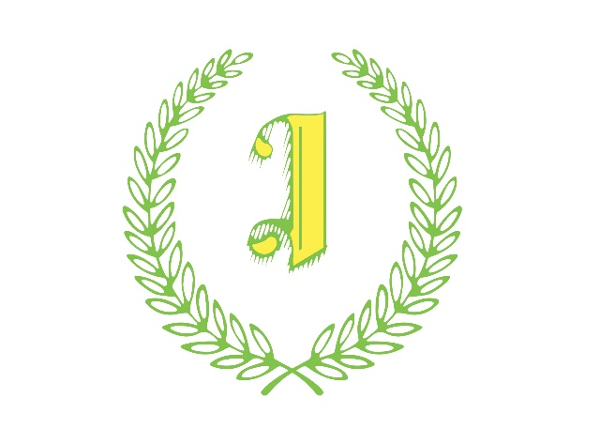

Safeguarding in Open Age Football

The FA safeguarding resources can be found by clicking on the link below:

FA Resources

Any assistance required by the Isthmian Football League please contact:

Kellie Discipline
01322 341999
safeguarding@isthmian.co.uk

