Belle (12A)

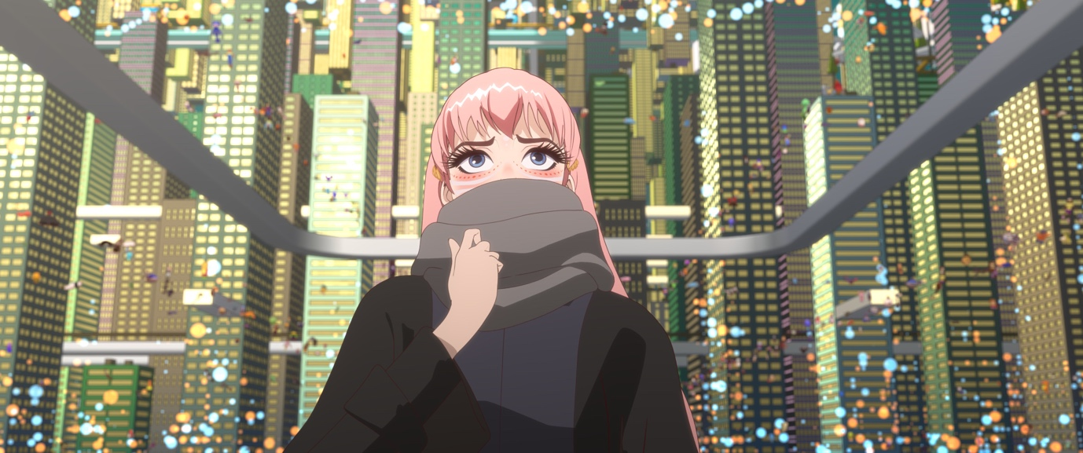

As Recommended by the FAN Young Consultants

Dir. Mamoru Hosoda|Japan|2021|121 mins

Distributor: National Amusements
Bookings: Distribution@National-Amusements.com
Available: 4 Feb 2021
Platform: Theatrical (DCP)
Versions: Available in Japanese with English subtitles and English dubbed.

Synopsis
Suzu is a 17-year-old high school student living in a rural village with her father. For years, she has only been a shadow of herself. One day, she enters “U,” a virtual world of 5 billion members on the internet. There, she is not Suzu anymore but Belle, a world-famous singer. She soon meets with a mysterious creature. Together, they embark on a journey of adventures, challenges and love, in their quest of becoming who they truly are.

The film comes from Studio Chizu and Mamoru Hosoda, the Academy Award nominated director of Wolf Children and Mirai.

English Language Dub Voice Cast
Suzu/Belle - Kylie McNeill
Justin - Chace Crawford (Gossip Girl & The Covenant)
Shinobu - Manny Jacinto (The Good Place)
Ruka - Hunter Schafer (Euphoria)

Social

Websites: https://bellefilm.co.uk/ (English dubbed trailer and music versions); https://studiochizu.com/works/belle (Japanese site)
Official Twitter: @AllTheAnime
Official Facebook: https://www.facebook.com/alltheanime
Official Instagram: https://www.instagram.com/alltheanime/
Youtube Trailer: Subtitled Dubbed
Hashtags: #Belle, #Bellemovie, #Belleanime, #MamoruHosoda
Additional hashtags worth exploring/adding: #Fanart, #Bellecosplay, #Anime, #DigitalArtist, #Illustration
Press

5* TimeOut
“Mamoru Hosoda’s cyber fairy-tale is basically wall-to-wall bangers, all backdropped by virtual worlds that wash over you in waves of world-building so detailed and epic, they’d make William Gibson’s eyes pop.”

3* Guardian
“Anime that makes for an intriguing big-screen spectacle”

Variety
“A Feminist Beauty and the Beast fable for the Digital Era”

Indiewire
“‘Beauty and the Beast’ meets ‘The Matrix’ in Mamoru Hosoda’s dazzling Anime”

Independent
“Anime master Mamoru Hosoda makes movies that, even at their most elaborate, can reach such staggeringly emotional heights that they seem to break free of anything you’re prepared for in animated movie — or in most kinds of movies, for that matter.”

Screen Daily
“At first, it appears that Hosoda merely wants to remake Beauty And The Beast, but there are surprises in store that shouldn’t be spoiled.”

Rotten Tomatoes
95% Audience score

Assets
Link includes:

- Mural images
- Living on sheet
- Posters
- Programming sheet
- Social Assets
- Stills
- Trailer
- Press kit including link to Empire Take 20 article

BBFC Guidance
Moderate violence, domestic abuse

FAN Young Consultants Feedback
The FAN Young Consultants group is a 10 strong group of under 30 year olds working in Film Exhibition across the UK. Working with Film Hub London’s Young Audiences Manager Moira McVean, the group is recommending new release films that they believe will resonate particularly well with their peers and young people aged 16-30.
Previous titles supported by the group include Parasite, Portrait of a Lady on Fire, The Assistant, Days of the Bagnold Summer, Babyteeth, Socrates, Rocks, County Lines, Mogul Mowgli, Willy’s Wonderland, Sound of Metal, Last Man Standing, Night of the Kings, Limbo, Souad, Gagarine, You Will Die at Twenty, Petite Maman, Bad Luck Banging: or Loony Porn, Boiling Point Packs can be downloaded here

James Calver
I’ve just finished it now and I’m still in absolute bits. As the film was working through the opening scenes I didn’t expect it to build up emotionally the way that it did but the final “performance” had me in pieces. When I read that it was an anime re-telling of Beauty and the Beast I thought that was a fun concept, but what I didn’t expect is the way in which they used that framework to tell a far more interesting story. It was also nice to see a story about a futuristic VR world where the world itself and its creators weren’t the plot. It just happened to be set there.

I’m not going to be the first person to point out the film is visually breathtaking at times, and even though I’m not the biggest anime fan I appreciated the difference in art styles between the real world and VR worlds. I’ve got a few friends and a brother who are quite into their anime and I’ve already recommended to them all.

Thea Berry
I absolutely loved this. The design is beautiful (and this is a real high for Hosoda, really stunning production and animation) and I thought this was a really moving coming of age story that really felt like it delicately explores para-social relationships, mental health, online escapism, and grief. I loved the nod to 1991's Beauty and the Beast which was one of my fave Disney films when I was small. I loved the score and found it really so moving. And also it was really nice to see a coming-of-age film that didn't have two female straight characters fighting over a boy and at each other’s throats because of that.

Louise Giadom
I loved everything about this film! It looks amazing, from the get go everything is just beautiful to look at. The music was great. It took me a while, and I kept thinking to myself 'this gives me Beauty and the Beast vibes' which was such a great addition and was beautifully done as expected. It constantly felt like it was going one way and then went somewhere completely different which was great and really kept me engaged with it. It felt like such a current film with so many themes to delve into that everyone can relate to but especially young people with social media, grief, anxiety etc. Overall it was a nice change from a coming of age film revolving around romance to one more focused on her finding her voice and realising she's not alone.

Caroline Wilson
I really liked Belle. The visuals and 3d element of it was super beautiful and the commentary on social media was so apt. I really appreciate the work that has gone into it. I think the film would be really popular amongst anime fans and would really promote a social media marketing campaign. To really push the film I would market it to 13-35 as I think it has a wide age group.

Feedback from students at the London College of Communications (BA Film & Screen Studies)
The students are part of the BA (Hons) Film and Screen Studies at London College of Communication, University of the Arts, London. They study the historical, theoretical, cultural, and critical analysis of film and screen, developing the next generation of filmmakers and influencers in the commissioning, distribution, curation and exhibition of film and screen.

- Beautiful in every aspect, the soundtrack gave me chills.
- Even though I’m not a fan of these animations, the film was quite engaging and the music suited the theme and story very well. At times I had a hard time following the girls’ purpose in this virtual reality. However, the visible point of the film are friendship and love.
- I thought it was really fun to watch. The songs were amazing from back to back I loved it.
- I liked the twist to the story and how the focus shifted from Belle to Suzu and to the beast.

Comparison/Complementary titles
Beauty and the Beast; Ready Player One

Key selling points
The music, visuals, beautiful animation style, twist on the Beauty and the Beast story

Themes
Loss, grief, anime, digital identity/identity, family, friendship, music, domestic violence, love, insecurity, online trolling, mental health, coming of age, beauty and the beast

Recommended age
13 – 30 year olds

Marketing/Eventising ideas

- Can you do a ticketing offer? Pay what you can model? 2 for 1 or group discount?
- Think about which platforms you’re using to communicate with your audiences. The images for this film are stunning and the Young Consultants and LCC students all highlighted the Artwork as a massive draw. Instagram and TikTok are key platforms for this.
- The Japanese subtitled version of the film will be top on the list for Anime fans but there’s a lot of love for the dubbed version too thanks to the casting of popular stars from top youth engaging shows. Take a look at this TikTok video that makes this point! Consider offering both versions if you can so the audience has a choice. So many more TikTok videos about the film out there too (just search Belle Anime on the site and they’ll come up). Some feature spoilers which are of course best avoided but the coming of age – friendship/love/courage scenes have really resonated.
- The music is another key selling point of the film as alluded to in the feedback above. The Soundtrack is available on Spotify under ‘Belle’. Both the English and Japanese versions of the song. Play the soundtrack in the foyer to promote the film.
- The students at LCC particularly suggested bringing live music into your venue in some way, particularly orchestral music!
- Also popular was the idea of themed Japanese food and drink such as Sushi and Sake
- Could you run an Anime comic book workshop or create a zine for the audience or a ‘mindfulness colouring’ session with line images?
- Cosplay is another option for a special screening, perhaps with a photographer/photobooth to capture the event.
- An introduction to the film/film season about the history of Anime and particularly Mamoru Hosoda’s body of work was also of appeal to the students.

Interesting Articles/Videos/contacts:

- Vulture.com interview with Mamoru Hosoda (printed)
- Zoom Q&A with Mamoru Hosoda at the New York Film Festival
- Anime news network interview about creating the English dubbed version

