County Lines (15)
As Recommended by the FAN Young Consultants

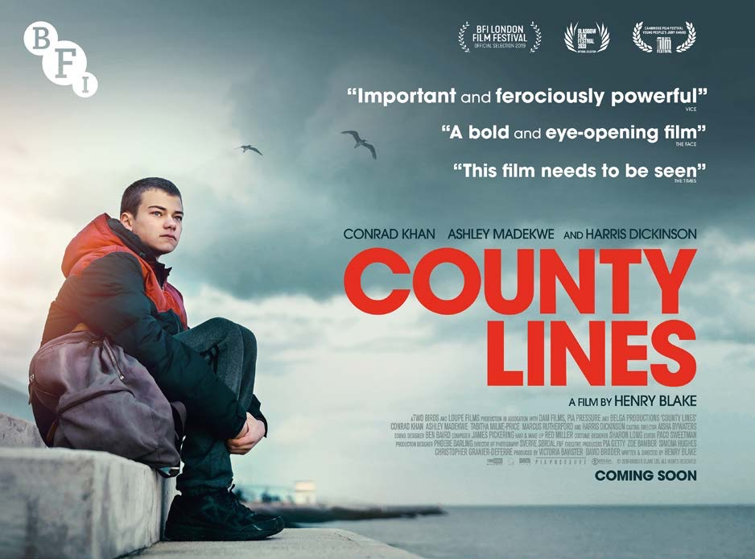

COUNTY LINES (15)
Dir. Henry Blake|2019|UK|90 mins

Distributor: BFI
Bookings: bookings.films@bfi.org.uk
Available: Friday 4th December
Platform: Theatrical & VOD
Cast: Conrad Khan, Ashley Madekwe, Harris Dickinson
Director: Henry Blake
Written By: Henry Blake

Synopsis

County Lines is a powerful and moving coming-of-age film about a 14 year old boy who is groomed into a ‘county lines’ criminal network.

Inspired by the stories he heard while mentoring young people at an East London pupil referral unit, writer-director Henry Blake’s powerful feature debut boasts a compelling central performance by Conrad Khan as 14-year-old Tyler, with strong supporting performances from Ashley Madekwe and Harris Dickinson.

Social
Official website: https://www2.bfi.org.uk/whats-on/bfi-film-releases/county-lines
Official Twitter: @COUNTYLINESfilm
Official Facebook: https://www.facebook.com/COUNTYLINESfilm/
Official Instagram: @COUNTYLINESfilm

Official hashtag:#BFICountyLines

Press
★★★★
‘Heartrending, moving... glimmers with the light of a raw young talent’ Empire (Sophie Monks Kaufman @MonksKaufman)
★★★★
‘Blake announces himself as an assured new voice in British film’ Little White Lies (Millicent Thomas @millicentgames)
★★★★
‘Poignant and informative’
The List (Emma Simmonds @EmmaSimmonds)
★★★★
‘Bold, powerful and eye-opening’
The Face (Sam Higgins @sam_higgins)
★★★★
‘A powerful piece of drama’
Total Film (Neil Smith)
Vice (JS Rafaeli @jsrafaelism)
‘This film needs to be seen’
The Times
‘Kids with no emotional support are easy prey’
LISTINGS PAGE
All screenings of the film will be listed at:
https://www2.bfi.org.uk/whats-on/bfi-film-releases/county-lines
(NB. If your screenings are not yet listed please send event details to marketing.films@bfi.org.uk)
MARKETING ASSETS
- Trailer
- Download trailer (including 30 second versions)
- Quad Poster – will be sent directly to venues
- Download quad poster (including 4* review posters)
- Stills –Download stills
- Review cards – Download review cards
FAN Hubs
Please contact your local Hub for specific regional support
FAN Young Consultants Feedback
The FAN Young Consultants are a 21 strong group of under 30 year olds working in Film Exhibition across the UK. Working with Film Hub London’s Young Audiences lead Moira McVean, moira.mcvean@filmlondon.org.uk the group is recommending new release films that they believe will resonate particularly well with their peers and young people aged 16-30.
Previous titles supported by the group include Parasite, Portrait of a Lady on Fire and The Assistant, Days of the Bagnold Summer, Babyteeth, White Riot, Socrates, Rocks, Mogul Mowgli Packs can be downloaded here

- This is a tough watch but it stuck with me. It has a rawness to it that doesn't seem manufactured. It didn't feel like one of those try hard 'gritty' dramas, it felt researched and knowing of its subject matter. I ended up talking about it the same day to friends who are teachers that have kids go missing in their class suspected to 'county lines' activity. I thought the quality of acting was great, and found the film beautiful in parts - the lead actor is amazing I think. It reminded me of Ray and Liz in that respect. What I think is very good is watching a film about contemporary issues such as County Lines which are a very real problem facing young people today. I hope this film gets as wider distribution as it can!

- A very intimate yet striking film. It feels like a return to a certain era of British Kitchen Sink drama, yet without feeling like you're being hit over the head with a kitchen sink.

- A gritty film that's delicately shot - I was glad to see a focus on the relationships (or often lack of) between Tyler (Conrad Khan) and the other characters, rather than just a bleak focus on the job/industry (although there is plenty of focus on that too) - essentially, I was most impressed with the focus on the human cost of drug dealing, and the honest and often uncomfortable way the film portrays it. My sister is a mental health nurse, and is currently working with a very young teen who works county lines - from speaking to her it sounds like the film was researched well and the circumstances that might lead someone to get involved in county lines definitely rings true. You can tell the writer had some kind of inside experience of these issues, which is partly why I think it works so well.

- A difficult film with a hard subject, but a well-acted gritty drama and overall fantastic debut for those involved. The tale of a child violently growing up too fast and just wanting to be a kid again is gripping, and with the context of the crimes, a real stomach-turner. Conrad Khan delivers a haunting performance.

- I really loved this film - it definitely reflected my experience and knowledge of growing up in London. I think this film is very important and marks a moment when British Film engages with real issues.

Feedback from students at the London College of Communications (BA Film & Screen Studies)
The students are part of the BA (Hons) Film and Screen Studies at London College of Communication, University of the Arts, London. They study the historical, theoretical, cultural, and critical analysis of film and screen, developing the next generation of filmmakers and influencers in the commissioning, distribution, curation and exhibition of film and screen.

- A thought-provoking masterpiece which can teach us all an important lesson. Following a few days of the life of 14-year olds Tyler, the film depicts the harsh reality of a lot of young people who are raised in a toxic family environment. Sometimes poverty and harsh atmosphere can push young people to make some unreasonable and unlucky decisions like getting involved in drug trafficking.

- A jarring, brutal, real film. The sound design was amazing. Although I wasn’t a fan for personal reasons connected to the content of the film and previous experiences, I can definitely say that it was of high quality and was very emotionally impactful.

- 3 words – intense, bleak, gritty. It was hard to digest but it was an intense realism film with heartfelt emotions.

- I don’t know if enjoy is the right word- it’s very hard hitting and thought provoking with beautiful cinematography. If I was being critical it could talk more about systemic problems- Simon is exploiting these kids but he’s a victim also.

- Amazing! Very hard to watch but it’s a film that people NEED to see. All the performances were outstanding, the music was mixed perfectly.

- I liked many aspects of this film especially the script which I thought perfectly crafted the characters of the mother and son, giving them a full, empathetic story arcs. This blended well with the tone of the film in terms of aesthetics, making it a great and deeply moving piece of cinema.

- A necessary punch in the stomach. The story is closer to you than you may think.

- I enjoyed it because it portrayed a realist(ic) set of circumstances that I cannot directly relate to but that I can empathise with. I thought the pace of the film was great and that key plot points occurred at natural/believable points.

- A gritty, gripping drama that displays a young man’s decent into drug smuggling. Henry Blake’s ‘County Lines’ is relentless in presenting the reality of the situation.

- I enjoyed the movie. The storyline was gripping and it teaches the ‘real-life’ side to drug-trafficking instead of glamorising.

Comparison titles
The Last Tree, Blue Story, Top Boy, Bullet Boy

Themes
Youth culture, Drug trafficking, familial relationships, grooming behaviour, exploitation of vulnerable/at risk young people, knife crime, gang activity

Key Selling Points

- Realistic (not glamorised) portrayal of gang culture & County Lines activity
- Debut feature of a British Director
- Director is from a youth work background so storyline is authentic
- Impactful and emotionally intense watching experience
- Critically acclaimed performances – 18 at the time, Conrad Khan’s quiet performance is devastating

Marketing ideas

- Can you do a ticketing offer? Pay what you can model? 2 for 1 or group discount for up to 6 (if your tier status allows)? Survey responses suggest that ticket price is even more of a barrier for young audiences than it was pre-Covid.

For more information about the sliding scale model see this article written by Young Consultant Megan Mitchell https://www.independentcinemaoffice.org.uk/video-killed-the-radio-star-but-netflix-didnt-kill-cinemas/

- Think about which platforms you’re using to communicate with your audiences – do you work with Instagram, Insta Stories, IGTV and Twitter? If you’re running an event, be sure to advertise it as such on Facebook and send on the day reminders.
- If permitted, could you host a post screening Q&A with a local youth worker/ex-addict talking about the issues the film raises and giving audience members the chance to ask questions? Organisations that might be able to help you with this include https://www.connectfutures.org/cc/ & https://www.stgilestrust.org.uk/
- If you’re not able to run a live Q&A the BFI has a 30 minute recorded one with Henry, Conrad and Ashley hosted by Guy Lodge. Please contact bookings.films@bfi.org.uk to access it.
- Audiences might also benefit from a safe space for discussions amongst themselves- can you provide that space?
- Have you considered moving out of your building and screening the film in a non-traditional setting? Do you have a local sixth form college or Pupil Referral Unit you could connect with? Into Film may be able to help you with this.
- It may seem like a ‘London-Centric’ film but the very nature of County Lines activity means what begins in London ends up in the regions so the film’s themes will definitely resonate with young people across the country, regardless of where they’re growing up.
- Could you invite a young person in your area/venue to write a review about it? Or perhaps record a podcast?

Interesting Articles/Videos:

- Conrad Khan speaks to The Guardian’s Steve Rose (@steverose7) about the film and his career so far.
- Rhiannon Sawyer of the Children’s Society sharing insight on County Lines causes and activity https://mypovonline.com/mypov/activity/780/
- Henry Blake discusses exploitation and vulnerability in County Lines http://outtakemag.co.uk/interviews/2020/11/30/henry-blake-county-lines-exploitation/
- Flip Your Wig interview with Henry Blake https://flipyourwig.net/county-lines-has-to-be-watched-2/
- Into Film has recorded 2 Q&As hosted by their Young Reporters:
Conrad Kahn interview: https://www.youtube.com/watch?v=4V20tZ7hVYw&feature=youtu.be
Harris Dickinson interview: https://www.youtube.com/watch?v=4V20tZ7hVYw&feature=youtu.be

County Lines links and additional resources – you may want to consider sharing these organisational links with audiences:

https://www.childrenssociety.org.uk/what-we-do/our-work/child-criminal-exploitation-and-county-lines

https://www.nationalcrimeagency.gov.uk/what-we-do/crime-threats/drug-trafficking/county-lines

https://stgilestrust.org.uk/county-lines-and-serious-violence

