Souad (12A)

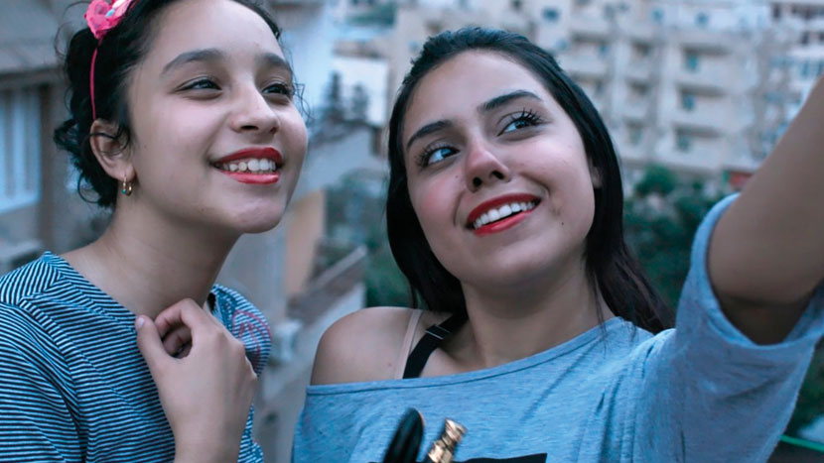

As Recommended by the FAN Young Consultants
⭐️ Berlin Panorama Selection 2021
⭐️ Cannes Official Selection 2020
⭐️ Tribeca, International Competition 2021

Dir. Ayten Amin|Egypt/Tunisia/Germany|2020|102 mins
Language: Arabic with English subtitles DCP also has HOH subtitles
Cast: With Bassant Ahmed, Basmala El Ghaiesh, Hussein Ghanem

Distributor: BFI Distribution
Bookings: bookings.films@bfi.org.uk
Available: From 27th August
Platform: Theatrical, BFI Player and SVOD from 12th November
Recorded Q&A: Director Q&A available on request

Synopsis
In a small city on the Nile Delta, 19 year old Souad (Bassant Ahmed) leads a double life. Conservative and veiled in public, online she obsesses over her appearance and embarks on secret virtual romances.

As the reality of her personal situation comes increasingly into conflict with her digital life, she struggles to reconcile her ambitions with her future until tragedy strikes.

Featuring astonishing performances from a cast of non-professionals, the film - co-produced by Wim Wenders - acutely examines the contradictions of teenage life in contemporary Egypt and the challenges of combining traditional values with social media.

A favourite at Cannes, Berlin and Tribeca – where the film won the best actress award – Souad received its UK premiere at the SAFAR Film Festival in July and has been described as 'one of the year's revelations' (Cahiers du Cinéma).

Social
Twitter: @BFI
Facebook: @Britishfilminstitute
Instagram: @Britishfilminstitute
Hashtag: #Souad

Assets
Trailer, Review cards for social, Stills and Quad Poster Artwork accessible here:
https://www.dropbox.com/sh/9q83v8683cob3yy/AAD-1kqmeAEdk6EkMJ4K5Ie4a?dl=0

Listings page
All screenings of the film will be listed at: https://www2.bfi.org.uk/whats-on/bfi-film-releases/souad

(NB. If your screenings are not yet listed please send event details to marketing.films@bfi.org.uk)

Press & Reviews

★★★★★
'Absolutely compelling and engaging'
The Upcoming

★★★★
The Financial Times

★★★★
The Guardian

★★★★
‘Powerful and enduring’
Empire

★★★★
‘Ayten Amin directs with great sensibility
in this moving expose of Arab society.’
Filmuforia

★★★★
Total Film

★★★★
Dirty Movies

'One of the year's revelations'
Cahiers du Cinéma

'A story that feels pertinent to the world today'
James Luxford, CITY A.M.

‘Authentic and haunting. A window into a
world we might never otherwise see’
Screen Daily

Sexting, lies and unveiled selfies: the Egyptian film
exploring the hidden lives of teenage girls (Interview)
The Guardian
BBFC Guidance
Moderate sex references, language, suicide references, discrimination

FAN Young Consultants Feedback
The FAN Young Consultants group is a 10 strong group of under 30 year olds working in Film Exhibition across the UK. Working with Film Hub London’s Young Audiences Manager Moira McVean, the group is recommending new release films that they believe will resonate particularly well with their peers and young people aged 16-30.
Previous titles supported by the group include Parasite, Portrait of a Lady on Fire, The Assistant, Days of the Bagnold Summer, Babyteeth, Socrates, Rocks, County Lines, Mogul Mowgli, Willy’s Wonderland, Sound of Metal, Last Man Standing, Night of the Kings, Limbo. Packs can be downloaded here

Thea - I really liked this. This is a world that's so so far removed from my own but what great coming of age stories do so well is to make someone's very specific experience feel relatable. That's what Souad does so well.

Caitlin - I thought Souad was a really brilliant film, I think it speaks to a feeling of social media anxiety and coming of age in such a specific and interesting way - it felt like an authentic and thoughtful insight into the lives of these girls - I found it quite moving!

Louise - I liked the film, I felt it was almost subtle in a way but had a lot it was trying to say at the same time. I think it was a really interesting insight into that specific culture and in particular, being a teenage girl in that culture while also having access to social media. I think it'd be a great watch for 16–24-year-olds, as younger teens can relate to Rabab. The change of POV after Souad's suicide reminded me of Waves which was an interesting twist I wasn't prepared for.

Rebekah - I liked Souad. I haven't had the opportunity to watch many Egyptian films. I liked how it gave me an interpretation on what domestic life is like as a young woman in Egypt.I thought Basmala Elghaiesh as Rabab was great as the young sister searching for answers.

Gabrielle - I really liked it - was interesting to see a portrayal of life in a different culture and see how Souad depicted herself differently in the different areas of her life. I thought it was a really thought provoking and discussion provoking feature.

Comparison/Complementary titles

- Eighth Grade
- Mustang
- Ingrid Goes West
- The Virgin Suicides
- Ava

Themes
Secrets, sibling/familial relationship, social media/sexting/influencers, depression/anxiety, teen romance, suicide, identity & belonging offline and on, religion and cultural sensitivity

Recommended age – 14+
Networks
Get in touch with local community groups, museums and school/university networks to spread the word about your screening. Contact your regional Film Hub to see if there are networks near you they can help you tap into.
Marketing ideas

- Can you do a ticketing offer? Pay what you can model? 2 for 1 or group discount for up to 6? Survey responses suggest that ticket price is even more of a barrier for young audiences than it was pre-Covid.
- Think about which platforms you’re using to communicate with your audiences – do you work with Instagram, Insta Stories, IGTV and Twitter? If you’re running an event, be sure to advertise it as such on Facebook and send on the day reminders.
- If you’re able to, host a Q&A after the film with a local charity/organisation about the multiple issues the film raises
- Could you engage a local blogger to write a piece about the film for you?
- Audiences might also benefit from space for discussions around cultural frictions within one identity. Who you want to be vs who you are. Social media has been a lifeline and a curse even more so during the pandemic as young people have struggled to stay connected and are increasingly suffering from mental health conditions and concerns.
- Connect with grass-roots advocates in your area or online – connect using the #Souadmovie #Souadthefilm or search for contacts via the site www.inclusivecinema.com

Interesting Articles/Videos/contacts:

Director Ayten Amin on BBC
Radio 4 The Film Programme

Finding Hope through Understanding
Medical Humanities blog Film Review by
Khalid Ali, Film and Media Correspondent

Birds Eye View/Reclaim the Frame Mistressclass with Ayten Amin
https://www.birds-eye-view.co.uk/event/mistressclass-with-ayten-amin/

User reviews
https://letterboxd.com/film/souad/

Interview with Ayten Amin for The Upcoming (Berlin Film Festival)
https://www.youtube.com/watch?v=ATK-F8LCUys

Arab British Centre

