WHITE RIOT (15)
As recommended by the FAN Young Consultants
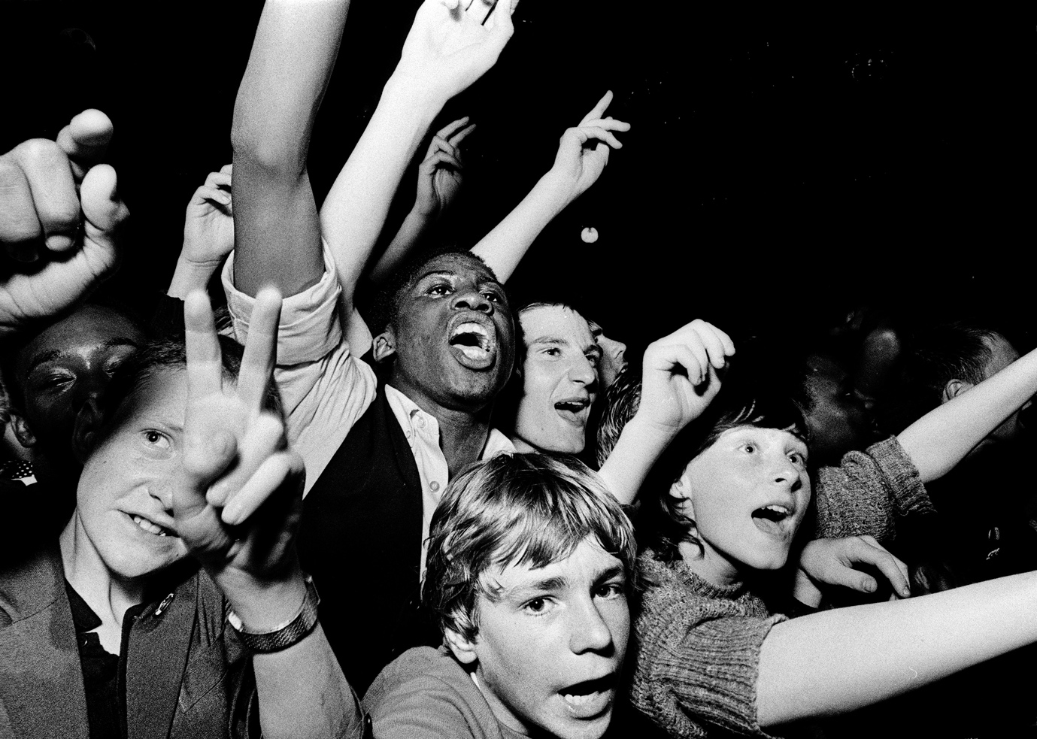
Specification details:
White Riot
Dir. Rubika Shah|80 mins|UK|2019
Distributor: Modern Films
Contact: Anna@modernfilms.com
Available: Theatrical & On Demand
Platforms: Modern Films (exclusive)
Key cast:
Writers: Ed Gibbs & Rubika Shah (Let’s Dance: Bowie Down Under 2015)
Featuring: Red Saunders; Roger Huddle; Kate Webb; The Clash; Steel Pulse; Tom Robinson; Poly Styrene; Sham 69; Alien Kulture

Director quote: ‘White Riot is an inspiring story about youth culture making a difference.’
Awards:
Winner Best Documentary at the BFI London Film Festival; Special Mention for the Generation 14+ Crystal Bear, Berlin Film Festival
Official Synopsis:

Short version: Follows the Rock Against Racism movement of the 1970s, revealing both the nastiness of the rising National Front at the time and the amazing power of music, activism and a real desire for social change at a grassroots level. Best Documentary BFI London Film Festival.
Long version: Rubika Shah’s energising film charts a vital London protest movement. Rock Against Racism (RAR) was formed in 1976, prompted by Eric Clapton’s highly controversial support of rascist MP Enoch Powell. White Riot blends fresh interviews with queasy archive footage to recreate a hostile environment of anti-immigrant hysteria and National Front marches. As neo-Nazis recruited the nation’s youth, RAR’s multicultural punk and reggae gigs provided rallying points for resistance. As founder Red Saunders explains: ‘We peeled away the Union Jack to reveal the swastika’. The campaign grew from Hoxton fanzine roots to 1978’s huge antifascist carnival in Victoria Park, featuring X-Ray Spex, Steel Pulse and of course The Clash, whose rock star charisma and gale-force conviction took RAR’s message to the masses.

FAN Young Consultants feedback
The FAN Young Consultants are a 21 strong group of under 30 year olds working in Film Exhibition across the UK. Working with Film Hub London’s Young Audiences lead Moira McVean, moira.mcvean@filmlondon.org.uk the group is recommending new release films that they believe will resonate particularly well with their peers and young people aged 16-30.
Previous titles supported by the group include Parasite, Portrait of a Lady on Fire and The Assistant, Days of the Bagnold Summer, Babyteeth, Socrates Packs can be downloaded here

“I think White Riot, with its focus on the Rock Against Racism movement, will really resonate with a lot of young people, across the full age bracket - 16-30.

People on the younger end of that spectrum might be less familiar with this era of social history and so might be discovering it for the first time through this film - I think it’s a really great and lively introduction.

The archive footage is amazing - I’ve watched a lot of documentaries about punk music/two-tone and 70s youth culture and I’ve never seen a lot of this stuff, of this quality too. I like that it has that kind of fanzine aesthetic and is really shot through with energy by music.

Brexit feels like a very long time ago now(!) and of course it saw a huge increase in racial tensions and division, but I think a lot of people are finding their anti-immigrant sentiment challenged at the moment with the NHS and its critical workers so fore-fronted, so the film feels strangely pertinent in that sense - I think it’s an interesting moment for this film because of that.”

“I loved it! Very interesting documentary about the organisation Rock Against Racism and how artists stood up against the National Front in UK in the late 70’s using punk music and culture. I’m not British so I didn’t know this part of the UK contemporary history, but the context is well explained, and the film gives a good overview of the political, social and artistic issues of this time. The work on the archive material is clever and creative and the soundtrack is energizing (especially if you like The Clash). It’s very easy to watch and to enjoy. Kind of film that gives smile and good vibes.”
“I enjoyed the doc overall. I had some knowledge of Rock Against Racism so I could keep up as it does jump from the political to cultural issues a lot and to the background of the particular individuals involved in the RAR. However, I felt that it gave a good overall look at what the social and political climate was like at the time as it’s such a large subject and it was really interesting to find out how the concert formed.”
“White Riot charts a gripping, and timely story about Britain's late 1970s protest movement 'Rock Against Racism'. The documentary wastes no time in getting to its subject matter; combing artist and activist interviews with news experts and shocking archival footage in an electrifying and intertwining look at the rise of fascism as a result of the far-right National Front political party, and the inspirational story of solidarity that brings culturally active punk rock and reggae artists together in protest. Footage shown here is stinging, and at times a searing echo of what remains in society today. I am reminded of this through the choice of words and phrases expressed by political campaigners who turn economic crises into anti-immigration agendas, to the youthful activist spirit marching in solidarity against the xenophobic, this all feels like it could have all happened yesterday. Stories of minorities afraid to go outside alone, afraid of being attacked by NF skin-heads, or targeted by police enforcing and abusing stop and search laws, really stick when compared to contemporary news stories. Appearances change, and progress is made, but hate remains, and 'the fight is far from over'.”

Key Themes
Activism
Youth culture
Music (general & well as artists featured)
Black British/British Asian history
Social history/politics

Suggested target audience: 16-30

Official UK Digital Assets:
The following can all be found here

- Trailer
- Stills
- Quads
- Social media assets
- Press kit

Social Media:
Twitter
@ModernFilmsEnt
@WhiteRiotFilm2
@Rubie_S
@EdGibbsFilm

Partner organisations
@lmhrnational (Love Music Hate Racism)
@NME
@LWLies

Instagram
modernfilmsent
Rubika411
lovemusichateracism

Facebook
@whiteRiotFilm
@modernfilms

Hashtags
#WhiteRiot
#WhiteRiotFilm
#RockAgainstRacism
#TheClash
#SteelPulse

Marketing ideas

- Modern Films have a 3-minute short film they’ve created that is exclusively available for cinema screenings that gives a round-up of the Summer music festival previews and events as an homage to the summer of 2020 and connecting the RAR movement with Love Music Hate Racism and Black Lives Matter. Venues are able to screen this ahead of the film, to set the mood for audiences. Contact Modern for more information.

- Focus promotion of the film to your audiences on the subject matter using the Hashtags below, and the key themes highlighted above.
- If you’re not able to run in person Q&A events or a live music session, could you create an online Q&A with speakers who could contextualise the film or record a session with a local band from your area to play after the screening?
- Is there a music festival in your local area you could partner with? Check for one here
- https://www.lovemusichateracism.com/ is working with Modern Films to promote White Riot and they have regional groups that may be able to support your activity.
- Connect with National organisation Stand Up To Racism (SUTR) https://www.standuptoracism.org.uk/
- Think about curating playlists featuring the artists in the film to share with your audiences or you can point young audiences to this on Modern Films’ website here

Interesting articles/video

- https://soundcloud.com/bafta/white-riot-film-qa (BAFTA Q&A with Rubika Shah & Ed Gibbs)
- https://www.youtube.com/watch?v=f2UPjzU2amI (Living Room Q&A with Rubika Shah and Mark Kermode followed by a live performance)
- https://www.theguardian.com/film/2020/apr/30/echoes-of-todays-uk-revealed-in-rock-against-racisms-1970s-struggle (Guardian article/interview)
- Reaction to winning Best Documentary at the LFF: https://www.youtube.com/watch?v=yV57tMpHK44
- Little White Lies piece about the first festival preview: https://lwlies.com/articles/white-riot-rock-against-racism-documentary-preview/
- NME piece about the first festival preview: https://www.nme.com/news/film/white-riot-all-points-east-screenings-documentary-2674090
Funding support for FAN members:
BFI FAN has a new Film Exhibition Fund aimed at supporting FAN member venues to resume their programming activity as venues start reopening. Contact your local Film Hub for more details. Applications are open until 30th September.

