Willy’s Wonderland (15)
As Recommended by the FAN Young Consultants

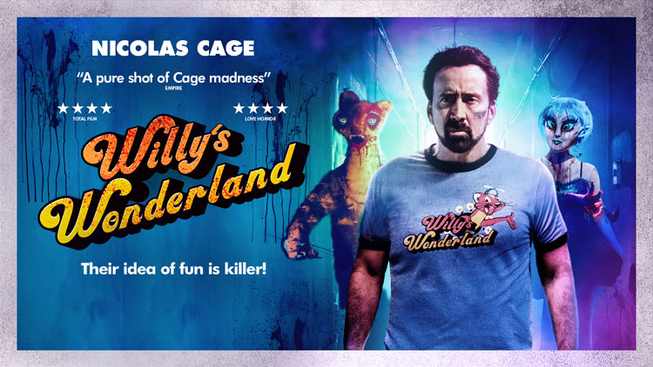

Willy’s Wonderland (15)
Dir. Kevin Lewis| US 2021|| 89 mins

Distributor: Signature Entertainment
Bookings: Connor@signature-entertainment.co.uk
Available: From Friday 12th February
Additional Release Dates: EST (BUY on Digital): April 12; VOD (Standard Rental Price): April 19; DVD & Blu-ray: April 19
Platform(s):
Modern Films partnership: Modern Films is hosting the film on their platform which cinemas and film societies can link to. Contact Connor@signature-entertainment.co.uk for more information.
Home Premiere (VOD) Sky, iTunes, Amazon, Google, Xbox, TalkTalk, Virgin Media, BT, Rakuten, Chili, Showcase at Home

Cast: Nicolas Cage, Caylee Cowan, Beth Grant, Emily Tosta
Director: Kevin Lewis
Written By: G.O Parsons

Full Synopsis

The legend Nicolas Cage takes on a set of violent animatronic amusement park mascots in this action packed, nail-biting tale of terror that will take you on the ride of your life. Stranded in a remote town with a car that won’t work and no way to pay the local repair shop, The Janitor (Nicolas Cage) agrees to spend the night in an abandoned theme park full of animatronic characters that were once a joy to the kids of the town, but now hold a dark secret. As night falls, these once happy mascots come to life and they’re out for blood. Survive at any cost, it’s only one night! Willy's Wonderland stars Nicolas Cage (Mandy) alongside Emily Tosta and Beth Grant. Directed by Kevin Lewis.

Short Synopsis
Stranded in a remote town with a car that won’t work and no way to pay the local repair shop, THE JANITOR (Nicolas Cage - Spider-Man: Into The Spider-Verse) agrees to spend the night in an abandoned theme park full of animatronic characters that were once a joy to the kids of the town, but now hold a dark secret.

As night falls, these once happy mascots come to life and they’re out for blood. Survive at any cost, it’s only one night!

Social Media campaign update from Signature:
To support the release of this insanely entertaining action horror our marketing team will be securing reviews across the board in national and online media. Last week saw the exclusive launch of the UK art and cutdown trailer for WILLY’S WONDERLAND go live with EMPIRE ONLINE to great fanfare. We are also working to create an engaging and entertaining social media campaign to compliment the film release. Our UK trailer has now reached over 3.2m views on Facebook without spend and more video content on the way. Our TikTok campaign has also ushered in over 100k video views within 48 hours of asset launch. To celebrate the Feb 12 launch we will also be utilising paid promotions for our cutdown trailer across social media platforms.

Interested in finding out more about Film TikTok? Take a look at this 15 min video essay which will get you up to speed!

Social
Official website: www.signature-entertainment.co.uk
Official Twitter: @SignatureEntUK
Official Facebook: @SignatureEntertainmentUK
Official Instagram: www.instagram.com/signatureentertainmentuk
Official TikTok: @Signatureentertainment
Official hashtag: #WillysWonderland

Additional Accounts:
Twitter: @willyswondermov
Writer (G. O. Parsons) Twitter: @GOParsons

Press
“A PURE SHOT OF CAGE MADNESS”
EMPIRE MAGAZINE
“GLEEFULLY OTT”
⭐⭐⭐⭐
TOTAL FILM

“ABSOLUTE INSANITY”
⭐⭐⭐⭐
BACK TO THE MOVIES

“THE CAGE FILM YOU’VE BEEN WAITING FOR”
⭐⭐⭐⭐
LOVE HORROR
“A VISCERAL THRILL RIDE”
⭐⭐⭐⭐
BOXOFFICEBUZ.COM

Assets

- Portrait Art
- Landscape Art
- Stills
- Social Media Trailer (Out Now on Home Premiere Messaging)
- For a captioned version of the trailer see here (thanks to Matchbox Cineclub)

FAN Young Consultants Feedback
The FAN Young Consultants are a 21 strong group of under 30 year olds working in Film Exhibition across the UK. Working with Film Hub London’s Young Audiences lead Moira McVean, moira.mcvean@filmlondon.org.uk the group is recommending new release films that they believe will resonate particularly well with their peers and young people aged 16-30.
Previous titles supported by the group include Parasite, Portrait of a Lady on Fire and The Assistant, Days of the Bagnold Summer, Babyteeth, Socrates, County Lines and Mogul Mowgli Packs can be downloaded here

“This was a lot of fun. I'll admit I'm a sucker for a Cage film anyway, and had been excited for this for quite a while and it delivered everything I wanted from it. It's by no means the best film ever made, but it delivers everything you'd expect from it - a bonkers slasher film that features a decent enough young cast, running through a story that's all over the shop. It was the perfect film for me to sit at home and relax with, simple and pure escapism. It would be great to see in a cinema, and can see it doing places like the Prince Charles once everything reopens, but it will also fit in just fine at home on a streaming service. Would happily recommend to anyone who wants something that's simply a bit of fun.”

“A fun Cage romp that offers some bloody but light relief. Possibly a film best viewed with others, but streaming applicable nonetheless.”

“It's a good laugh this. Everything you'd expect from Cage and some fun freaky puppets”.

“A fun change of tone from the features I’ve watched recently. Appreciated the shapes thrown at the pinball machine. Would look good on the big screen!”

“A ridiculous horror perfect for slasher fans, and an otherwise fun watch for those long lockdown nights. With a premise I might explain as being 'Five Nights at Freddy’s meets Drive'; it's fun to watch Nic Cage play the silent protagonist clean-up a run-down children's entertainment venue, both literally as the janitor, and physically as he battles his way through evil animatronics out for blood. Willie's Wonderland is VERY different from anything else we've promoted, and not typically the sort of film I would have ever watched. But it makes a nice change of pace from the over-serious bleak teen dramas of late.”

Comparison titles
Halloween, Mandy, Evil Dead, Friday the 13th
Themes
The film is loosely based on the very popular Five Nights at Freddy’s video game. The main theme is staying alive! But be aware that there are references to the animatronics being possessed by the spirits of paedophiles.

Target Audience
16-25. We can particularly imagine the trapped in digs student audience would be into this!

Marketing ideas

- Think about hosting an introduction with a Cage or Schlock Horror expert to add value to your online or in person screening. Lindsay Gibb for example has written ‘the book’ on Cage. You can find her on Twitter @lindsay_gibb
- Matchbox Cineclub’s Cage-a-rama festival co-founded and programmed by Sean Welsh and Young Consultant Megan Mitchell is also a great source of inspiration!
- When cinemas reopen - can you do a ticketing offer? Pay what you can model? 2 for 1 or group discount for up to 6? This is a film that’s best watched together so celebrate that aspect if you’re able.
- Think about which platforms you’re using to communicate with your audiences – the film is naturally building audiences via TikTok- have a look at the video essay link above to find out more about Film TikTok. Otherwise focus on Instagram, Insta Stories, IGTV and Twitter. If you’re running an event, be sure to advertise it as such on Facebook.
- Can you run a cult horror (particularly titles from the ‘80s) or Nicolas Cage season?
- Have a look at how creator/writer @GOParsons/@willyswondermov has been promoting the film. He’s building the idea of audiences as ‘employees’ – could you get involved?
- Could you host a ‘Willy’s-themed’ Escape room online or (when we get there) in person party?

Interesting Articles/Videos:

Geek Vibes Nation interview with Writer/Creator G O Parsons

