Review of the financial statements of Shrewsbury Town Football Club Limited
for the year ended 30 June 2025.
This review has the goal of making the latest Shrewsbury Town Football Club Limited statutory accounts understandable for all Salop fans – whether you have an accounting background or if the words 'profit and loss' mean nothing to you whatsoever!
The key things to remember before you start reading:
- These accounts cover the year from 1st July 2024 to 30th June 2025, i.e., the 2024/25 season, where STFC competed in League One.

- The period since 30th June 2025 is not covered as part of this review, as no financial information for this period is publicly available yet, unless specifically stated in the wording accompanying the accounts.

- These accounts will be publicly available via the Companies House website in due course.

- I have not made any assumptions, judgements or estimates unless explicitly stated. This is important because it means that anyone else could reach the same conclusions as I have from reading these accounts.

- This is not an exhaustive review, but I have highlighted the key points from the accounts.

- These accounts are also externally audited. An audit is a check on the accounts to make sure they are free from 'material' error i.e. that they do not contain any significant errors which would change the views of those reading them.
Summary
If you don't want to read the details below, the headlines are as follows.
- The club made a loss in the year of £0.6m (23/24 season - £1.6m loss). The £1.0m reduction in the loss year on year is primarily due to:
  - Increase in turnover/revenue of £0.4m
  - Reduction in costs of c. £0.6m
  - Decrease in other operating income of c. £0.3m
  - Reduction of tax provision of £0.3m

- The club continues to have no external debt, but cash in the bank in June 2025 remains low at £70k (June 2024 - £96k)

- The Chairman and Vice-Chairman have loaned a further c. £0.9m in total to the club during the 2024/25 season. During the season, as reported in the prior year accounts, £2.1m of loans were converted into shares. The total amount owed to directors is £1.3m at June 2025 (June 2024 - £2.5m). The loans are interest-free. No payments (e.g. salary / dividends) were made to directors, consistent with prior years.

- The club was in a positive net assets position at 30th June 2025 of £10.6m – that is to say it had £10.6m more assets than liabilities at that date (June 2024 - £9.2m) – the year-on-year increase is due to the loan conversion to shares of £2.1m noted above, offset by the loss in the year.

If anyone has any questions/comments, please feel free to drop me an email: ant.d.thomas83@gmail.com

The “Profit and Loss ("P&L") Account” or “Statement of Comprehensive Income”
This is the first key statement shown in the accounts.
The profit and loss account shows the "financial performance" of a company – that is:
- The revenue/income the club has earned in the year e.g., ticket sales, player sales, prize money less;
- The costs it has incurred in the same period.
Where the income is higher than the costs, this is called a profit. Where the opposite is true, this is called a loss.
Note that an increase in profit of say £100 does not mean the same thing as an increase in cash of £100. This is because of the way accountancy works, and some costs do not have an impact on the cash you have in the bank (an example of this is “amortisation”, which is discussed in the “intangible fixed assets” section below).
Each element of this statement is discussed below.
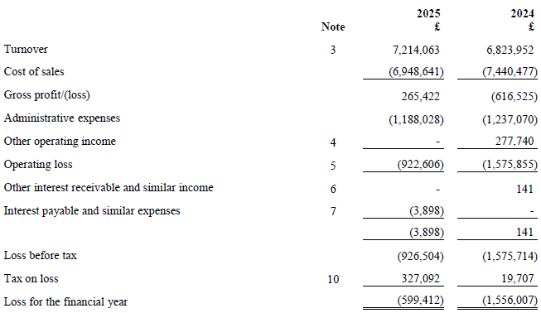
Turnover: This is the income the club has earned in the year. For a football club, this will relate to ticket sales, merchandise sales, prize money, TV money, etc. This is sometimes called “revenue” or “sales”.
The club provide a breakdown of turnover in the accounts:
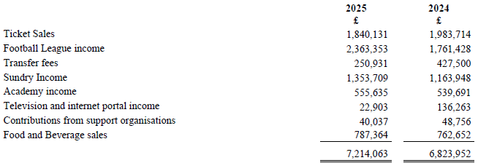
The most significant turnover streams for the club are ticket sales, income from the football league and sundry income (no further details are given on this last item).
In the 2024/25 season turnover increased by £390k – the key reasons being.
- Higher Football League income (+£601k)
- Higher sundry income (+£190k)
- Higher food & beverage sales (+£25k)
- Offset by lower ticket sales (-£143k), transfer income (-£177k) and TV/ internet portal income (-£113k)
Other operating income: In the year this decreased by c. £0.3m. No further information is given on what this relates to.
Cost of sales: This is the first cost we see in the P&L account, and it is the cost required to deliver the services provided for a company. For example – for a company that sells cars, their turnover is the amount received per car, and the cost of sale is the cost to manufacture that car and any other costs needed to be able to sell that car. For a football club, the key cost of sale is salaries.
The accounts give details of the total amount spent on salaries/ wages – this covers all club staff, including players and administrative staff. The amount spent on salaries in the 2024/25 season was £5.4m, a minor reduction year-on-year.
Administrative expenses: These are other costs of the club and are likely to include utilities (such as water, electricity, etc.) and repairs/ maintenance needed on the stadium. These costs have decreased by c. £50k year on year.
No further breakdown of these costs is required to be presented in the accounts by the accounting standards.

The “Balance Sheet” or “Statement of Financial Position”
This shows the "financial position" of a company and is shown for the year-end date only – in this case, 30th June 2025. It shows how many "assets" a company has, and how many "liabilities" – the difference between these two figures is called the “net assets”. The balance sheet also shows a company’s “capital and reserves” – this is the amount that has been paid for the shares in the company and the historical profits/ losses made by the company since it was formed.
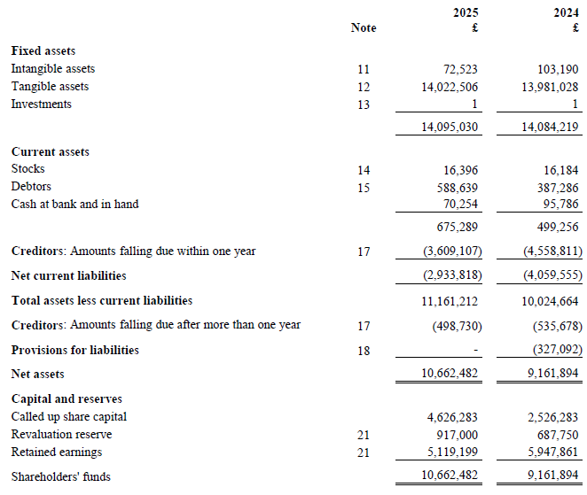

Assets
An asset is a resource owned by a company which has some economic benefit to the company – either short-term or longer-term. Each sub-category is discussed below. The most obvious asset for any business is cash – the “economic benefit” being that it can be used to buy other assets, or pay bills, etc.
Fixed assets - tangible
These are assets that are used by the company to generate economic benefit/ are used in the running of the business. Tangible means they physically exist. For STFC, these mostly relate to the stadium. The balance has not moved significantly year on year.
Fixed assets – intangible
Intangible assets are ones that cannot be physically held like a tangible asset can. For some businesses this may mean an online platform/ website which will result in revenue for the business going forward.
For football clubs, these primarily relate to players' contracts when a transfer fee is paid and can also relate to other items such as trademarks. This “asset” is then reduced each year of the contract. This reduction is called "amortisation" in accounting terms and is recorded as an expense to the business and so is included in the P&L account.
This reflects that when a player is bought on, say a 3-year contract, the club is expecting to get the benefit of that contract over the next 3 years, rather than just on the day the player is acquired.
The intangibles balance has decreased marginally from £103k to £73k. This has been driven by additions of £45k, offset by amortisation of £75k.
It is worth noting that transfer fees agreed after 30 June 2025 (i.e., pre-season for the 2025/26 season would not be included in this set of accounts).
Current assets
These are called "current" because they are easier/quicker to turn into cash than fixed assets (generally within twelve months). Each sub-section is discussed below.
Stocks
Stocks are either club-shop merchandise or items used by the club in its day-to-day running (e.g., food). The balance has remained consistent at £16k.

Debtors
These are amounts owed to a company by other companies or individuals. For a football club, they can relate to amounts owed by other football clubs (e.g., for transfer fees), from other organisations (e.g., the FA) or "prepayments" – this is where a company pays for a future service in advance. For example, if you paid for the whole of next year's car insurance now for £300, you would have a £300 prepayment – as that is not a cost that relates to your current year, hence doesn't impact the P&L for this year.
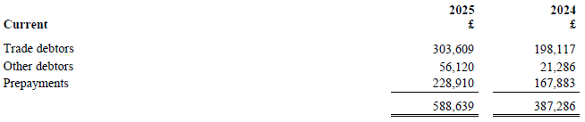
Overall, debtors have increased from £387k to £589k year on year albeit the accounts do not include further detail of who these amounts are owed by.
Cash
This is just what is sounds like – what is in the club's bank account. Ever heard of the expression “cash is king”? It is because without it a business can’t operate – because it wouldn’t be able to pay its staff or suppliers. For a football club who is so reliant on its staff, it is therefore vital to ensure you have a means to pay salaries and other costs.
The cash balance has decreased marginally from £96k to £70k. The club includes a “cash flow statement” in its accounts which gives the main reasons for movements in its cash balances.
Although the cash balance has remained largely stable year on year, this is because of some notable inflows and outflows. The losses sustained in the year have resulted in cash outflows (e.g. to pay staff and other expenses) whilst there has been an inflow of cash from the directors to support the cash needs of the club (more on this below), albeit both elements have reduced year on year.
Liabilities
A liability is an amount owed by a company which will lead to the outflow of economic benefits – for example, a payment in cash for a debt owed – either in the short term (in the next twelve months) or long-term. Each sub-category is discussed below.
Current liabilities
This description is given to amounts the club owes to individuals or other clubs/ organisations. They are called "current" because they are repayable in less than 12 months. The key items for STFC are:
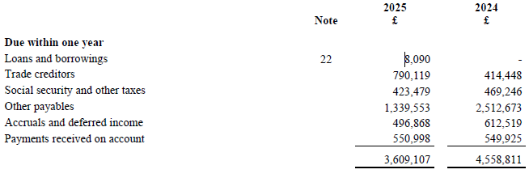
- Trade creditors: Amounts owed relating to the day-to-day business – this could be transfer fees, payments to suppliers to the club etc. The balance has increased year on year but there is no further detail required to be given in relation to this movement.

- Payments received on account and deferred income (e.g. season tickets paid for in advance): When you buy a season ticket for next season, and pay for it in advance, the club cannot recognise it as "turnover" until the season in which it relates to. So advanced season ticket sales for the 24/25 season are not included in the turnover figure in the P&L. Instead, they are shown as a current liability. Why? Because theoretically the club have not provided the service to the customer yet (giving them access to the matches) and the customer could ask for their money back if they changed their mind before the season starts.
These balances are also likely to include any other cash received up front by the club by 30 June which could relate a future season (e.g. 2025/26) such as marketing/ sponsorship sales, advanced merchandise sales or advances for TV rights etc.
This balance has remained consistent year on year.
- Other current liabilities (taxation and social security, other creditors, accruals, and deferred income): This relates to items such as payroll tax, one-off bills or where invoices have not yet been received by the club. The term "accrual" is used in the accounts. This is the opposite to a "prepayment”, and it means a company have used a service but not paid for it yet. A good example would be if you pay £20 a month for broadband but pay for the current month's usage next month. This would lead to an accrual in the balance sheet of £20. Overall, these balances haven’t moved significantly year on year.

- Other payables –

- The movement year on year saw a starting balance of £2.5m, reduced by £2.1m of loans converted to shares, and increased by further amounts owed to the directors during the year of c. £0.9m, giving the balance on 30th June 2025 of £1.3m. The loans are interest-free.

- The accounts state that in the year, £2.1m of loans outstanding were converted into shares. This improves the club’s net debt position, as these amounts are no longer owed to the directors.

- Based on further information in the accounts, this line includes amounts owed to the Chairman and Vice-Chairman. This balance has decreased from £2.5m on 30th June 2024 to £1.3m on 30th June 2025.

