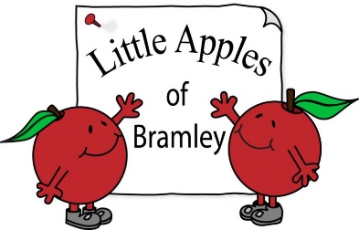
explore engage enjoy excite
Registered Charity No. 1045353
Tel: 07598 588460
Little Apples – Uniform Order Form (Uniform is optional)
Name
 | Quantity required |  |  | Total
 | Age 2 | Age 3-4 | Age 5-6 | £
Zip-through fleece
£13.00
Polo Shirt  £7.00 |  |  |  | £

Total order cost |  | £

Payment may be made by
Cheque: payable to Little Apples of Bramley
Cash: in a named envelope please
BACS: Sort Code 09-01-55
Account Number 93272080
Reference ‘Child’s name, uniform’
For Little Apples use | Payment received |  | Order provided

