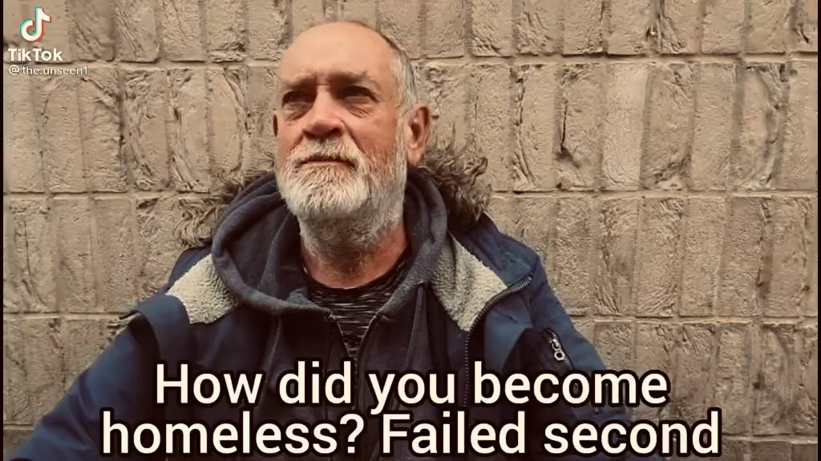

PLEASE CLICK ABOVE FOR VIDEO INSPIRATION
A scruff man in his 40s - but looks 10 years older than that – wearing a worn t shirt and hoodie sits facing the camera. He looks tired, hard lived and sympathetically troubled.
INTERVIEWER
How did you become homeless?
HOMELESS MAN
Failed marriage, depression, too much drinking.
(beat)
We got divorced, sold the house, and made a nice little profit but she got most of it. After the lawyers I didn’t have much left. My depression got worse, and my drinking got out of control. And, err, I lost my job.
INTERVIEWER
What do you miss the most?
HOMELESS MAN
companionship.

He starts to become teary eyed. He tries so hard to fight back the tears.

HOMELESS MAN
I hate being alone all the time.
INTERVIEWER
What have you learned from being in your position?
HOMELESS MAN
Treat people with respect. That’s important. Cos you’ll get respect back, you see.
INTERVIEWER
If you could do anything differently, what would you do?
HOMELESS MAN
Never drink alcohol.
INTERVIEWER
So, you have a job interview, right?
HOMELESS MAN
that’s right. I’m quite nervous.
INTERVIEWER
Well, let’s get you ready.

we morph into a montage of the homeless man having a haircut, his beard trimmed and being cleaned up with carter products.
We cut to the homeless man returning to sit on the stool to face the camera. This time he’s a new man – wearing a suit and looking highly presentable and 10 years younger.

INTERVIEWER
How do you feel?

HOMELESS MAN
(teary eyed)
I feel extraordinary. Thank you.

INTERVIEWER
Here’s to a second chance.

HOMELESS MAN
Yes, sir.

