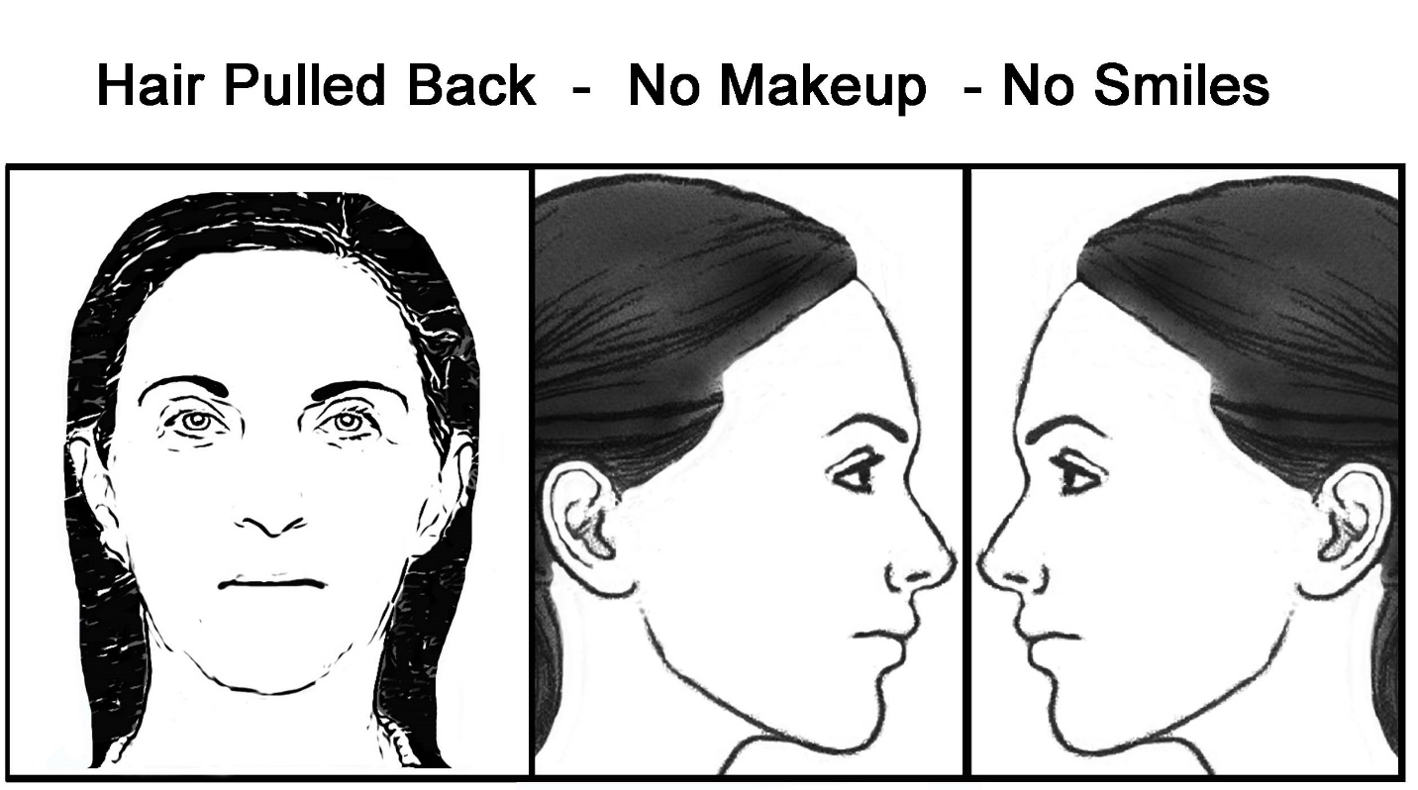
Here are examples of the selfies we are looking for.

