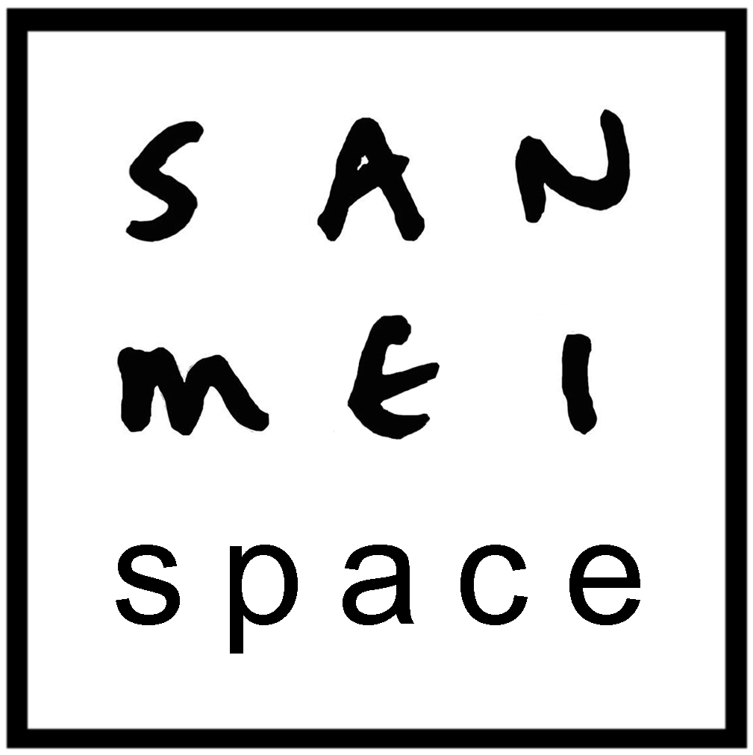

Space Hire terms and Conditions

Hirers are required to pay £200.00 as a security deposit at the point of booking. This deposit will be returned within 5 working days after the hire provided that there are no losses or damages to the hire space

The full hire fee must be paid 4 weeks before the hire date unless otherwise agreed with San Mei Space

In the event of the hirer cancelling up to 15 days before the event, San Mei will make refund the hire fee but retain the security deposit. If the event is cancelled within 14 days of the agreed date San Mei will retain the full hire fee

In the unlikely event that San Mei need to cancel the booking the security deposit and any hire fee paid will be returned in full to the hirer

The hirer must provide San Mei with details of the event and activities taking place within the hire time, an estimate of the number of people attending and information about any additional equipment being used.

Hirers will need to sign the Space Hire Agreement form and return this to San Mei within four weeks of the hire date

The Gallery is to be locked and secure when left unattended

Set up and clean up for events and usage must take part within the agreed hire times

Hirers are expected to leave the space in the state they found it in. If additional cleaning is necessary the cost of this will be taken out of the security deposit.

Hirers must consider the use or protection of the grand piano in the space. Nothing may be placed on the piano.

San Mei Space is in the same building as an education office, and café with residential flats above. For this reason, space hirers must take into account the requirement for minimal disruption

San Mei Space is not responsible for any damages or other costs arising out of or in connection with any damage to any property or any injury caused to any person caused by Hirer’s use of the Space. We recommend that Hirers arrange their own public liability insurance to cover the event.

