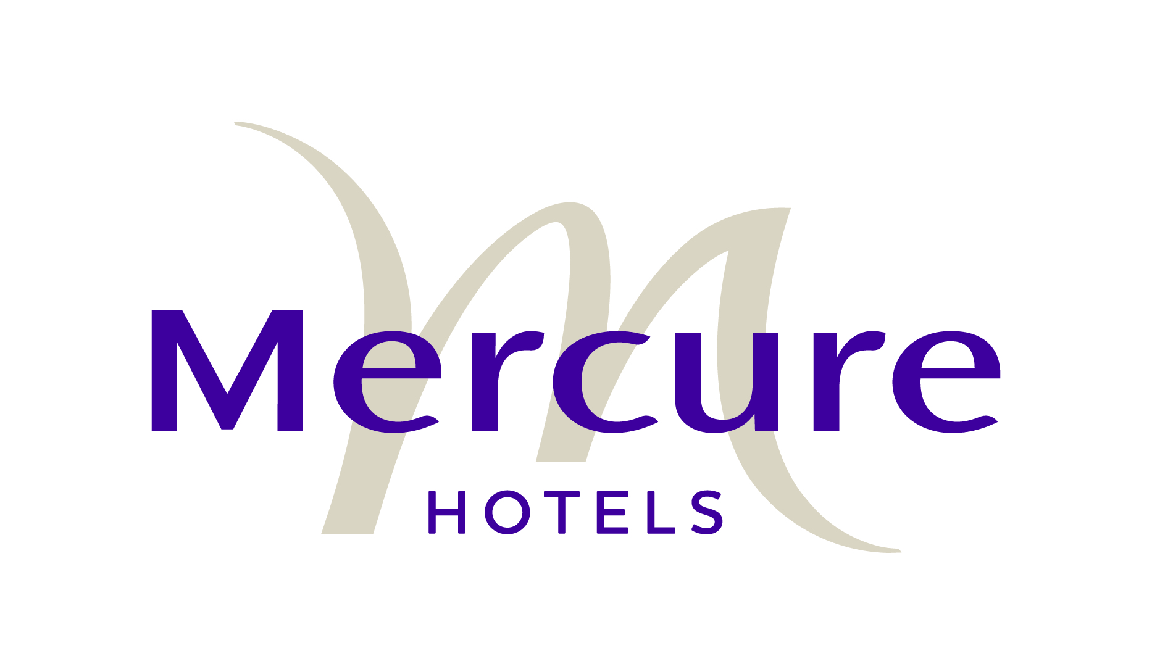

NOTTINGHAM CITY CENTRE

Standard Contract for Meetings and Conferences

CONTRACT TERMS AND CONDITIONS

Definitions
- Reservation – the written request from the Customer for facilities, which Mercure Nottingham City Centre accepts upon these conditions
- Mercure Nottingham City Centre – Mercure Nottingham City Centre, part of London Town Hotels, trading as Mercure Nottingham City Centre and its employees
- Customer – The individual, company or other body contracting to hire facilities at Mercure Nottingham City Centre
- Hotel – The Hotel and premises known as Mercure Nottingham City Centre
- Event– The event in respect of which the Customer has made a booking

Signing of the Event Contract
- Please review the Event Contract carefully. Sign and return all pages to Mercure Nottingham City Centre by return
- Mercure Nottingham City Centre reserves the right to release any event space or bedrooms being held if this agreement is not returned within 7 days of despatch
- The event space and bedrooms is not considered as a confirmed reservation until the signed Event Contract is returned to the Hotel
- The event space and bedroom accommodation offered in this contract is for the exclusive use of the Customer and its affiliates and resale of such facilities is not permitted

Amendment of Contract
- The Event Contract is based on the Customer’s requirements at the time of confirmation by the Customer and will form part of the Event Contract
- Any request by the Customer wishing to amend part of the Event Contract must be made in writing
- Any additional requirements that the Customer wishes to add to the Event Contract must be confirmed in writing. The Hotel will issue the Customer an amendment to contract, which will form a part of the Event Contract.
- Upon signature of the Event Contract, any request by the Client to amend part of the Event Contract thus reducing the agreed minimum guaranteed contracted revenue by means of reducing minimum number of guests and/or accommodation and/or minimum catering price and/or access and vacate times, the Hotel reserves the right to amend the Event Contract and its prices to compensate against loss of revenue incurred from the original Event Contract

Terms of Payment
- Unless otherwise agreed all events are to be pre-paid in full or valid credit card details to be provided.
- Cheques are to be made payable to Mercure Nottingham City Centre and must be received no later than 7 days prior to the start of the event
- BACS details are available on request

Schedule of Payment
- An amount equal to 10% of the total event revenue is due upon signature of the Event Contract
- An amount equal to 40% of the total event revenue is due 90 days prior to the event date
- Payment of the final 50% of the total event revenue is due 30 days prior to the event date
- For all events confirmed 29 days or less prior to the event date are to be pre-paid in full upon signature of the contract
- Payment of any additional requirements that have been added as part of the Event Contract falls into the schedule here above mentioned.
- Mercure Nottingham City Centre reserve the right to charge the client interest on late payments at a compound rate of 2% for each month, or part month that the payment is overdue
- If the Customer is likely to incur additional charges on the day(s) of the event such charges must be paid by a pre-authorised credit card prior to departure. Details of any such card must be supplied to the Hotel a minimum of 7 days prior to the event by completing a ‘Credit Card Details Form’
- All amounts invoiced must be settled within 30 days of event departure. Failure to do so will result in interest charges being applied at a rate of 2%
- All questions relating to the final invoice should be addressed to the Conference Manager at the Hotel within 14 days of the event departure date

Room Set Up
- The Customer agrees that the Setup of each contracted meeting space is as described in the Event Contract. Should the Client ask to make amendments to the set up whilst on site and deemed by the Hotel as being extensive, an additional charge will be applicable according to the needs of the Hotel to bring additional manpower to meet the Customer’s demand

Minimum Guaranteed Revenue & Numbers
- Minimum guaranteed revenue and numbers are agreed at the time of contracting and will form part of this Event Contract
- In the case of a significant reduction in guaranteed minimum revenue or minimum numbers the Hotel reserves the right to change the event space allocated

Banqueting
- Minimum food and beverage spend will be agreed at the time of contracting and will form part of the final Event Contract
- Reduction in the minimum food and beverage spend may result in additional room hire charges being applied equal to the value of the reduced food and beverage spend
- Minimum catering numbers must be received at the Hotel no later than 14 days prior to the event. This number may be increased up to 48 hours prior to the event subject to the capacity of the event space contracted or alternative space being available
- All special dietary requirements must be received at the Hotel no later than 3 working days prior to the event. No additional charges will be incurred for such meals and these will be charged at the agreed menu price per person
- If notification of special dietary requirements i.e. kosher, vegetarian etc is received less than 2 days prior to the event an additional charge of 50% of the agreed menu price will be charged for each meal provided
- No food or drink is to be brought into the Hotel without prior agreement and additional charges may be applied where consent is given

Accommodation Contracted & Guaranteed

- Hotel check-in time is after 2:00pm on the day of arrival.
- Check out time is before 12:00noon on day of departure, check out after this time will incur additional charges
- All individual reservations must be guaranteed by a valid credit card holder or full pre-payment deposit of the accommodation charges
- Rooming lists must be received at the Hotel no later than 14 working days prior to arrival
- If for any reason any accommodation is not available at the Hotel, Mercure Nottingham City Centre will supply the Customer and their clients with alternative accommodation. That accommodation will be of equal or superior quality and at the same agreed rate. Customer shall be bound to accept such alternative accommodation without affecting the terms of this agreement. The Customer shall not be entitled to bring any claim on its behalf or on behalf of its clients
- The above number of rooms is provisionally reserved. If the signed contract has not been received within seven days of despatch the accommodation will be released
- If additional rooms are required above the offered number, these will be subject to availability of the room and rate
- All ‘ no- shows’ or non-arrivals will be charged at the full contracted rate

Guests paying own account
- If the Customer supplies rooming list, payment details are to include detailed instructions as above covering full name & credit card information for each individual who is responsible for settling the room & incidental charges. All guests must present a credit card on check- in /registration. Without credit card information all miscellaneous services cannot be provided – (telephone /mini-bar/Food & beverage). If a credit card is not presented then the contracted room rate for the full stay must be pre-paid
- All individual charges must be settled prior to departure
- The Hotel reserves the right to debit a credit card given as a guarantee if the client fails to pay on departure

Reservations & Payment
- All bookings must be guaranteed by individual credit card or advance deposit. Any reservation cancelled within 72 hours prior to arrival or no shows will forfeit one night’s room charge.
- The individual guests are responsible for their accommodation and any related extra charges. Every reservation must be guaranteed by the individuals’ credit card at time of booking or prepayment (cash/cheque). The following information is required: Credit card holders full name, credit card number & expiry date, issue number where applicable, billing instructions and guest name if different from the credit card holder. A debit form will also need to be signed by the credit card holder

Cancellation
- In the event that the Customer has to cancel all or part of the event, cancellation charges will apply
- Total event revenue includes accommodation charges and all other charges related to the event
- Cancellation of all or part of any event and accommodation must be received by the Hotel in writing

Meeting Space
4 week prior to the event date -No Charge
Less than 4 week prior to the event date -100% of the total event revenue

Cancellation of Guaranteed Accommodation
- If the Customer cancels any booking or part of a booking at any time or if this agreement is terminated for any reason, the Customer shall promptly pay the following cancellation fees:

4 week prior to the event date -No Charge
Less than 4 week prior to the event date -100% of the total event revenue

Advertising
- The Customer shall not use the Hotel’s name or trademarks without it’s prior written permission and all material bearing such Hotel information must be approved in writing by the Hotel prior to publication. This includes the use of any material on the Internet
- The Customer undertakes to dismantle and remove all signs and advertisements erected and affixed by the client in or about the Hotel at the close of the event making good all damages caused as the Hotel may consider necessary
- Use of Hotel facilities by the Client, their Servants/Contractors
- The Customer and persons acting on their behalf and attending the event shall:
    - Not act in a disorderly manner, arrive and leave promptly at the appropriate times as detailed in the Event Contract and obey any reasonable requests from employees of the Hotel
    - Not bring live animals into the Hotel without prior written consent
    - Adhere to all noise abatement requirements when entering and leaving the Hotel
    - Use access doors and lifts as indicated by employees of the Hotel
    - Not carry out any electrical or other works at the Hotel, including the installation of audio visual equipment without the Hotel’s prior consent
    - Comply with all licensing laws and other regulations relating to the Hotel
    - Not affix any materials of any kind to walls, doors or the fabric of the Hotel
    - Not use any public areas of the Hotel for the display of promotional literature or signage without the Hotel’s prior approval
    - Be aware that any damage to the fabric of the Hotel, including carpets and walls will be charged at the full replacement value where such damage is caused by the Customers guests, its’ agents and servants.
    - Ensure that all people entering the Hotel in relation to the event are suitably attired
    - Comply with all Hotel requests to exclude any persons from the event whom it deems to be unacceptable to enter the Hotel, including any entertainers and contractors
    - Not arrange for the delivery of, or deliver any goods or materials to the Hotel unless servants or agents of the clients are available and ready to accept delivery thereof
    - Not to make any alterations to the premises or to remove any of the Hotels furniture or fixtures
- Whilst Mercure has taken all reasonable steps to ensure that the information contained in its brochures, leaflets and advertisements is accurate, it reserves the right to alter, substitute or withdraw any services, facilities or amenities, without notice.

Health and Safety
- The Customer will at all times clear and remove all the rubbish, refuse and other materials not belonging to the Hotel from the premises and the Hotel so that the premises are completely clean and tidy at the end of the event. Should the Hotel occur expenses as a result of clearing rubbish left by the Customer, such expenses will be recharged to the Customer.
- The Customer is responsible at all times for the safety and security of any items belonging to them and brought to the Hotel and the Hotel will not in any circumstances be liable to the client for any loss or damage to any such item howsoever arising
- The Customer is advised to consider arranging insurance for the Event, covering Public Liability and Loss or Damage to its property and that of any person attending the event
- The Customer will not store or place on the premises or in the Hotel any flammable, combustible or objectionable substance or liquid.
- The Hotel will be liable to the Customer and persons attending the event for injury to persons or loss or damage where and to the extent that the Hotel has been negligent but otherwise will be under no liability to the Customer whatsoever, however arising
- The Customer undertakes to comply with all statutory, local authority, and standards institutions regulations, standards provisions, requirements, codes of practice, recommendations and laws for the time being in force that are applicable to the use of the Hotel facilities as contracted by the Customer
- All event floor plans are to be received at the Hotel no later than 14 days prior to the event date. All such plans are subject to Hotel and where appropriate Local Authority approval
- The Hotel has the right to remove and dispose of any goods or articles remaining on the premises upon the expiry of the period without any liability whatsoever.
- Mercure Nottingham City Centre has dedicated security personnel at the Hotel 24 hours
- Clients are strongly advised to contract added security personnel to ensure the safeguard of valuable pieces of equipment being displayed by the company or any other parties during the event. The hotel security can provide recommendations for suitable security agencies to meet all requirements.

Termination
- Mercure Nottingham City Centre reserves the right to terminate this agreement:
    - If the Customer fails to pay monies when due to Mercure Nottingham City Centre as per the Schedule of Payment as referred in clause 16, 17, 18 and 19.
    - If the Customer is in breach of any of the provisions (including the Terms and Conditions) of this agreement;
    - If the Customer goes into liquidation or is placed under the management of a receiver, receiver and manager, or administrative receiver.

Force Majeure
- If Mercure Nottingham City Centre is prevented from carrying out it’s obligations to the Customer in relation to the contracted event by circumstance beyond it’s reasonable control including (without limitation) government intervention, strikes, labour disputes, accidents, acts of God, national or local disasters or war or any event causing the whole or a substantial part of the Hotel be closed to the public the Hotel will either
    - Substitute similar or comparable function space and accommodation or
    - Cancel the booking and refund all deposits and payments received and have no further liability to the Customer

English Law
- English Law will govern this agreement.

Name: | Title: | Date: Monday, 18 December 2017
Signed on behalf of Mercure Nottingham City Centre

Signed on behalf of:

Name: | Title: | Date:
Client Authorised Signature

