MANICOMIO
CITY

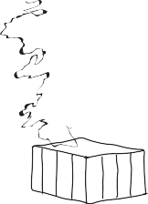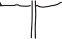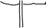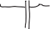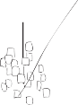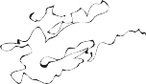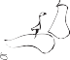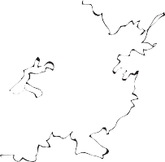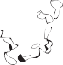

ANTIPASTI

Puntarella & Pear Salad
Honey, Pecorino & walnuts

Burrata Pugliese
Bresaola & baby artichokes

Seabass Carpaccio
Kholrabi, radish, blood orange & fennel oil

Char-grilled Cuttlefish
Brussel tops & nduja sausage

Salumi Board
Parma ham, capocollo, bresaola & carasau bread

Antipasti Board (for two people)
Selection of small antipasti

Celeriac & Kale Soup
Brumale truffle & Raschera cheese

9.95

10.50

10.50

10.95

10.50

19.50

8.75

PASTA | Portland Brown Crab Linguine  Tomato, chilli & majoram | 26.75
 | Tuscan Sausage Tortelloni | 17.50
 | Wild fennel, guianciale & tomato
 | Aylebury Duck Strozzapreti | 17.75
 | Marsla, juniper & sage
 | Pumpkin Gnocchi | 16.50
 | Cavolo nero pesto & gorgonzola
 | Clam & Mussel Tagliolini  Zucchini, garlic, basil & chilli | 18.50

The Wilderness Foundation
We are proud supporters of this charity and its valuable work in the plight of the African rhino and elephant. We hope you will join us in supporting this cause by means of accepting the voluntary £1 which will appear on your bill.
However, if you are not in favour please do let us know and we will remove it

CARNE E PESCE

Steamed Skrei Cod
Jerusalem artichokes, agritti & 'bagnacauda'

Char-Grilled Calves Liver
Heritage squash, pancetta & Tropea onions

Black Atlantic Tiger Prawns
Borlotti beans, tomato, chilli & garlic

Salt Marsh Lamb Shoulder
Smoked aubergine, sesame & burnt king cabbage

Grilled Cornish Monkfish
Cockles, black rice, garlic, morbido & chilli

Organic Rhug Estate Chicken Tagliata
Chard, chilli, garlic & lemon

24.75

25.50

26.75

26.50

29.75

24.50

CONTORNI
Misticanza, chilli & garlic

Borlotti beans
4.50

5.50
Rocket and parmesan salad

Rosemary new potatoes
4.75

4.50

DOLCI
Rum Baba
Tropical fruit tartare &passion fruit & mango cream

Rhubarb & GingerTart
Rose & pink prosecco

Banana & Chocolate Millefoglia
Tonka bean anglaise & chestnut brownie

Salted Caramel Tart Tatin
Vanilla ice cream

Tiramisu
Mascarpone Marsala cream, coffee & Savoyardi

Artisan Italian Cheese Board
8.50

8.00

8.50

7.75

7.50

10.50

Please be aware that some dishes may contain traces of nuts or other allergens. Cover charge £1.50 and optional service charge of 12.5% will be added to your bill

