
Catering Options

We can provide almost any catering that you require. Please contact Sarah with your requirements.

Typical catering options are as follows:
Complimentary arrival refreshments with all bookings*

Breakfast Options:
Cake and fruit or Bacon/Sausage/Veggie rolls (or alternative) £3 per head

Mid-Morning:
Refreshments and Biscuits ** £1 per serving

Lunchtime:
Refreshments +
Option 1 : Sandwiches and cake £6 per head
Option 2 : Light Buffet lunch of sandwiches, mini savouries and cake £9 per head
Option 3 : Buffet lunch of sandwiches, mini savouries, juice and cake £12 per head

Mid-afternoon:
Refreshments and biscuits (+ Cake for Option 3) £1 per serving
Refreshments comprise:
Tea
Coffee/decaf
Fruit tea
Biscuits
£1 per serving

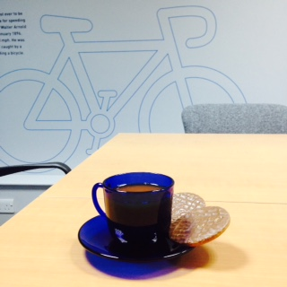

*bookings outside of 9-5.30 may not include complimentary refreshments
**refreshments can be served at any time the above is for typical requirements
all prices are ex VAT

