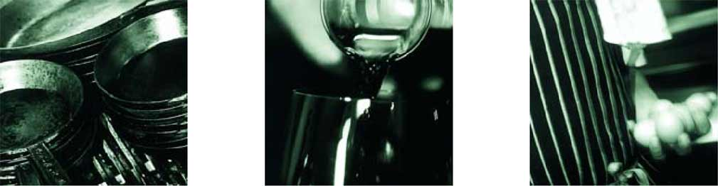
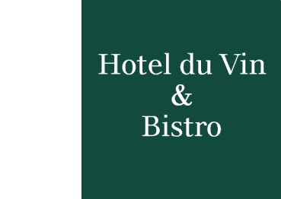
Information on Hotel du Vin Bristol

Accommodation
The hotel features 40 individually styled bedrooms, including several stunning double-height loft suites. The best accommodation rates can be found on the hotel’s website at www.hotelduvin.com.

Car parking
There are 8 spaces in front of the hotel which are complimentary but are offered on a first come first served basis. If these are not available then the nearest car park is the NCP on Rupert Street. The hotel offers a 25% discount on the published rates of this car park. Simply bring your parking ticket to the Reception Desk for validation.

Directions to the Hotel du Vin Bristol

Leave the M4 motorway at Junction 19 taking the M32 into Central Bristol. At the end of the M32, follow signs to the city centre proceeding past Broadmead shopping centre located on the left of St James Barton roundabout. After approximately 400 yards, you will see Rupert Street NCP car park on your right hand side, As you pass the NCP, the hotel is situated on the opposite side of the carriageway. Follow the road to the traffic lights at the war memorial keeping in the right hand lane. Turn right, around the memorial, onto the opposite side of the carriageway you have just driven on and be sure to move into the left hand lane. After approximately 200 yards, you will approach a pedestrian crossing. Hotel du Vin & Bistro is visible here from the main road on Narrow Lewins Mead a small side road directly on your left.

Hotel du Vin & Bistro
The Sugar House, Narrow Lewins Mead, Bristol, BS1 2NU
Tel: 0117 9255577
Web: www.hotelduvin.com

