Hands-up pupil travel survey

Date:
Class:
Number of pupils normally in class:
Number of pupils surveyed today:

Please complete the table below by asking your class the two questions in the table. Pupils can make only one choice for each question.

You can print out and use the travel mode flash cards (see p2-4) for your hands-up survey. You can either hold up the cards in turn and ask pupils to raise their hands when they see the one that shows the mode of transport they use, or stick the flash cards along a wall in your classroom and ask pupils to stand by the one that shows how they travel/would like to travel.

Staff must ensure that Q1 is completed accurately as this is important for our School Travel Plan. If pupils find it difficult to make a choice for Q2 then do not complete this column.

Type of Travel | Q1. How do you most often travel to school?  Enter the total number pupils for each travel mode | Q2. How would you like to travel to school?  Enter the total number pupils for each travel mode
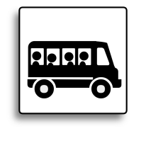
By school bus/ taxi

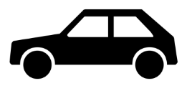
By car parent/ carer drop-off

On foot
(either independently or with an adult)
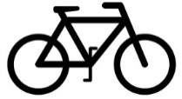
By bike
By public bus (either with an adult or independently)
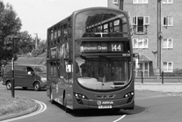
On the underground, train or tram (either with an adult or independently)
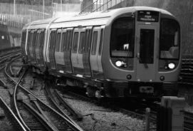

By school bus or taxi

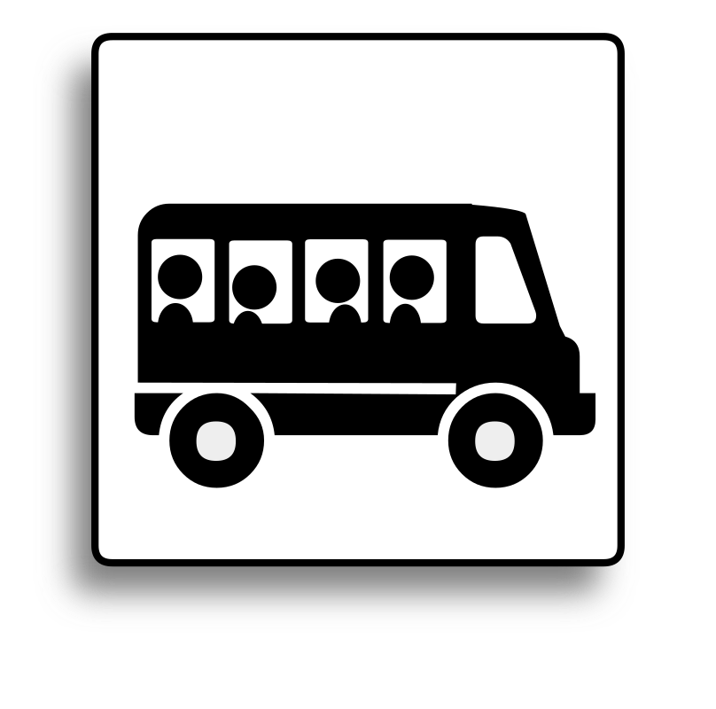

By car

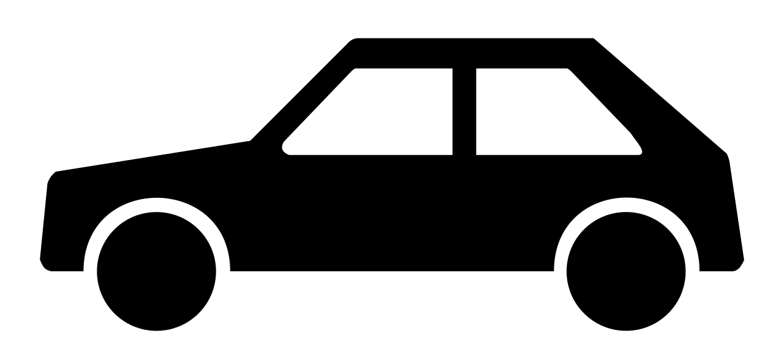

On foot

By bike

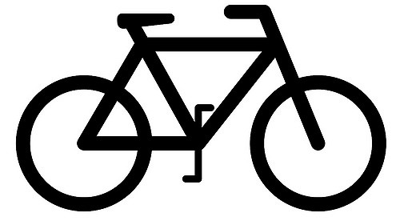

By public bus

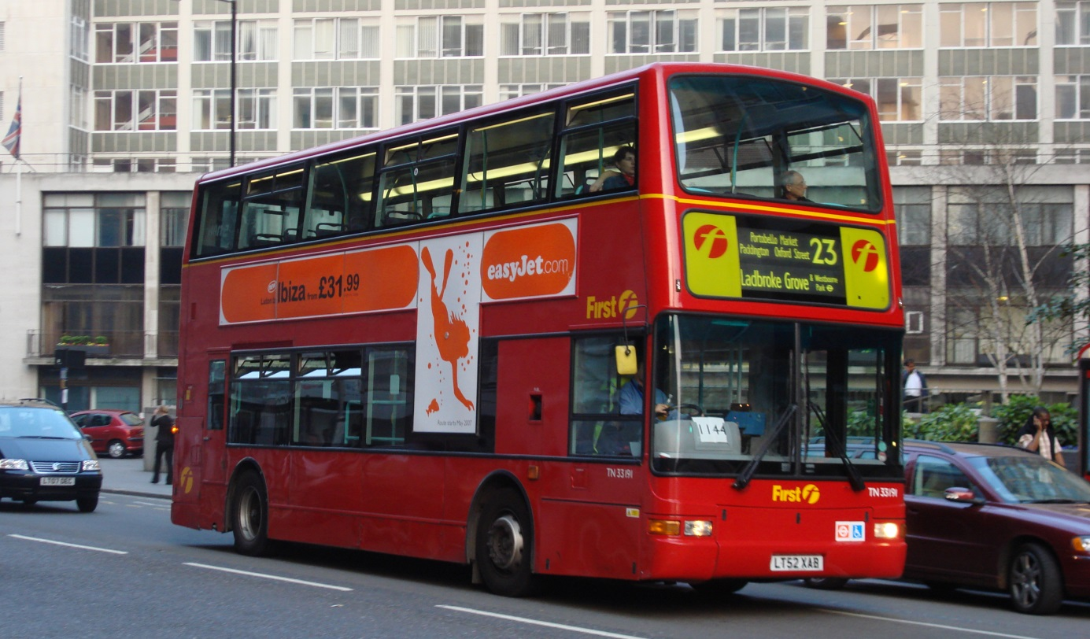

On the underground, train or tram

