WELCOME GUIDE
* Please read the instructions carefully before using the product and keep the user manual in a safe place for future reference.
EasyCut 2 | OCL-233N
SAFETY PRECAUTIONS 安全操作
When using this product, basic precautions should always be followed, including the following:

Danger
1. This product and its accessories are not toys. Please put them out of the reach of children to avoid danger.
2. Do not use wet hands to plug in or unplug the power cord. Keep the power cord away from sticky substances or other liquids.
3. Make sure to keep the hair clipper's body, adapter, and power cord dry. Do not use it in the bathroom.
4. Do not use the hair clipper when its power cord or adapter is damaged or when the connection between it and the electric outlet is loose.

Warning
1. Keep the appliance dry.
2. Do not rinse the hair clipper with water.
3. Before connecting the power cord and charging, make sure that the voltage marked on the body of this product matches the local power supply voltage.
4. If the power cord is damaged or lost, please purchase the original model from the manufacturer or after-sales maintenance department for replacement.
5. It is recommended to charge, use, and store this appliance at temperatures between 5℃ to 35℃.
6. If any abnormality or malfunction is found, stop using it immediately. Please deal with the problem according to the type of malfunction and if necessary, take it to the maintenance department of our company for repair.
7. Do not use broken or damaged trimming comb.
8. Do not disassemble the hair clipper's body for battery replacement.
9. Do not immerse this product in water or any liquid.
10. Do not knock down or drop this product. If it is damaged due to collision or fall, please stop using it.
11. This appliance is not intended for use by persons (including children) with reduced physical, sensory or mental capabilities, or lack of experience and knowledge, unless they have been given supervision or instruction concerning use of the appliance by a person responsible for their safety.
12. Please do not use it on animals.
13. Before taking out the battery, the motor must be turned off.
14. Cleaning and user maintenance shall not be made by children without supervision.
15. Children should be supervised to ensure that they do not play with the appliance.
16. When charging, make sure to use a charger of 5V⎓2A.
17. Do not charge this clipper for extended periods of time while leaving it unattended, and do not charge it longer than 24 hours.
18. This appliance contains a built-in lithium-ion battery. Do not disassemble, impact, crush, or throw the battery into fire. Stop using the product if the battery is severely swollen.
19. Be aware of the risk of terminals of the battery-operated appliance on battery being short circuited by metal objects.
20. Before charging, make sure that the clipper body, especially the charging ports, are dry.
21. Before removing the battery, make sure the battery is depleted.You can make the clipper work until it stops automatically to drain the battery.

PACKAGE CONTENT 包装内容
Hair Clipper *1
Guide Combs *6
Lubricant Oil *1
Charging Cable *1
Cleaning Brush *1
Welcome Guide *1

PRODUCT OVERVIEW 产品图解
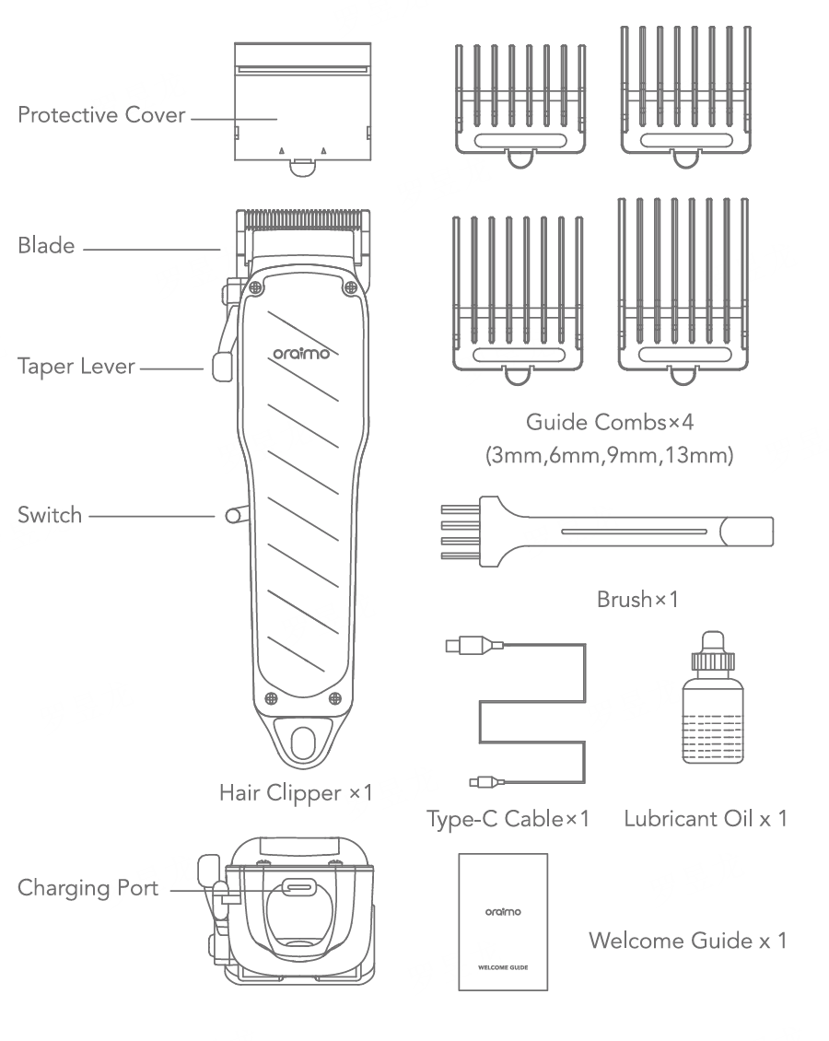限位梳改为6个 带不锈钢弹片和铝合金铭牌
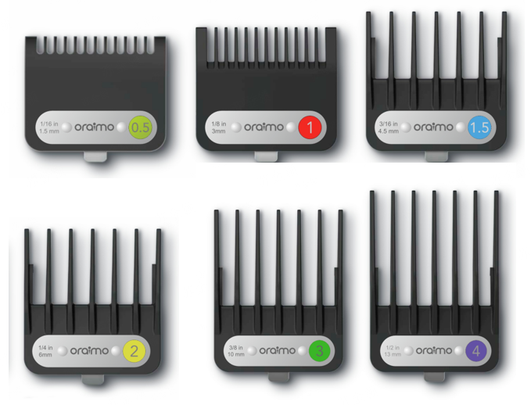

BASIC PRODUCT SPECIFICATIONS 参数
Model: OCL-233N
Product Material: ABS
Blade Material: Stainless Steel
Rated Input : 5V⎓2A
Charging Time: 2 Hours
Working Time: Up to 2.5 Hours
*oraimo Lab test results

USAGE INSTRUCTIONS 使用指引
When cutting hair, take off the blade protective cover, push on the switch and then move the blade head slowly against the direction of hair growth, and move in a straight and circuitous way.

Adjustable to Zero Gap
The taper lever can help customize your haircut, and adjust the cutting length between the guide
comb lengths.
1. Move the taper lever up for the shorter cut, and down for a longer cut.
2. Move the taper lever up and down several times if your blades are jammed with hair.
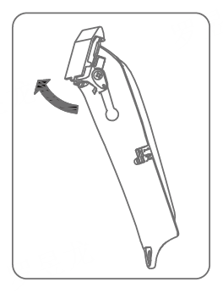

Charging the Clipper
1. To charge the product, please connect one end of the Type-C charging cable to the Type-C port at the bottom of the product, and the other end into a charger, and then plug the charger into a power socket
2. Connect the power supply, and the display light turns red, which indicates the charging status.
3. A full charge takes 3.5 hours, when the red light turns green, the product is fully charged.
4. The clipper can be used for up to 2.5 hours when fully charged. When the battery level falls below 20%, the indicator light will turn solid red.

DISPOSAL OF THE RECHARGEABLE BATTERY
Danger
1. The rechargeable battery is exclusively for use with this clipper. Do not use the battery with other products.
2. Do not charge the battery after it has been removed from the product.
3. Do not throw the battery into fire or expose it to heat.
4. Do not hit, disassemble, modify, or puncture the battery with a nail.
5. Do not let the positive and negative terminals of the battery come into contact with each other through metallic objects.
6. Do not carry or store the battery together with metallic jewelry, such as necklaces or hairpins.
7. Do not charge, use, or leave the battery where it will be exposed to high temperatures, such as under direct sunlight or near other sources of heat.

Warning
1. After removing the rechargeable battery, do not keep it within reachof
children and infants.
2. The battery may be harmful if accidentally swallowed. If this happens,
consult a physician immediately.
3. If battery fluid leaks out, follow the steps below.
4. Do not touch the battery with your bare hands.
5. The battery fluid may cause blindness if it comes into contact with your eyes.
6. Do not rub your eyes. Wash immediately with clean water and consult a physician.
7. Battery fluid may cause inflammation or injury if it comes into contact with the skin or clothing.
8. Wash it off thoroughly with clean water and consult a physician.

ENVIRONMENTAL PROTECTION
To protect the environment and promote material recycling, please dispose of the built-in lithium-ion battery at an official collection point, if available in your country.

MAINTENANCE 维护与保养
1. Be sure to disconnect the power supply and shut down the product before cleaning, take out the attached comb (if the comb was used), and gently brush the remaining hair on the blade with the provided cleaning brush.
2. After cleaning, to obtain a better effect on the blade, if necessary, drop a drop of lubricating oil on the top left, middle and right of the blade head, and switch on the clipper several times. Wipe the surface of the outer blade head, to keep it sharp, rotate it lightly and prevent abrasion.
3. When the clipper is not in use, put the protective cover on the blade to prevent damage to the blade.

CUSTOMER SERVICE
【用模版】

