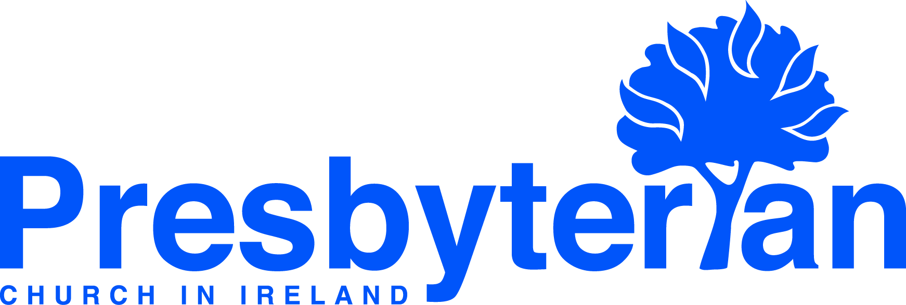
Let’s Pray | Sun 2 - Sat 8 August 2026
Sunday 2 August
- Moderator | Give thanks for the Moderator’s overseas tour to Zimbabwe, for the many events and engagements that took place and for his
safe return home. Pray that the trip will have enhanced and strengthened PCI’s connection with the church in that country.
- Resting in God | ‘Return to your rest, my soul, for the LORD has been good to you.’ Psalm 116:7. Thank God for his provision and protection
and ask that you might find fresh faith to rest in him in worship today.

Monday 3 August
- Naomi Keefe (global mission workers, Brazil) | Continue to pray for the Reading in the Park, Good News Club and Coffee with God activities, especially that God’s Spirit would write the truth of His Word on the hearts of many who participate. Pray for Naomi currently on home assignment, that she would have a time of rest and refreshment, and also as she engages in a programme of deputation, sharing about what God is doing in Brazil.
- Christ the Saviour Presbyterian Church, Poland (CTS) | Give thanks for the opportunities and blessings of the recent children's and teen’s camps, praying that God would be working in the hearts of those who attended.
Tuesday 4 August
- Naas (Rev Mark Proctor) | Pray that the Naas congregation will be able to minister more effectively in the neighbouring town of Newbridge. A former Presbyterian congregation there closed in 1938. Please pray that there will be renewed Presbyterian witness in Newbridge once again before the centenary of that closure.
- Angela Hamilton (Community Outreach Worker, West Kirk) | Give thanks for connections made with families during the Holiday Bible Club. Pray that the gospel seeds sown will bear much fruit. As the church year approaches pray for new community initiatives being planned.
Wednesday 5 August
- Stephen and Angelina Cowan (global mission workers, Kenya) | Give thanks for the hard work and commitment of the GI Mission Exposure Team who experienced first-hand some of the challenges of life in mission. Pray for all the preparations currently well underway for the youth and children’s camps in August, especially for those travelling from Waringstown Presbyterian Church and the four leaders from Nairobi. Pray for the team as they work on the camp theme, games, crafts, printed T-shirts, and all the other arrangements.
- Thimar – LSESD, Lebanon | Pray for the work of Thimar – LSESD as it works alongside and strengthens the witness of the Church in the Arab World through inclusive education, community development, and church discipleship. Pray that this work would continue to thrive, that lives would be changed and communities transformed, even though much of it is being carried out in a time of war and crisis in the Middle East.
Thursday 6 August
- Prison Chaplaincy | Give thanks for Rev Rodney Cameron’s work as a part-time chaplain within Hydebank Wood. Pray that he may know God’s presence as he ministers in this context and that he and his chaplaincy colleagues would be encouraged, as they seek to be salt and light.
- Central Belfast (Rev David Dickinson) | Give thanks for the congregation of Central, which has journeyed through a season of significant transition in the past year. Pray for Rev David Dickinson as he ministers, as well as for the staff and leadership team, that this would be a season of rest, refreshment and reset before stepping into the Autumn with fresh vision, heart, expectation and kingdom advancement in Belfast.

Friday 7 August
- General Council | As Assembly Buildings staff, ministers and others return from annual leave, pray for the re-start of the General Council Committees, Task Groups and Panels and the preparatory work that will be ongoing over the coming weeks in anticipation of the new season.
- Training in Ministry | Ministry Students are in the middle of their summer assistantships in local congregations. Pray that this experience will shape them and their practice of ministry, that the congregations in which they serve will be blessed through them, and that they will also have time for holiday to re-charge for the next academic year.

Saturday 8 August
- Corkey House | Corkey House situated in the hills of Glencairn in Belfast is a Residential Home for older people. Pray for the residents, Manager - Lorraine Coggles and her staff team, may all who live and work in Corkey House know God's love and feel the presence of his peace.
- Public Affairs | Pray for young people who will be receiving exam results and are making decision about future studies at school or in further or higher education in the coming weeks. Pray that the advice they receive would be helpful and wise, and that in the midst of uncertainty they might know the sure and steadfast hope of Christ our Saviour.

