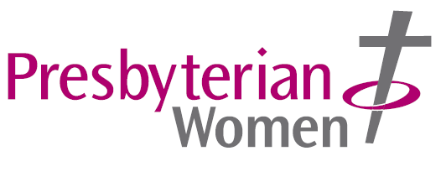
INSPIRE

Presbyterian Women, CCLW Office, Assembly Buildings, 2-10 Fisherwick Place, Belfast, BT1 6DW Tel: 028 9041 7257

Postal Subscription Rates

Inspire is the magazine of Presbyterian Women. It is published quarterly in March, June, September and December. The Annual Postal Subscription rates for 2025, inclusive of postage, are:
United Kingdom: £16.40
Europe (inc. Republic of Ireland) €31.80
Rest of the World £36.20

If you wish to take out a subscription for yourself, or as a gift for a friend, please complete the form below and send it to:
Presbyterian Women, CCLW Office, Assembly Buildings, 2-10 Fisherwick Place, Belfast, BT1 6DW

Payment can be made by cheque or bank transfer.
Danske Bank: Sort Code: 95-01-21 Sterling Account No: 61000675

Euro transfer: BIC: DABAGB2B IBAN: GB27 DABA 9501 2100 1768 18
Please make cheques payable to: Presbyterian Church in Ireland

Inspire can also be obtained in digital format. See issuu.com/presbyterianireland
-----------------------------------------------------------------------------------------------------------------

I wish to take out a postal subscription to Inspire magazine and

I enclose a cheque to the value of £/€ _______ to cover my subscription

I have paid by bank transfer – Date of transfer: ________ Bank Ref: ________

Name: ______________________________________________________

Address: ______________________________________________________

______________________________________________________

Post Code/Eircode: __________ Telephone No. (Daytime) ____________________

Email: ________________________________________________________________

Delivery address of magazine if different from above:

Name: ______________________________________________________

Address: ______________________________________________________

___________________________ Post Code/Eircode: __________

