LIGHT
There are two different ways that you can access the Light materials produced by Scripture Union.
1. The Red and Blue Compendiums
These spiral bound books are divided into three age groups for preschool and primary-school children.
They include two years’ worth of sessions for each age group, one blue and one red, with 52 lessons in each book. Seasonal sessions are also included. Photocopiable resource pages and extra resource downloads are available too.
Samples can be downloaded from:
https://content.scriptureunion.org.uk/.../bubbles...
https://content.scriptureunion.org.uk/.../splash...
https://content.scriptureunion.org.uk/.../xstream...
2. You can create your own curriculum
The Light resources from previous years can be downloaded for free. You simply have to create an account with Scripture Union and then you have access to all their online resources – including the Light materials.
All resources can be accessed at the Scripture Union online resource bank:
https://content.scriptureunion.org.uk/light-free-resources
This is particularly useful if you are looking to create your own syllabus that follows a sermon series or want to order them in a way that suits you.
More details of the resources and what is available can be found at
www.scriptureunion.org.uk
In terms of price and resources, this is a good choice. There is a lot more within the resources than you may need for a typical week, but the menu system allows you to pick according to the children you have and the time available.

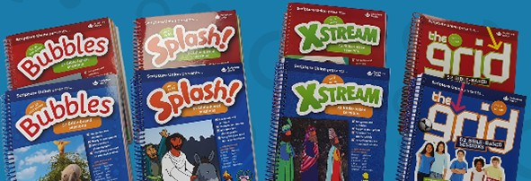

CLICK

The Click curriculum, from The Good Book Company, provides easy-to-use, Bible-centred teaching material for Sunday schools and kids’ clubs. Each session has a clear teaching point and imaginative and fun activities to support it.
There are two ways to access the materials for this resource:
1. A physical leader’s manual
This is comprehensive and easy to use, and includes a child’s component to take home. The resource covers three age groups across preschool and primary ages.
2. Through PDFs of the leader’s manual and other resources
For the same price as one physical copy, there is the option of downloading a manual electronically and sharing it with up to three leaders within your ministry organisation.
In terms of price and resources, this is a good choice. Like the Light material, there is more than enough material in this resource for a group and the key is to choose, from the menu system in each session, which activities work best for your group and the time that you have available.
More details of the resource and what is available can be found at https://www.thegoodbook.co.uk/series/click/

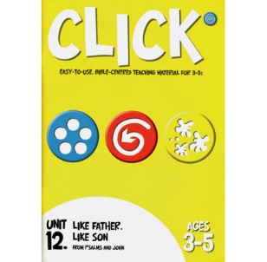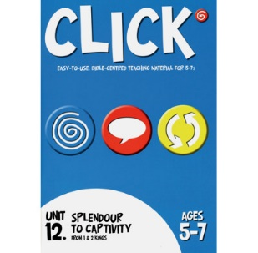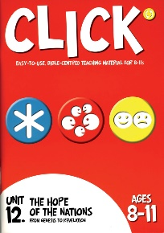
JESUS STORYBOOK BIBLE CURRICULUM
Based on the award-winning Jesus Storybook Bible, the Jesus Storybook Bible Curriculum Kit is great for children’s ministry use. Geared towards 4–7-year-olds, children will love the vivid illustrations and animated videos that bring to life Bible stories from both the Old and New Testament. They’ll learn that every story in the Bible points to Jesus — and what that means for them!
The Jesus Storybook Bible Curriculum features everything you need for nearly a year of lessons! The kit includes 44 individual lesson plans plus six review lessons (three Old Testament, three New Testament – available online) plus ideas for engaging activities, easy-to-use instructions and notes for teachers based on material from Timothy Keller, as well as memory verses, colour handouts, and more.
More details of the resources and what is available can be found at
https://www.sallylloyd-jones.com/.../jesu.../curriculum-kit/
This resource is really good, especially in terms of price, but is aimed at the younger age range. The physical version of this kit is difficult to get hold of, but the digital version is easily accessible and simple to use.

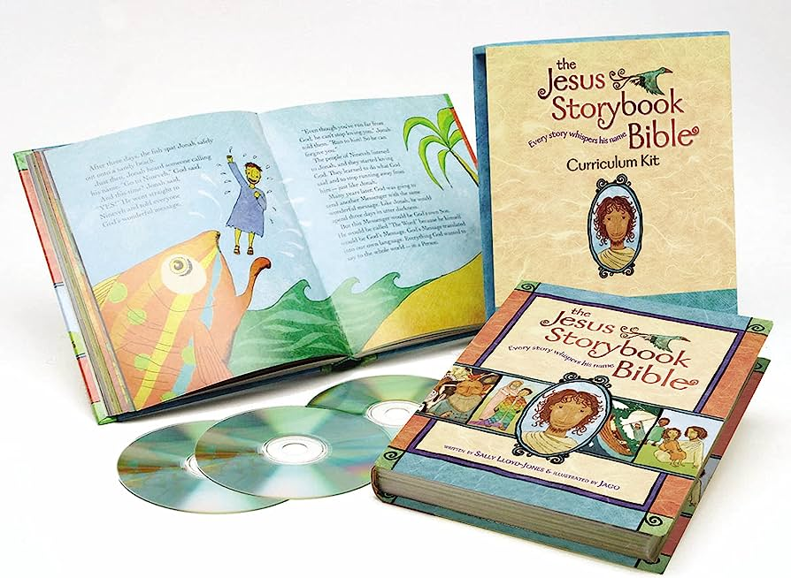

HEARTSHAPER CURRICULUM

HeartShaper Children’s Curriculum is published by David C. Cook, and is designed to help children in your Sunday school or activity club discover God through his Word. Each session will take your group through the Bible and its key themes, encouraging a life-long love of Scripture and helping children to see how God can shape their lives.
There are two primary-age editions, aimed at ages 5 to 11, which have 52 sessions each, with guided leader’s notes and reproducible activity pages. Each session’s leader’s guide comes with four clear steps to guide you (‘Focus in’, ‘Explore his Word’, ‘Make it real’, and ‘Live it out’) and are flexible enough to match the length of your session. The reproducible activity pages include special needs friendly resources to ensure every child is included and made to feel welcome.
There is also a pre-school age edition with 52 sessions.
More details of the resources and what is available can be found at https://www.heartshaper.co.uk/
This is an easy-to-use resource which connects with children as you seek to teach them the gospel. It is also a great price at under £100 for all three books.

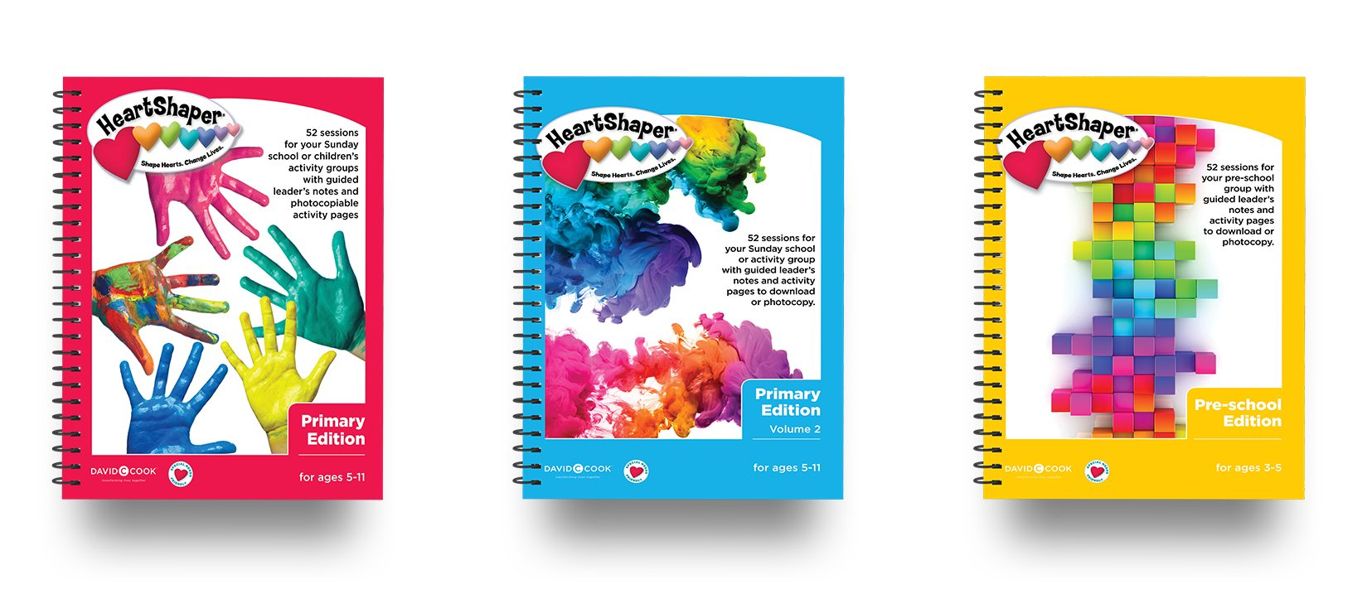

GO TEACH

Go Teach is used by many congregations in the Presbyterian Church.
The purpose stated by Go Teach is to glorify God by advancing the Christian faith through the production of Bible teaching material for use with children and young people.
The teaching material is based on a syllabus designed to teach fundamental Bible truth, give a basic framework of Bible history, teach the main events of the life and work of Christ and introduce the Bible's other main characters and events.
The Go Teach teaching programme is in a four-year-cycle.
Each issue contains lessons from the Old and New Testaments, as well as the Gospels. The Old Testament and Acts are taught chronologically, and the Gospels are covered in mainly chronological stages. All age ranges follow the same teaching topics, with one or two exceptions for the younger groups.
This is an easy-to-use resource for leaders as it can be read to the children and requires little preparation. The teaching material is ‘sound’, but the style of this resource means that it does not always help children learn how to be disciples. It will give a good head knowledge of the Bible and faith, but does not help to make disciples of the children who have a living vibrant relationship with their Saviour.
This resource is not recommended for congregations who are looking for something new.
More details can be found at https://goteach.org.uk/

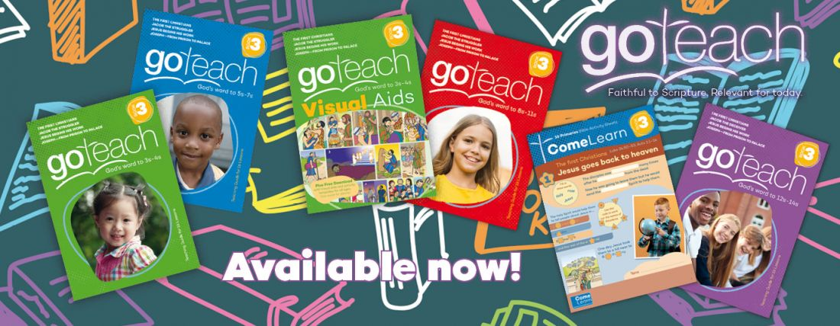

GOSPEL STORY FOR KIDS

The Gospel Story for Kids is published in the United States but is available to buy in the UK.
This curriculum is designed to span three years, with 156 lessons presenting key stories from Genesis to Revelation, each highlighting God’s plan of redemption in a way that’s engaging, interactive, and easy to understand. Each lesson teaches a Bible story, shares how it connects to the bigger picture of the gospel, and shows how Jesus ties into it.
This can be used throughout the different ages in children’s ministry. This curriculum helps children explore the same Bible stories at three different learning levels, presenting the material in a fresh way for each age group. It allows children to see the Bible through a lens of redemptive history and build on their knowledge each time they journey through the Bible. This also allows families to talk together about what the children learned that week in class.
Its main benefits are:
- It comes in PDF format with no limit on the number of handouts made.
- It’s reusable at the end of each three-year cycle.
- There is a menu for leaders to pick and choose the best activities for the children and time they have.
It is a great curriculum to teach kids the span of the Bible, pointing to Jesus. It is initially expensive, but the material will last for years and so over time is very good value.
For more information on the resource go to https://martymachowski.com/book/gospel-story-curriculum/

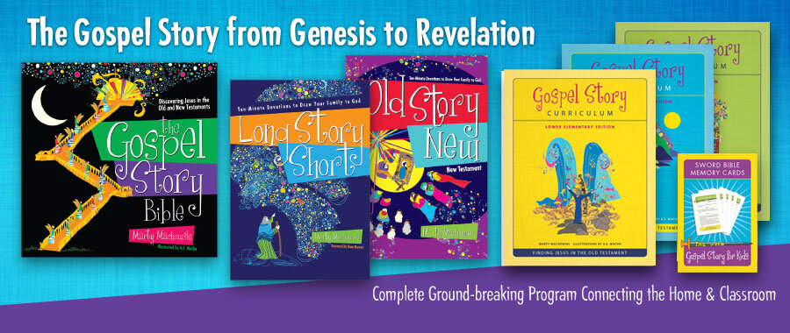

GOSPEL PROJECT FOR KIDS

The Gospel Project is a weekly Bible study that helps kids dive deep into the big story of the Bible – God’s plan to rescue his people through his Son, Jesus Christ.
Part of an all-age curriculum that can be used across all ages in the congregation, it focuses on helping children see how the whole Bible points to Jesus and the gospel. It has a chronological study plan that unites the big story and themes of Scripture. It focuses on discipleship taught through the Bible rather than learning about moral living. The pack includes art, videos, music and activities to keep kids engaged every week.
This curriculum is available as a printed or digital resource.
As well as the teaching material, there are videos and resources to enhance the teaching. There are also lots of training videos to help leaders with the development of the curriculum and how to teach and apply it to the different ages of children.
More details of the resources and what is available can be found at https://gospelproject.lifeway.com/kids/?link=homepage



252 BASICS

252 Basics is another comprehensive curriculum published in the US. It is produced by an organisation called Orange, which aims to create a community between churches and families in order to mobilise the next generation to love God and serve others.
The 252 Kids curriculum combines child development and theology to create a comprehensive children’s ministry programme and strategy.
The aims of the curriculum are:
- To disciple each child – child development and theology are combined to create a more engaging experience for primary-aged kids, inspire deeper faith and help each child apply God’s truth to their lives.
- Engage every parent – what happens at home is more important than what happens at church. The resource helps parents and guardians continue the faith conversation at home.
- Elevate your volunteers – volunteers are the most valuable resource to help children see and know God. Invest and develop your leaders and helpers each week with support and training.
Orange also produces a preschool curriculum called First Look which can be used to precede the 252 Basics materials.
As with some of the other curriculums, this may seem initially expensive, but the materials last over many years and so can become more cost effective. The curriculum contains a lot of resources, so careful consideration is needed of the best use of what is available.
More details of the resources and what is available can be found at https://thinkorange.com/252-kids-ministry-curriculum/

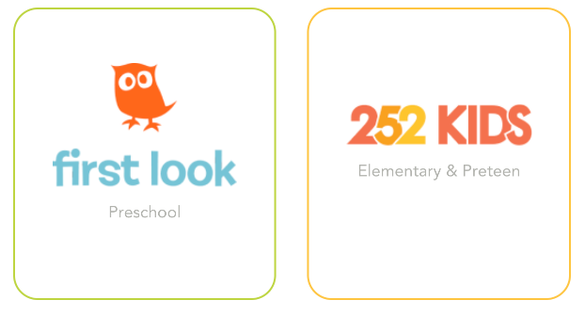

GOD'S STORY

God's Story is published by Bible Reading Fellowship in the UK.
Use as a year-long weekly programme or dip in and out to highlight individual stories at key times of year and supplement other activities. The varied storytelling methods enable children to engage with God's big story in different ways, and there are a range of activities to illustrate and explore the story. The resource caters for different learning preferences and play styles and uses materials that most children's groups will already have to hand.
Its main features are:
- 36 key stories from the Bible
- A year's user-friendly session plans
- A wide range of easily-sourced activities
- Differentiated learning styles
Extra resources are also available online.
This would be a great resource for a children's church or weekly kids’ club. The books are not expensive and so are very cost effective.

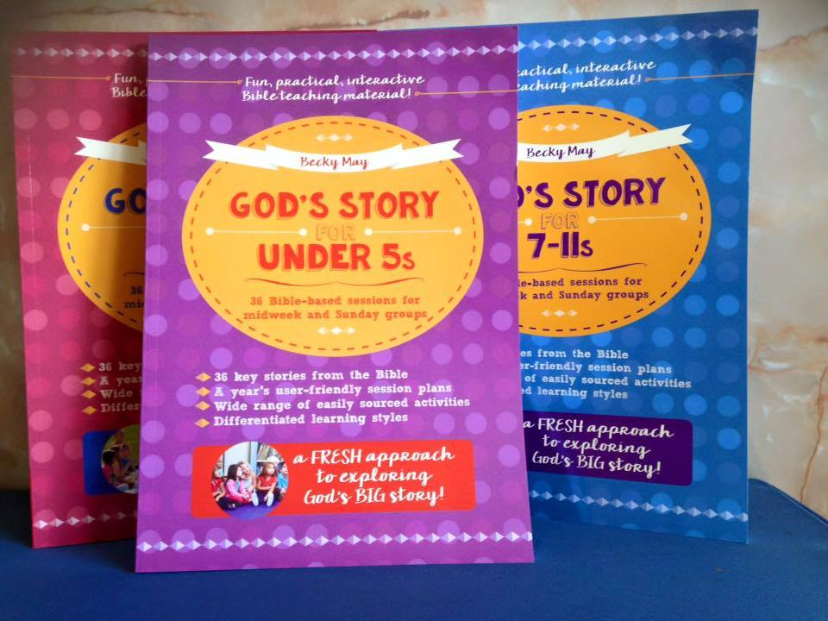

GENERATIONS OF GRACE

Generations of Grace helps Sunday school teachers and parents lead kids through the narrative of Scripture, from Genesis through to Revelation, outlining God’s redemptive plan.
Every week, children in each age range learn from the same passage of Scripture in a way that is appropriate for them. A unified curriculum enables families to discuss one passage together each week, reinforcing the lesson children have learned in Sunday school.
Each year the curriculum covers a different part of Scripture. Over the nine-year period a child spends in Sunday school, Generations of Grace will lead that child through God’s redemptive plan three times, each at a deeper level.
More details can be found at https://gracecurriculum.org/.../about-generations-of...
This curriculum again seems to be cost effective, though may require a larger than normal payment initially.

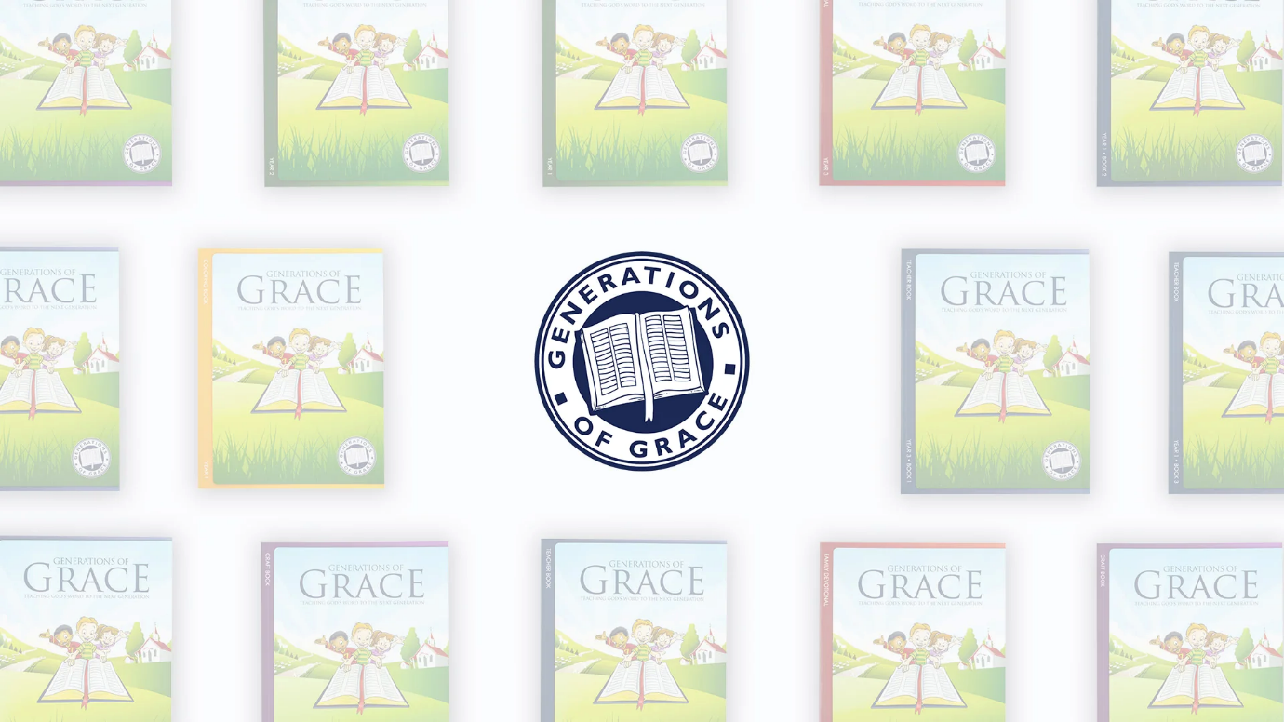

THE BIGGEST STORY

The Biggest Story is a new curriculum from Crossway Publishing, written by Kevin de Young.
The teaching resource books for this curriculum are beautifully designed and packaged. They come in a sturdy presentation box which will help to keep them in good condition as they are used over a series of years. The books are also available in PDF form. There are five books in the set.
The story each week is told using one of three formats: reading the text from the Bible passage; using The Biggest Story Bible Storybook; or through videos, which are free to download from your account on the website. The script of the video, which is the same as the passage from the storybook, is also printed on the back of the poster.
There are also separate activity and colouring books available to purchase. The individual pages in these books come as a free download from the website, along with other craft templates. You simply need to set up a free account. They match the illustrations in the rest of the resource.
The final part of this resource to highlight are the posters and verse cards. The posters could be displayed around the walls or set on a table. The verse cards could be given to each family to learn. Again, they match the beautiful illustrations for each part of the resource.
For more information on all the parts of The Biggest Story resource check out https://www.thebiggeststory.com/
All of the resources in this curriculum are available to purchase from The Good Book Company or from 10ofthose.com to save on US delivery charges. PCI’s children’s development officer also has the full resource, if anyone would like to see it before purchasing.



SIMPLY LOVED

Simply Loved is published by an American company called Group Publishing.
This resource aims to keep the programme simple for both children and leaders, to allow them to teach and learn the simple but incredible truth of how much God loves them through the story of the Bible.
Group say that this resource is:
- Simply for you
- Simply for volunteers
- Simply for kids
- Simply for families
Through Simply Loved, journey chronologically through the Bible, and discover friendship with Jesus throughout God’s story. Simply Loved features 12 quarters of all-new content. Each quarter explores the Old and New Testaments and is divided into three units, each with its own featured ‘Bible Memory Buddy’.
The resource is available in both physical and digital formats and so makes delivery to PCI congregations much easier.
More information and free lesson downloads are available at https://www.group.com/childre.../sunday-school/simply-loved/

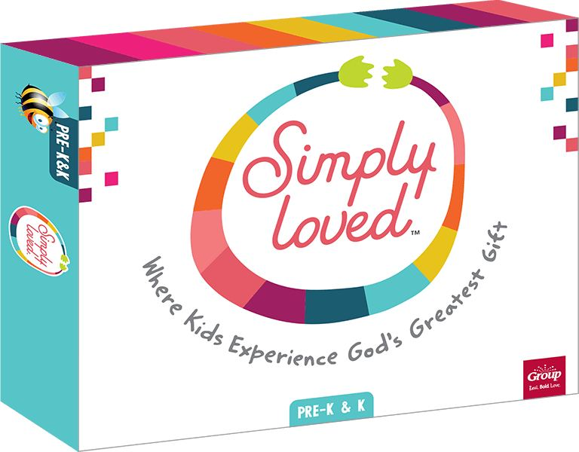

D6 EVERYDAY

D6 is an American curriculum and has resources for the whole church based on the passage from Deuteronomy 6 on sharing faith in many everyday situations.
D6 Everyday Foundations provides the very best small group and Sunday school Bible studies designed for all ages, with a particular emphasis on fostering family interaction and learning through shared biblical themes.
Their philosophy is based on the fact that out of 168 hours in a week, the average time a person is discipled is one hour (often from a Sunday sermon or small group at church). It is not enough, therefore, to rely only on the church for believers to grow strong in their faith. The church must equip the home to pass down faith to the next generation through everyday moments.
For more information and downloadable samples go to https://d6family.com/d6curriculum/

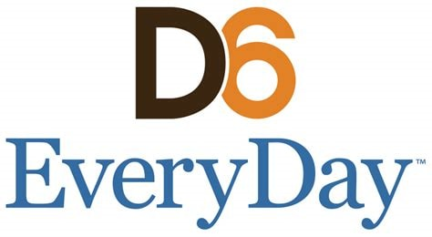

IMPACT/DETONATE/FUSION

Each of these books contains a year’s worth of teaching materials for 5–12-year-olds. They would be useful for Sunday schools, schools and camps, and they include a step-by-step curriculum guide, games, stories, and Bible lessons.
These books include practical information on those aspects that underpin successful children's work: publicity; good planning; use of leaders; pastoral care; and the logistics of running a programme.
Each book aims to help children hear the gospel and have an encounter with the living God.

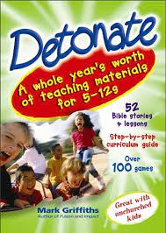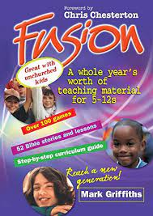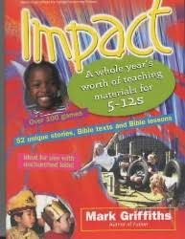

GROW CURRICULUM

Grow is a new curriculum which has options for preschool, primary and teenage ministry. The resources are available online and there is a free trial so that any leader can get a good sense of what the material contains.
The strategy of the resource focuses on six key elements to help the ministry with children grow:
- Discipleship
- Teaching
- Weekly programming
- Events
- Volunteers
- Parents
Each part of the resource gives ideas and guidance on each of these areas with videos, resources and editable programmes for the children’s ministry.
The resource seems very comprehensive. You can watch the introductory video from the co-creators at this link to get an idea of the thinking behind the curriculum: Stuff You Can Use | Helping Churches Grow
Each year you receive 12 months of material. There is also access to a free holiday Bible club resource each year and a free library of games which would be useful to use in any ministry context which can be accessed at the links below. These would even be useful to access without using any of the curriculum.
https://growcurriculum.org/free-vbs/
Grow Games (stuffyoucanuse.org)
The material is reasonably expensive, but there are a lot of resources available as part of the whole package and the philosophy behind the resource is very good.
To find out more and to access a free trial and resources go to freetrial.stuffyoucanuse.org



T5 RESOURCES

Tales That Tell the Truth is a series of storybooks from the Good Book Company, featuring beautiful illustrations and engaging Bible-storytelling which captures imaginations but always remains faithful and true to the biblical text. The resource comes in the form of board books for toddlers and storybooks for early primary-aged children. There are currently 15 T5 books available.
Alongside these books, The Good Book Company has produced visuals from the storybooks which can be used to tell the stories in children’s ministry or in an all-age service.
Each story also has a free children’s ministry lesson to go with it that caters for the whole scope of primary-age children.
There are also two multiple lesson books:
- A five-lesson resource based on The Garden, the Curtain and the Cross book, which could be used for a holiday Bible club, a children’s small group or a short five-week series in Sunday morning children’s ministry.
- A three-lesson resource based on The Christmas Promise book, which could be used for the three weeks running up to or over the Christmas period in a children’s ministry setting.
The T5 books are really good. Having the full-size visuals for both children’s ministry and for all-age services is also a really good resource – and all free!
The only thing downside is that the storybooks are aimed at 3–6-year-olds, but the resources are for all of primary age, and so sometimes can be hard to reconcile. It may work best to either read the story to the younger children from the book and use the Bible for the older kids, or simply not use the storybook at all.
The resources are very reasonably priced and a lot of the options are free, so they are good to have access to for both children’s ministry situations and all-age services.

