The Presbyterian Church in Ireland
Peninsula Business Services Limited
Health and Safety Advice to Congregations

The Presbyterian Church in Ireland has entered into a contract with Peninsula Business Services to provide Health and Safety Advice to congregations. Peninsula can be contacted on 0844 892 2786.
You will need to quote the client account number and password which can be obtained
from the Financial Secretary’s Department on +44 (0)28 9032 2284 or email finance@presbyterianireland.org
You will also need to give the following information:
- Your full name.
- Your position in the church e.g. minister, treasurer etc.
- Your church location.

Congregations should already have a hard copy of the Peninsula Business Services Health and Safety Manual. This is also accessible through their web site.

STEP 1: Go to www.peninsula-uk.com

STEP 2: Select Peninsula Online Log On | 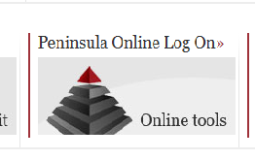
STEP 3: Select Business Wise | 
STEP 4: If you are already registered Login, entering your  - Account No.  - Username and  - Password.  (if not already registered go to STEP5) | 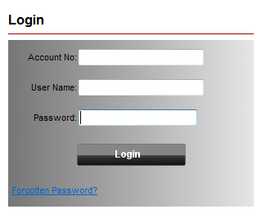
STEP 5. Register to use the site by entering  - Account No.  - First Name  - Surname  - Telephone No. and  - E-Mail | 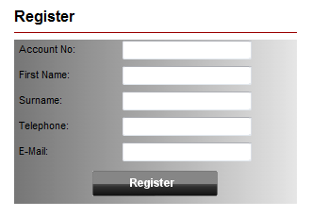
STEP 6. Select the Safety Wise Tab  The Manual is under H&S Management Documents | 

