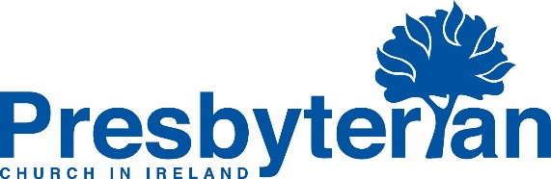

FORM FOR NOTIFICATION TO CLERK OF PRESBYTERY OF CHURCH’S RELEVANT PERSON UNDER SECTION 11 OF THE CHILDREN FIRST ACT
The Children First Act requires relevant services (which includes each church) to appoint a ‘relevant person’. Their role is to oversee the statutory risk assessment which is necessary under the Act and to oversee the completion of a Child Safeguarding Statement for the Congregation. They will often be the Clerk of the Session or a senior Elder with governance experience.
This is an important appointment with the post holder ensuing they have lead responsibility for the risk assessment, Child Safeguarding Statement and that the congregation’s safeguarding procedures are in line with best practice.
This is a distinct and separate role to Designated Liaison Persons and those with Mandated Reporting responsibilities.
This form is to be used by Kirk Sessions in the Republic of Ireland
Compliance with Children First requirements is also a requirement of the Charity Regulator

Name of Congregation
Person appointed a relevant person for purposes of Children First
Date of appointment
Confirm this has been agreed by the Kirk Session
Confirm Notification to Clerk of Presbytery
I have added this to the list of relevant persons help me on behalf of PCI

Clerk of Presbytery Signature:

