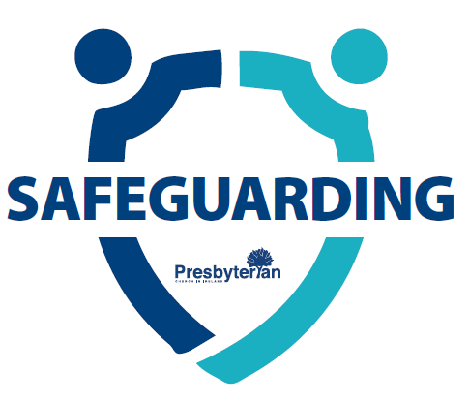
REGISTRATION OF NEW DESIGNATED PERSON (DP) / DEPUTY DESIGNATED PERSON (DDP) / ADULT SAFEGUARDING CHAMPION (ASC)
On approval by Kirk Session as the DP/DDP, please complete this form and send to the general safeguarding email safeguarding@presbyterianireland.org
Congregation:
Please circle where applicable:
I am a new DP / DDP / ASC
I am replacing a current DP / DDP / ASC
If replacing, please state the name and role of the person you are replacing.
Name: Role:
Please circle what role you are taking on:
Designated Person
Deputy Designated Person
Adult Safeguarding Champion

New DP/ DDP/ ASC Contact Details
Name:
Address:

Email: | Tel No: | Mobile No:

Verification by Kirk Session
Kirk Session for (insert congregational name) confirm they have recruited this individual in line with the policy and procedures for Safeguarding in PCI.
Kirk Session confirm they have vetted this individual and will ensure the individual keeps their safeguarding training up to date.
Kirk Session are satisfied this individual is capable of holding this role, and will support them to do so.
Signed:  (Clerk of Session, on behalf of Session) | Date:

