
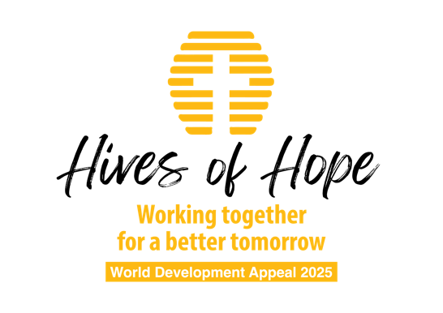

Additional projects

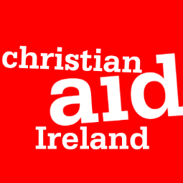

Kenya
Urban farming to tackle poverty in Nairobi, Kenya
Women in informal settlements in Nairobi face many layers of challenges : inadequate education, unsatisfactory healthcare, having access to little money, the widespread nature of gender based violence, a lack of access to land as well as the impact of the changing climate. Many families in the Dagoretti area eat only one or two meals a day.
Christian Aid partner, Beacon of Hope, aims to help women through organising self-help groups, establishing demonstration gardens to train women in climate-smart agriculture that works in an urban setting, increasing employment opportunities for women through vocational training in areas like baking and hospitality as well as strengthening the capacity of community volunteers to offer support to survivors of violence.
Dominican Republic
Seeking peace in Dominican Republic
The border between Dominican Republic and Haiti can be unstable due to high levels of poverty, inequality and discrimination. Systemic gender discrimination, the displacement of Haitians fleeing gang violence as well as environmental conflicts have all exacerbated the tensions further. Addressing these interconnected challenges requires a holistic approach that integrates peacebuilding, social cohesion, and sustainable livelihoods.
Christian Aid partner, Social Service of Dominican Churches, was founded in 1962. Their response to the instability at the border is to help faith leaders to play their part in creating dialogue and a welcoming society to those migrating from other places. They are engaging faith leaders to counter hate speech, to build shared understanding between different groups of people, and to build trust between Dominican and Haitian officials. They will lead reforestation and environmental clean-up activities which involve both Haitian and Dominican populations to encourage cooperation and sustainable management of shared resources.
Zimbabwe
Building Resilience in Zimbabwe
Communities in the Midlands Province of Zimbabwe are experiencing little rain and erratic rainfall patterns leaving families unable to provide three meals a day. At the same time, other extremes such as drought are a risk. In this province, there has been conflict over land and mineral resources as well as polarisation which further limits economic progress. Violence, anger, fear and mistrust grow.
The Zimbabwe Council of Churches aims to reach and support at risk households with their ‘livelihoods for peace’ work, recognising that helping communities have enough to eat links directly to peacebuilding – uncertainty and instability can exacerbate tensions. They will train local leaders on peacebuilding through sustainability and livelihoods, support community dialogues to identify potential threats to peace and support households with skills training programmes, community peace gardens and ‘peace poultry hubs’.



Ethiopia
Breaking the cycle of poverty and environmental ruin
Partner: Meserete Kristos Church (MKC)
In Meskan, Ethiopia, economic, environmental, and social challenges are threatening livelihoods dependent on vulnerable rain-fed agriculture. To address these challenges, Tearfund’s local partner, the Meserete Kristos Church (MKC) is working to empower local communities. By teaching sustainable farming techniques and green livelihood skills like beekeeping, they will equip people to manage their natural resources sustainably while taking charge of their future.
Pakistan
Building resilience
Partners: LAMP Pakistan & PAK Mission Society
Jamshoro, in the Sindh province, is in dire need of support. The region has endured consecutive years of drought, followed by devastating floods in 2022. These extreme weather events have had a catastrophic impact on people's lives, wiping out homes, livelihoods, and agricultural land. The community, heavily reliant on agriculture and livestock, struggles to recover. Women, in particular, have been disproportionately affected, as they contribute to household income through farming and livestock care.
Tearfund’s partners empower women through self-help groups; saving, supporting and investing together. Through skills training and business support, families are equipped to build resilient livelihoods that will withstand the next crisis.
India
Sustainable incomes while caring for creation
Partner: NEICORD (North East India Committee on Relief and Development)
In many parts of India, people are thriving. You may well have visited the country yourself, and seen how prosperous and high tech many of the cities are. India even has a $1.55 billion space programme, which is understandably a great source of national pride.
Given that India is a middle-income country, one might wonder why so many of India’s people are still living under the dark clouds of poverty. Why is it that this nation has one of the highest levels of poverty in South Asia (based on income, education, health and many other factors)? The answers to those questions are complicated and multi-faceted. Yet the fact remains that many people and communities in India are still struggling to provide the basic necessities for themselves and their families. And they are desperate for a way to overcome their suffering.
Resourced by Tearfund, NEICORD, our local partner, equips churches with vital skills. These churches are now leading community development efforts to end the grinding poverty in their villages. They do so by caring for their communities, and the environment upon which those communities depend.
Mozambique
Entrepreneurship and livelihoods
Partner: ICUM (United Church of Christ, Mozambique)
This project aims to support communities in overcoming two key challenges: lack of sustainable livelihoods and ongoing cycles of poverty, and environmental degradation which damages future livelihood opportunities.
Communities that have undergone or begun the Church and Community Transformation process through our local partner, will be equipped and encouraged in new income generation activities through the sustainable harvesting of Moringa and Aloe vera plants and the production of soaps, toothpastes etc. This was identified as an exciting source of sustainable income by communities - while also preventing further environmental degradation through deforestation and harmful farming practices. It is an income source that can grow despite further climatic changes, since the growing and harvesting techniques learnt are resilient and sustainable. There is a particular focus on engaging young people in the program.
Democratic Republic of Congo
Scalable Income Generating activities for young people impacted by violence
Partner: El Vision (Christian agency working in Eastern DRC)
The project aims to transform the socio-economic conditions of young people in the city of Butembo in North East DRC, in response to the M23 crisis and its effects on the city. In the short term, it will provide economic opportunities to vulnerable young people through training, financing and personalized monitoring, thus creating 40 direct jobs and 60 to 100 indirect jobs. This will reduce the vulnerability of young people to risky behaviors, such as violence or joining armed groups. In addition, promoting civic engagement and responsible behaviors will strengthen social cohesion.
In this project, we are working closely with the Church and other community groups to involve the local community in key processes. The Church will support in the identification and selection of entrepreneurs, drawing on its in-depth knowledge of the local context and its proximity to different social categories. With a particular focus on young people, the project aims to strengthen the economic independence and resilience of youth in the city, creating long term, sustainable income.

