
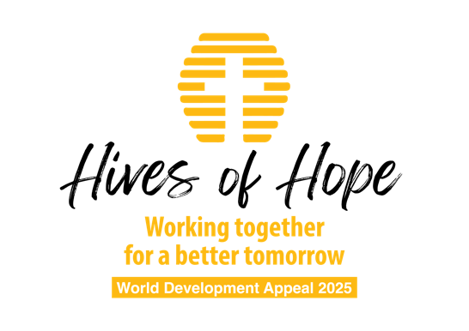

Children’s talk A

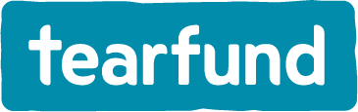

Children’s Talk- Your Kingdom Come
Optional prop: a broken toy, a broken screen

- Intro: eg ‘Today is World Development Appeal Sunday’ so we are thinking about what it means to belong to Jesus in his big wide world.

- Remind Children of the Creation story
  - Now, we know that God made the world don’t we? He is the Creator - he made everything.
  - Who can tell some things that God has made? Eg The blue sky, or the rain clouds, the trees and the grass, the beaches and the mountains and of course all the amazing variety of animals: everything from the smallest ant, to the massive Blue Whale and everything in between: including you and me, which is amazing!
  - When God made everything he said ‘it is good’. It was perfect!!!

- We look around today and we see so much of that goodness but we can see that things aren’t perfect. The world can sometimes be a bit hard, a bit unfair. People get sad. Sometimes people can be mean or unkind. In the big world out there, one of the ways we see that the world isn’t quite perfect is that lots of people, just like you and I, live really hard lives: maybe their country is fighting a war and they are scared, maybe there isn’t enough food to go around and they are hungry, maybe they get sick and there isn’t a doctor nearby that can help to make them better!

- So while God made the world ‘Good’ and ‘Perfect’, the world we live in is a bit broken. It’s a bit like this (use a broken toy, or a broken screen on a phone, or simply ask the question: Mums and dads, has anyone ever broken the screen on their phone or tablet?). When something breaks, we still know what it is and how it is meant to work, we can see the inventor's design in it, but it isn’t how it is meant to be. It is broken.

- The world we are living in has been broken by sin. We read about that way back in the first few pages of the Bible. And sin has broken God’s good world - it causes all the things I mentioned just a minute ago: the fighting, the sadness, the hunger and the sickness. It’s not how God has made the world.

- Did you know that Jesus came not just to save you and me from our Sin, but to save and fix the whole world from this sin and brokenness? In fact, the Bible tells us that when Jesus comes back - he’ll fix everything once and for all - there’ll be no more poverty, no more wars, no more unkindness, no more sadness. The nations will be healed and there’ll be no more curse, no more sin anywhere.

- That is a really good thing to remember if we are ever faced with things that make us sad.

- But do you want to know something even more amazing? God invites us to join him in this mission of making the world ‘good’ again, of making it more and more into how God wants it to be: where people aren’t sad and lonely, where people have enough food and water, where people don’t fight and also, when everybody has had the chance to know that Jesus loves them. That’s what Christians mean when we pray ‘Your Kingdom Come’. We pray that prayer not just for our own home and street and community but for places right across the world - places like Ethiopia where Tearfund are working with local churches - just like this one - to see God’s Kingdom come, to see communities where there is no more of those sad things: hunger, sickness, fighting.

- We’ve the chance to join in that mission today as we support the World Development appeal through our denomination.

- End by praying (Option: Lord’s prayer together - Your Kingdom come)

