
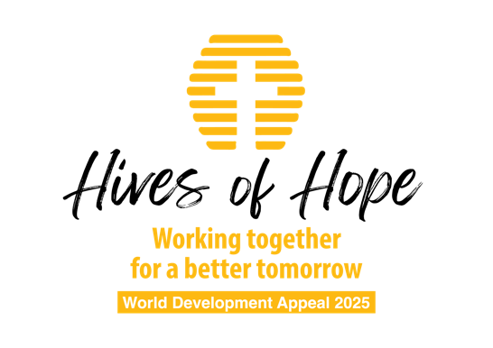

Children’s talk B

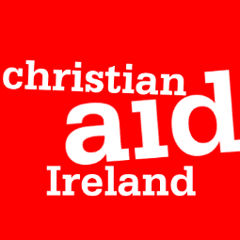

Have you ever wished you were bigger? Maybe tall enough to reach the biscuits your mum put on the high up shelf? Maybe big enough to play football with the older kids in school?
Sometimes it can feel like being little is a bad thing. It might feel like it stops you from doing the things you’d really like to do. But do you know that Jesus doesn’t think that being small means that you can’t do really amazing things?
Jesus loves to tell stories, and when grow-ups read them they’re called parables. One of the parables that Jesus told his friends is called The Parable of the Mustard Seed, and I’m going to read it to you now:
The Parable of the Mustard Seed - Mark 4
Again he said, “What shall we say the kingdom of God is like, or what parable shall we use to describe it? It is like a mustard seed, which is the smallest of all seeds on earth. Yet when planted, it grows and becomes the largest of all garden plants, with such big branches that the birds can perch in its shade.”
Can you show me what size you think a mustard seed is?
You’re right! It’s a teeny tiny seed (you could bring one as an example). And when we think about how small it is, it’s really hard to imagine it growing into a big tree that birds can live it, but it does!
Jesus wants us to think about how we are like the mustard seed when we love him very much. Because when we love him, and we live the way he shows us, we can make a BIG difference to lives of the people and the world around us. Just because something is little, doesn’t mean it can’t make a BIG difference.
I’m going to tell you about how people in a country called Honduras know this too!
In Honduras, a lot of families are struggling to have enough food to for everyone to have breakfast, lunch and dinner. Imagine if you could only eat breakfast and then not eat again until the next day? It would be awful!
But, something very small, just a little larger than a mustard seed, is helping to solve this terrible problem!
The solution is…Bees!
Our friends at Christian Aid are helping families to care for teeny tiny bees so that they can make their lives much better thanks to the honey that the bees make.
Communities in Honduras are learning how to take care of their small but mighty bees, as well as learning how to repair and build their beehives so that their colonies can grow BIGGER and BIGGER.
Bees might be small, just like the mustard seed, but they are making a big difference to the families that Christian Aid are helping.
And we can help even more people to change their lives too!
Churches like ours, all over Ireland, love to think about others and share the good gifts that God has given us to help these communities become great beekeepers. In Jesus’ parable, the mustard seed can grow into the biggest of all the plants in the garden. We want this bee project to grow just as big!
We can help these bee projects grow by supporting the World Development Appeal. By supporting the beekeeping families to build hives, buy seeds to plant different types of flowers for food and pay for local beekeepers to teach them how best to look after their bees, we’re living the way Jesus teaches us to.
With our help, families will learn how to safely collect their delicious honey and sell it at their local markets. This means everyone will have money to spend on food, their homes, school uniforms, new jars for their next honey collection, and they even make some savings in case they need extra money in the future.
Even the smallest mustard seed can become a big tree. Even the smallest insect can change the future of whole communities. Even the smallest person who loves Jesus can make a BIG difference to the lives of people around the world.
Let’s pray:
Heavenly Father,
Thank you for never overlooking the smallest seed or the littlest person. Thank you for helping us to grow and that you can use us to help other people too.
We pray for the families in Honduras who are learning how to care for little bees so that they can make a big difference to their lives. We ask that you would help Christian Aid to reach more people who need help to feed their families and make a better life for themselves.
Help us to remember that even though we can feel very small, that Jesus tells us that through him we can make a big impact on the world around us in his name.
And it is in Jesus’ name we pray,
Amen.

