
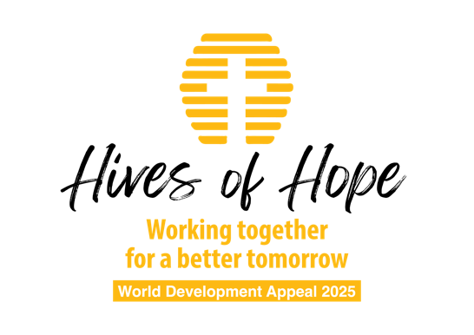

Church announcement

The World Development Appeal this year is entitled: “Hives of Hope. Working Together for a Better Tomorrow.”
Honduras is in a region of the world that is heavily impacted not only by climate change but also by drug trafficking, political instability, gender-based violence and food insecurity.
How can we work together for a better tomorrow?
Christian Aid is working in Honduras through charities on the ground to bring hope and stability to families struggling to provide enough to cover their basic needs.
One of those charities is OCDIH: The Christian Organisation for Integral Development of Honduras. OCDIH is a faith-based charity that works with indigenous communities on a range of issues with small farmers in western Honduras. OCDIH is helping to create sustainable livelihoods through projects such as bee keeping — providing the know-how to manage the bees and also creating the means to access the markets to sell the honey into.
We commend the World Development Project 2025 to your prayers and we ask that you give generously to the work which will also support Christian Aid projects in the Dominican Republic and in Kenya and also Tearfund projects in Ethiopia, India, Pakistan, Mozambique and Zimbabwe.
Please make use of the appeal envelopes where you will find more information.

The video

On the video presentation you will see how a simple project of establishing bee hives makes for a better tomorrow for many families.

