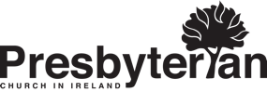
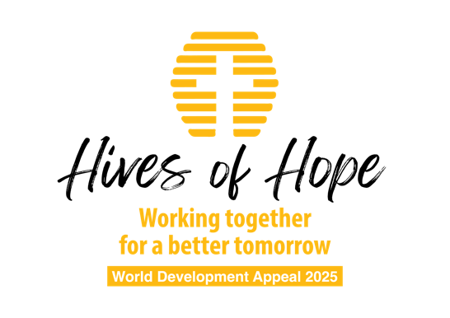

Notes For ministers

Background

Honduras is a country in Central America with a population of just over 10 million people and a land area 25% larger than the island of Ireland.
Honduras has a sea coast on the Gulf of Mexico and on the Pacific. It borders Nicaragua to the east, El Salvador to the south and Guatemala to the west. The official language is Spanish and is predominantly Roman Catholic.
Honduras has a tropical climate and a mainly agricultural economy.
Around 60% of the population live in poverty and 19% of children under 5 years of age have impaired development. The problems of climate change, inconsistent economic growth, growing levels of inequality and poverty, violence, political instability, displacement and limited access to basic social services are some of the main factors leading to food insecurity and malnutrition.
Western Honduras is located in the so called “Dry Corridor” a region that is particularly susceptible to climate change and has frequent droughts. Within Western Honduras the Lempira region is the poorest in Honduras

The Project

Christian Aid is working through a faith based organistion called OCDIH: The Christian Organisation for Integral Development of Honduras.
OCDIH works with indigeous communities on a range of small projects including bee keeping, fish farming and coffee production.
This project came about as a result of an earlier project tackling domestic violence, as it became clear that one of the causes of violence in the home was poverty. So the question was how to generate an income to try and aleviate the financial pressure on families.
Beekeeping was chosen as an income generating project and it has proven very successful.
This project works on different levels. There is the income generated through selling honey which helps to support the family and provide for the education of the children. There is also a strong cohesion arising from this co-operative venture which enables the women to grow in confidence and support one another. The women gain a much better awareness of how important it is to look after and maintain the environment. And then it also allows the women to develop leadership as they grow their small business.
OCDIH is providing training in beekeeping, is supporting the small co-operative venture and helping to produce and market the honey. As a faith based organisation OCDIH also promotes a biblical worldview, holds devotional reflections and encourages reliance on God.

Examples:

Candida has 11 children and 37 grandchildren.

“I haven't been to school a single day in my life… My parents were very, very poor. Too poor. They couldn't put any of their family [in school]. I cannot even read but I am very motivated.”

“First they gave me one [beehive] in one year, then the second one I received in the next year. Out of those I already have four beehives, four beehives!”

“And my future, if I have ten, twenty beehives, I will sell 10 and I will stay with ten and continue...”

“My husband helped me [make the hives] doing the frameworks on the filters and everything with the wood. And we live peacefully – I used to be very stressed. I was very stressed. Now you can see I'm very happy. It has changed my life a lot.”

Maria has two daughters and runs a small shop from her home. She received two hives two years ago and has now divided them into four. She wants to build up the number of hives to ten and then start selling the honey.

“It was a dream. I wanted to have those beehives, but due to the situation, I couldn't, but thanks to Christian Aid, this dream was a reality.”

“My husband helps me building them, he's the one that does the frames. Yes, indeed. It's a team effort. Yes. My small daughter also, she loves watching them. My daughter say this ones are going to be mine and I tell her no, they are from God!”

“Well, if you could pray for this project, because this project, I hope it can continue this progress. It can continue growing and please pray for our families so that God can give us the wisdom to manage it, the few that we have to manage it.”

Sermon Ideas

James 1:27 - “Religion that God our Father accepts as pure and faultless is this: to look after orphans and widows in their distress and to keep oneself from being polluted by the world.” We have an obligation to live out what we believe in practical ways and supporting projects like this is one of those ways.

Matthew 14:15-21 – “You give them something to eat.” A little goes a long way when the Lord takes what we give him and he multiplies it to do his work.

Matthew 25:34-40 - “The King will reply, ‘I tell you the truth, whatever you did for one of the least of these brothers of mine, you did for me.’” The poor are to be assisted in practical ways. We serve the Lord when we serve the poor and the Lord acknowledges this.

Ex 23:11; Lev 19:10; 23:22 – The Law of Moses enabled the poor to help themselves as far as possible. This gives dignity and worth to the person being helped. Very often people simply need a small amount of help to accomplish a great deal with God’s help.

