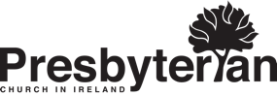
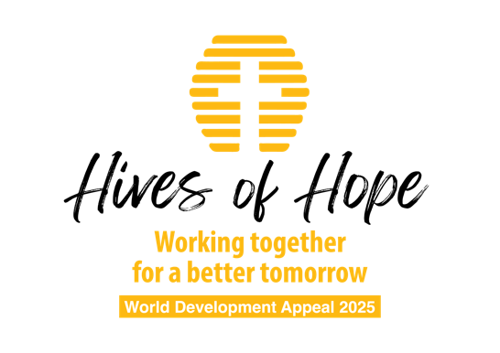

Powerpoint script

SLIDE 1 Introduction to the World Development Appeal
The annual World Development Appeal of the Presbyterian Church in Ireland offers congregations the opportunity to learn more about, and to support work undertaken by our development partners, Christian Aid and Tearfund. Proceeds from the appeal are used to support a variety of development projects around the world. However, each year the appeal also focuses attention on one particular project. This gives congregations the opportunity to ‘go deep’ in understanding some of the challenges of sustainable development in a particular location, while also being able to ‘go wide’ in contributing to projects in several parts of the world.
The World Development Appeal 2025
Around the world, millions of people face obstacles that make it difficult for them to get out of poverty. Christian Aid and Tearfund are working through their partners to help families and communities to generate a sustainable income and build a better future.
SLIDE 2 Honduras
Honduras sits in the middle of Central America, bordered by Nicaragua, El Salvador and Guatemala. The economy largely depends on agriculture, including bananas and coffee, making it vulnerable to the effects of climate change and natural disasters. 60% of the population live in poverty.
The Global Climate Risk Index ranks Honduras third in the list of countries most affected by extreme weather events, due to its vulnerability to tropical storms, floods, droughts and landslides.
Apart from climate, Honduras faces challenges from drug trafficking, political instability, food insecurity, gender-based violence and economic migration.
Western Honduras is located in the so called “Dry Corridor” a region that is particularly susceptible to climate change and has frequent droughts. The Lempira region is the poorest in Honduras.
SLIDE 3 OCDIH
Christian Aid is working in the Lempira District through OCDIH: The Christian Organization for Integral Development of Honduras. OCDIH works with indigenous communities on a range of small projects including beekeeping, fish farming and coffee production with the aim of combatting the causes of poverty and marginalization.
OCDIH is a faith-based organization and their work is strongly based on a Christian identity and Christian principles.
SLIDE 4 Hives of Hope
The beekeeping project in the Lempira region seeks to provide a means of income generation to enable people to lift themselves out of poverty.
OCDIH trains women in beekeeping and helps to produce and market the honey. The project has been very successful. Income is generated through selling honey and this can then be used to support the family, as well as provide education for the children. The project is a cooperative venture, allowing women to support one another, learn about the environment and develop leadership skills.
SLIDE 5 The people
Maria has three children and runs a small shop from her home. She received two hives two years ago and has now divided them into four. She wants to build up the number of hives to ten and then start selling the honey.
“It was a dream. I wanted to have those beehives, but due to the situation, I couldn't, but thanks to Christian Aid, this dream was a reality.”
Candida has 11 children and 37 grandchildren.
“I haven't been to school a single day in my life… My parents were very, very poor. Too poor. They couldn't put any of their family [in school]. I cannot even read but I am very motivated.”
“First they gave me one [beehive] in one year, then the second one I received in the next year. Out of those I already have four beehives, four beehives!”
“We live peacefully – I used to be very stressed. I was very stressed. Now you can see I'm very happy. It has changed my life a lot.”
SLIDE 6 Hives
These are more than just beehives, they are a means of income, an opportunity, a future. They are hives of hope.
SLIDE 7 Tearfund project
The World Development Appeal will also support a Tearfund project in Ethiopia, working through MKC (Meserete Kristos Church Relief and Development Association) and TDA (Terepeza Development Association) to develop self-help groups delivering food security and empowerment of women.
The community in Meskan, Ethiopia is dependent on agriculture, which is subject to economic, environmental and social threats. MKC are teaching people environmentally friendly farming techniques and green livelihood skills to equip people to manage their natural resources sustainably.
SLIDE 8 Prayer points
- Pray for the growth and development of the beehives in the Lempira region, so the beekeepers can generate and sustain good income to lift themselves out of poverty
- Pray for wisdom for the beekeepers and for the staff of OCDIH as they train more communities
- Pray for hope and a future for the people of Honduras and Ethiopia

