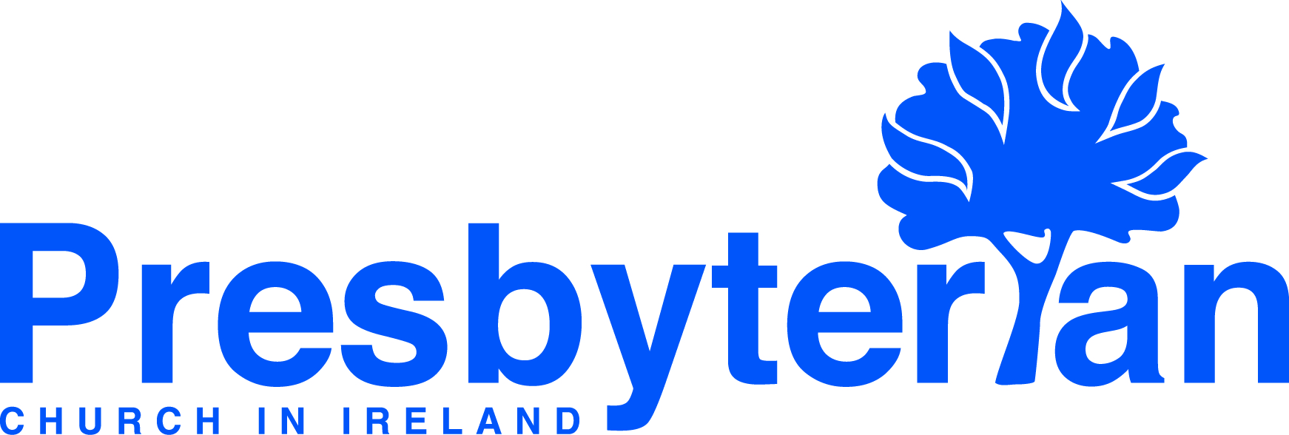
Sunday 13 September
- Moderator | This week the Moderator will be visiting the National Ploughing Championships event in Tullamore. Pray for him as he engages
with various aspects of society; churches, charities, civic life, farming and businesses – that each encounter over the two days would be
meaningful as the church is represented at the event.
- Knowing the blessings of God in worship | May the God of hope fill you with all joy and peace as you trust in him, so that you may
overflow with hope by the power of the Holy Spirit. Romans 15:13. Ask that as you worship today you may know the blessings of God’s
overflowing hope, joy and peace.
Let’s Pray | Sun 13 September - Sat 19 September 2026
Saturday 19 September
- Thompson House | Give thanks for Tim Higgins and the staff team who work and witness in Thompson House, PCI’s supported housing
scheme for offenders. Remember Tim and the staff as they come alongside residents providing support and guidance, from finding employment and further education opportunities, to assisting them establish homes of their own.
- Council for Public Affairs | Pray for Rev Jonathan Boyd as he settles into his role as Secretary of the Council for Public Affairs. Pray for
wisdom, confidence and grace as the Council continues to engage in the public square.
Friday 18 September
- General Council | As the normal schedule of meetings resumes, pray for internal meetings, such as the General Assembly Business
Committee, under the leadership of its new convener, Rev Mark Neilly and external events such as the Irish Inter-Church Committee Meeting
being held at the end of the week. Ask that God’s guiding and influence might be felt in each setting and wise decisions would be made.
- Training in Ministry | As the new College year commences, pray for the staff, students and residents in their various circumstances. Pray
that the arrangements and planning that has already taken place will bear fruit in a harmonious community, where learning and serving
together will take place. Pray for those commencing studies, especially those embarking on their studies for the ordained ministry of PCI.
Thursday 17 September
- Mission Pioneers | Pray for the recruitment process for Mission Pioneers to be involved in work across Ireland. The closing date for the next cohort of applications is 16 November and all applicants will be assessed in terms of suitability before being assigned a programme of apprenticeship and training, some of which will be alongside ongoing service.
- Mission Pioneers | Pray for those already deployed as Mission Pioneers, as they seek to reach out with the good news of Jesus and establish new outreach initiatives within various settings.

Wednesday 16 September
- Naomi Leremore, global mission worker, Kenya | Give thanks for the blessings of family time in Ireland and the opportunity to reconnect and strengthen the ties that bind. Pray for Thomas and Silas in Kenya while Naomi engages in deputation during September. Remember Aaron as he settles in Northern Ireland. Give thanks for the Holistic Nurturing of Children Course run by the PCEA’s Theological Education by Extension (TEE) programme, for its relevance and effectiveness in training leaders working with children.
- Presbyterian Church of Pakistan (PCP) | Pray for Pakistan's disaster management system which is struggling to protect vulnerable communities repeatedly exposed to floods, cloudbursts, landslides, and glacial lake outburst floods due to extreme monsoon rains in recent months. Pray for those grieving loss, given the death toll of over 160 people, with around 500 people injured since the monsoon season began. Pray for a strengthening of infrastructure and robust preparedness so as to limit damage.

Tuesday 15 September
- Drum, Cootehill and Kilmount, Rev Daryl Edwards | Please pray for the forthcoming harvest services over three weekends in September and October. As we give thanks for God’s faithfulness through another year, pray for engagement with our rural communities and for God to give the growth as his Word goes forth.
- Healthcare chaplaincy, Tallaght University Hospital, Rev Mark Proctor | Pray for the challenges in interacting with patients who speak little or no English, particularly for hospital staff, chaplains and those who find it distressing as they struggle to communicate. Give thanks for translators and translation apps that help everyone, including chaplains seeking to bring God’s comfort.
Monday 14 September
- Edwin and Anne Kibathi, global mission workers, London, UK | Give thanks that this month marks the Kibathis’ 20th year since starting in PCEA UK outreach. Please pray for the joint thanksgiving service planned for Saturday 26 September in London with the three other congregations in Luton, Birmingham and Reading in attendance. Pray for God’s guidance and wisdom as the congregations look to the future.
- Presbyterian Church of South Sudan (PCOSS) | Pray for the thousands of Presbyterians who, having lived at one time as urban refugees in Khartoum, then fled conflict to refugee camps in White Nile State. Pray that as they go about life in very confining, vulnerable circumstances, they would know adequate provision of food, accommodation and educational resources. Pray also for trauma healing and for God to strengthen their faith in the face of much adversity.

