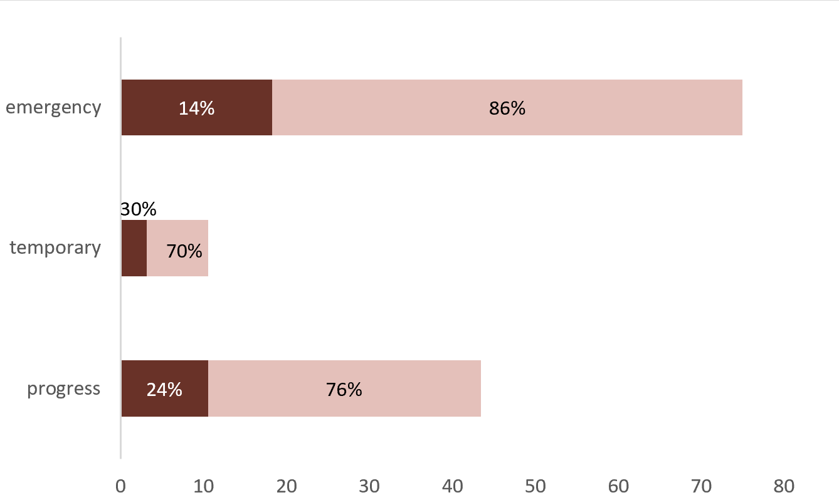
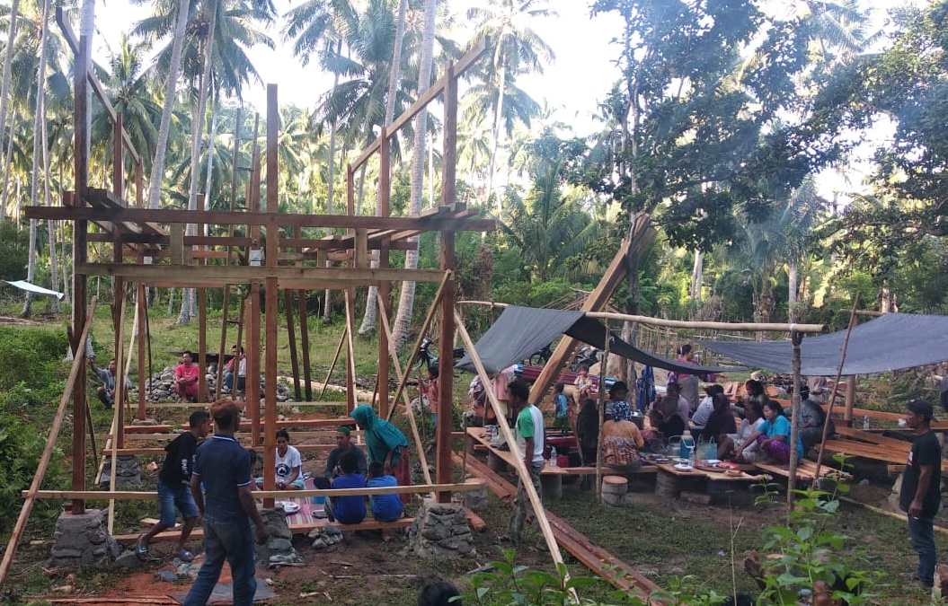
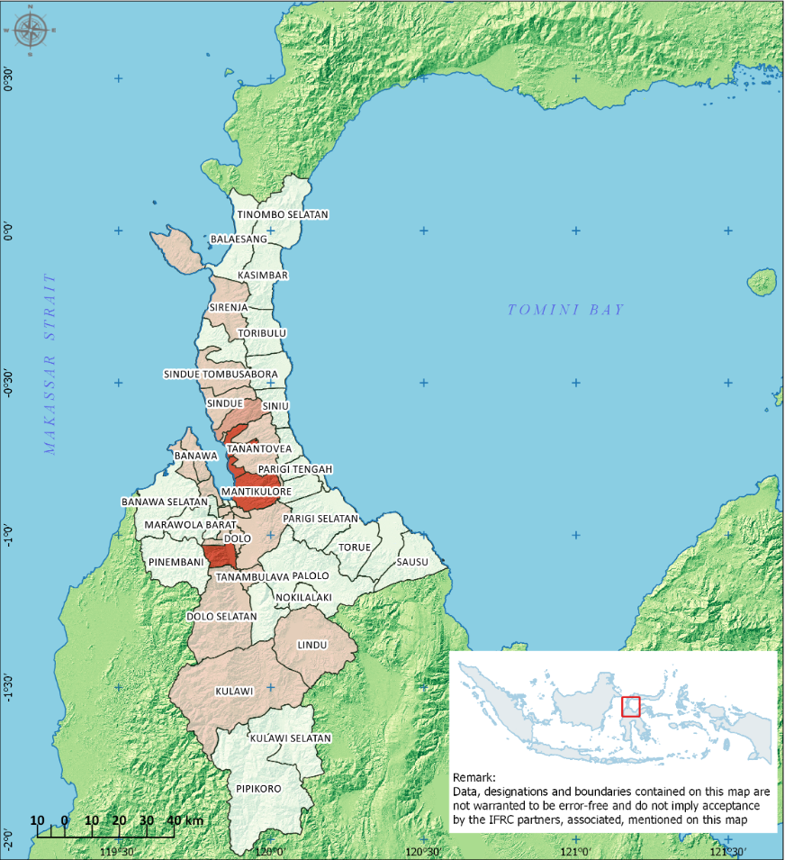
Temporary Shelters (Completed vs Needs)
Tents
Tarpaulins
Temporary Shelters (Individual)
Temporary Shelters (Completed)
Temporary Shelters (Needs)
Temporary Shelters (Collective)
Thousands of HH
KEY FIGURES (HH)

Completed Temporary Shelter
Completed Emergency Shelter
Source: Wanda Chanafiar/ Relief Box
Targeted: 22,971 HH or 114,855 people
Disaster-affected population (Government data)
Population in the affected sub-districts (Census 2014)
Cluster Partners
CENTRAL SULAWESI, INDONESIA
NEED ANALYSIS
- A massive quake hit the island nation’s Central Sulawesi province. The magnitude-7.5 temblor struck at 5:02 p.m. Friday, Sept. 28, generating a devastating tsunami and liquefaction.
- At least 4,547 people have been killed and nearly 173,000 people displaced (11/03/2019).
- Estimated over 100,000 houses are affected with 4,050 houses gone and more than 30,000 houses heavily damaged. However, the actual figure is likely to be much higher.
RESPONSE
- Over 100 cluster partners are recorded in the shelter sub cluster. Of these around 20+ agencies report and engage regularly in the sub-cluster.
- Most agencies are currently focusing in providing temporary shelters (individual or collective).
- Shelter coordination meeting is conducted every two weeks, with SAG and district focal points have been established.
GAPS / CHALLENGES
- Lack of reliable data due to conflicting definitions of displacement and damage.
- Quality of shelter assistance varies and not according to the agreed shelter standards
- People are reluctant to move to the government-led collective shelters program due to uncertainties with the available facilities and services.
- Housing, land, and property rights due to relocation of families to safe zones
- Political situation with the upcoming general election in April 2019
- Floods and landslides risk due to the ongoing rainy season. Aftershocks also still occurred.

Photographer / Organisation, Year
SHELTER SUB CLUSTER TEAM
National Coordinator
Iyan Kusmadiyana (Ministry of Social Affairs)
iyankusmadiana@gmail.com / +62 819-3145-8272

National Co-Lead
Wahyu Widayanto (IFRC)
Wahyu.widayanto@ifrc.org / +62 819-737-529-71

Information Management Coordinator
Hijaz Jalil (IFRC)
hijaz.jalil@ifrc.org / +62 811 611 2880

Technical Advisor
Dave Hodgkin (IFRC)
dave.hodgkin@gmail.com / +62-813-920-99-666

Communication Focal Point
Avianto Amri (IFRC)
avianto.amri@gmail.com / +62-855-210-66-10

KEY DATES
26 October 2018: End of emergency relief period
24 April 2019: End of emergency transition period, r

KEY DOCUMENTS
- Temporary Shelter Standards
- Meeting Minutes
- Maps

KEY LINKS
- Country page on ShelterCluster.org
- Country page on Indonesia’s Shelter Sub Cluster Website
- Country page on ReliefWeb

KEY FIGURES
109 984 K / 173 K

CLUSTER MEMBERS TARGET

