Vulnerability Classification Working Group
Global Shelter Cluster Meeting – Breakout session Summary
3 October 2018

Key Links and documentation:
- Dimension and Class mapping(with updates from Shelter Week 2018) https://docs.google.com/spreadsheets/d/1L-KAQVhPC9zBKQTMqpDE2GemYUbC25_BlrYtG1TOR8o/edit?usp=sharing
- SVC Manual draft https://docs.google.com/document/d/1VNv2cn7_KG9hs1j_5u8VC1cTWUU2mVJajqpQ2mWzP5A/edit
- Dropbox-https://www.dropbox.com/sh/gwo17muwnhpnikq/AABBdXMFjKcfP3M0w2aolzy9a?dl=0
- What we are trying to do - +What we are trying to do (working draft)
- Preliminary ToC/ Conceptual Framework (with updates from Shelter Week 2018)-https://www.dropbox.com/s/dle18xir6x2vrfu/conceptual%20framework.pdf?dl=0

Draft Framework for discussion as presented:

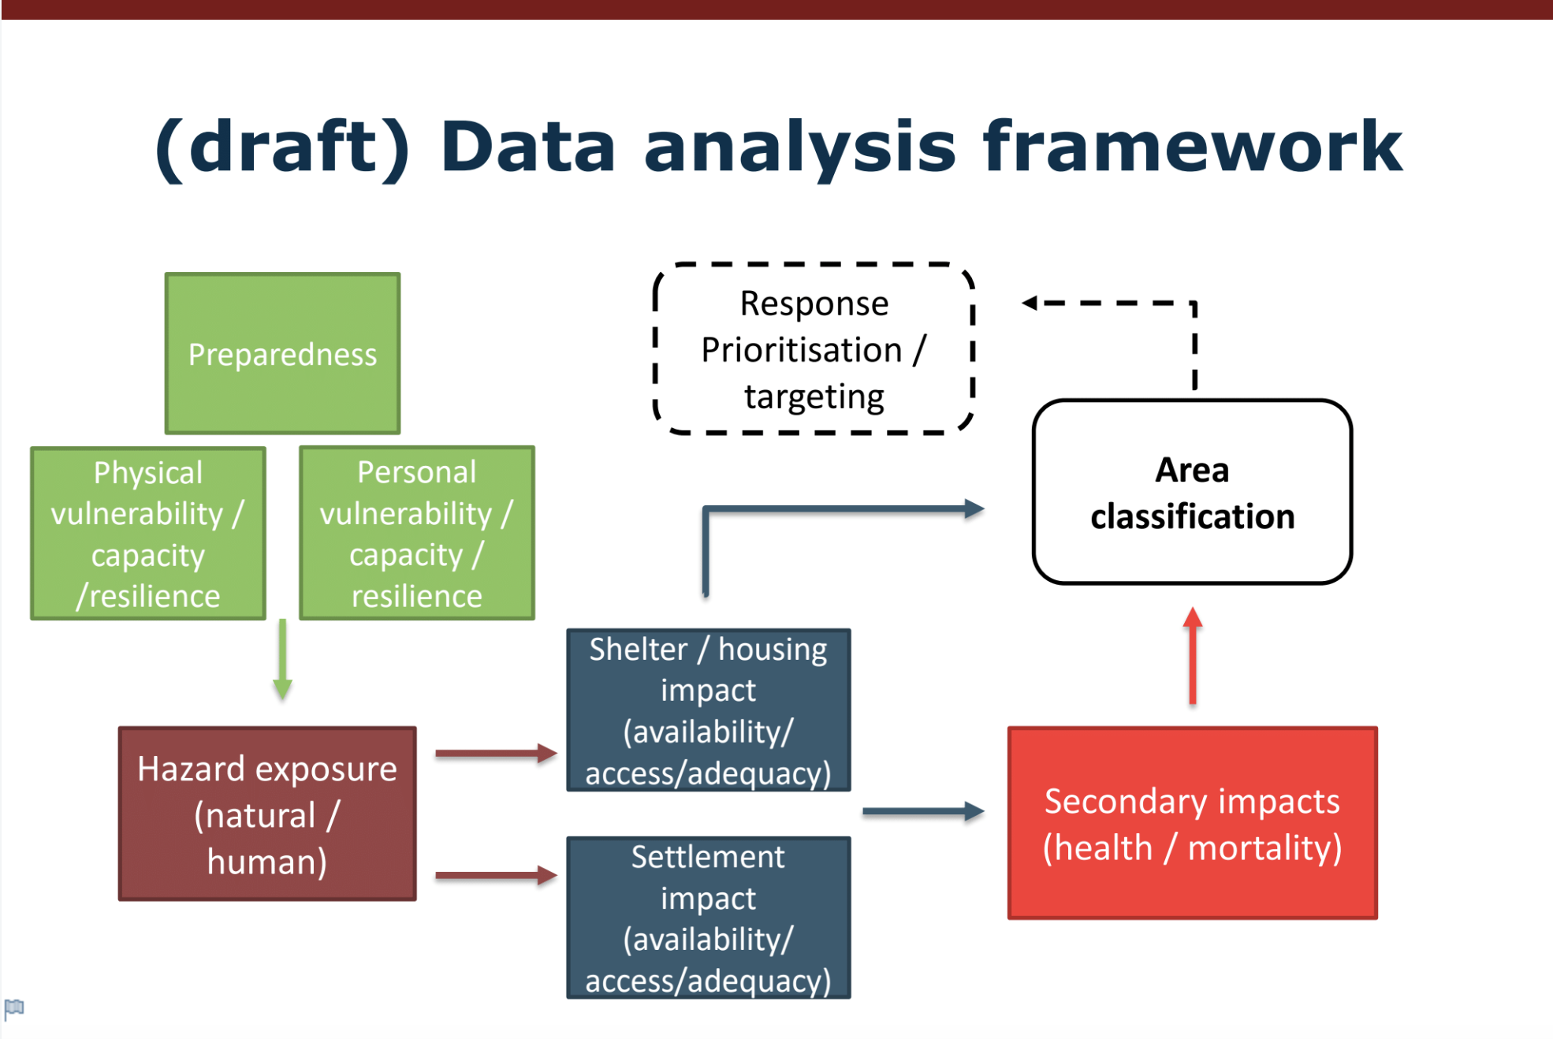

Meeting Summary:

3 Things We Learned:
- “This is not as easy as it looks”
- Hazard-type should be the starting point – it may be more useful to structure the framework based on the temporal sequence of dimensions, therefore beginning with preparedness/hazard could be an intuitive beginning.
- Response dimensions will require expanded expertise profiles

3 Things to Action/Expand for 2018/19:
- Conflict categories and components – these dimensions need to be tested against complex/conflict crisis situations
- ID linkages between dimensions (ex. Stockpiling vs. Accessibility)
- Micro/Meso/Macro level across all dimensions – dimensions may require scale contextualization with consideration of how they are understood at individual, household, community or regional levels.

An Emerging Question/Issue:
- Building Coherence between human/conflict and natural disasters. There is not yet a common way of comparing conflict contexts and how vulnerability dimensions are impacted by those complex conditions. These dimensions are largely (but not entirely) created through the sudden onset natural disaster lens and it is uncertain how coherent the set can be simultaneously for both.

This Working Group’s Contribution to Strategy Outcomes:
- Evidence-based response (Pillar 3)
- An Enabler for Advocacy (Pillar 2)

